Title: IoTRing - A Trusted bio-inspired Sensing Approach

Dr Sasan Adibi¹, Professor Jemal Abawajy¹
¹School of IT, Deakin University, Geelong, Victoria, Australia

Keywords: Smart Ring, Hospital Cloud Abstraction Layer (HCAL), Internet of Things (IoT), Unified Smart Hospital Cloud (USHC).

- Abstract Body (up to 250 words)

This paper presents the design and deployment of a bio-inspired, body-worn, medical-grade, gadget-based on a trusted IoT platform, which incorporates a unique biometric ID for each user/patient. This ring-shape communication device is capable of authenticating and authorizing the user biometrically and creating a secure health-tag (H-tag) based on secure keys derived from physiological information, characteristics, data pattern, as well as fusing with other uniquely identifiable information (e.g., date of birth).

This health-based device is more than just an ID tag, which is a design-based complex intelligent system, able to track a number physiological signals (e.g., heart rate, blood oxygen, breathing patterns, stress level, etc.) and characterize and transmit bi-directional data (central agents can also communicate with the end-users remotely). The physiological signal tracking capability is in addition (and complimentary) to the IoT-based universal patient ID/data management capability.

This ring features a number of communication protocols and handshakes with the Unified Smart Hospital Cloud (USHC) and Patient Digital Registry (PDR). This is done directly through the Hospital Cloud Abstraction Layer (HCAL).

The objective of this paper is to present the IoTRing system and associated communication and security protocols and discuss about the current trends and future directions of the Smartphone diagnostics, wearable biosensors space.

- Image:

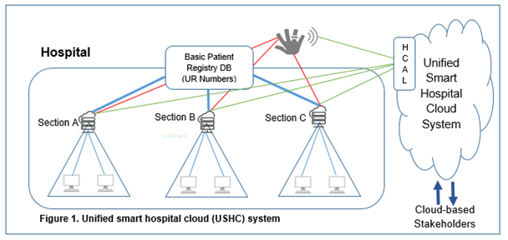

  - Reference:

- W Kienzle, KP Hinckley, “Smart Ring”, US Patent 9,582,076, Google Patents, 2017

- Bing Qin LimChong Keat ChuaWai Kuen GohKhay Loon HengWooi Ping Teoh, “Smart ring providing multi-mode control in a personal area network”, US Patent, US20190155385A1, 2019

- Eija Halkola , Lauri Lovén , Marta Cortes, Ekaterina Gilman , Susanna Pirttikangasax, “Towards measuring well-being in smart environments”, International Joint Conference on Pervasive and Ubiquitous Computing and Proceedings of the 2019 ACM International Symposium on Wearable ComputersSeptember 2019 Pages 1166–1169, 2019

IV. Biography:

Sasan Adibi (BS’95, MS’99, MS’05, PhD’10, SMIEEE’11) has a PhD degree in Communication and Information Systems from University of Waterloo, Canada and the recipient of the best PhD thesis award from the IEEE Society. He is currently involved in the research, design, implementation, and application Electronic Health (eHealth) and Mobile Health (mHealth). Sasan’s research publication background is mostly in the areas of Quality of Service (QoS), Security, and eHealth/mHealth. He is the first author of 80+ journal/conference/book chapter/white paper publications and is a co-editor of four books, two of which are in the areas of mHealth and the other two books are in the areas of 4th Generation Mobile Networks and QoS. He is an inventor/co-inventor of 4 patents in the areas of Health Informatics. He has 12+ years of strong industry experiences, having worked in a number of high-tech companies, including: Nortel Networks, Siemens Canada, BlackBerry Corp., WiMAX Forum, and Huawei Technologies. He is the founder and managing director of Cyber Journals and serving as Cyber Journals Health Informatics Associate Editor. He served as a Vice Chancellor Research Fellow at Royal Melbourne Institute of Technology (RMIT) at the Department of Business IT and Logistics for two years. He is currently a faculty member in the School of Information Technology at Deakin University.

    - Presenting author details



Full Name: Sasan Adibi

Contact number: +61 3 925 17616
Twitter account: N/A

Linked In account: https://www.linkedin.com/in/sasan-sam-adibi-phd-smieee-7k-a089371
Session name/ number:

Category: (Oral presentation/ Poster presentation)
Passport Number:

Meetings International Pte Ltd

Phone/WhatsApp: +65 31581626

