Portable and wearable chemical sensors based on organic electrochemical transistor: from materials to devices

Gualandi I¹, Mariani F¹, Scavetta E¹, Tessarolo M², Tonelli D¹, Fraboni B²
¹ Department of Industrial Chemistry “T. Montanari”, University of Bologna, Italy
² Department of Physics and Astronomy DIFA, University of Bologna, Italy

Keywords: Organic Electrochemical Transistors, Chemical Sensors, Wearable Sensors, Organic Electronics, Conductive Polymers

- Abstract Body

The development of portable and/or wearable sensors is of high importance in several fields, such as point-of-care medical applications and environmental monitoring. Organic Electrochemical Transistors (OECTs) offer consistent advantages such as easy and cheap readout electronics, low supply voltage (usually < 1 V), low power operation (< 100 μW), biocompatibility, and ease of integration¹. Moreover, the transistor configuration provides intrinsic amplification of the output signal and gives design freedom in terms of device geometries and substrates (flat/flexible).
This contribution provides an overview on portable or/and wearable sensors based on OECTs to detect external dangerous agents for safety applications, or to monitor the concentration of specific compounds in bio-fluids for healthcare. The material science plays a key role in the development of non-invasive devices that can be embedded in every-day wearable gadgets because all elements should be realized with flexible, lightweight and safe components. Moreover, these materials must be able to convert the chemical signal in an electrical one with high sensitivity and selectivity, which are mandatory considering the operation in a complex medium containing many interfering compounds². Finally, new composite organic semiconductors can be exploited to simplify the device architecture with relevant implications on the read-out electronics, adaptability to unconventional geometries and response time³. Thanks to these favourable features, fully-textile devices can be obtained by depositing the composite material directly onto a cotton yarn for real-time sweat monitoring (Image).

- Image:
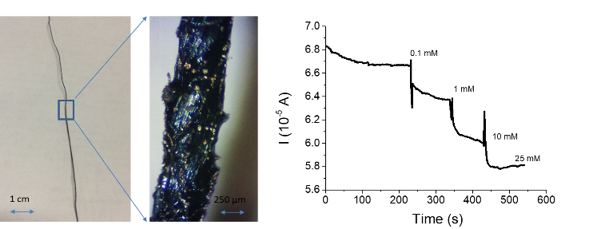
Left. Image of textile chloride sensor. Right. Sensor response to chloride

  - Reference:

- Lin, P. and Yan, F., 2012. Organic Thin-Film Transistors for Chemical and Biological Sensing. Adv. Mater. 24: 34–51

- Tessarolo, M. Gualandi, I. and Fraboni, B., 2018. Recent Progress in Wearable Fully Textile Chemical Sensors. Adv. Mater. Technol. 3: 1700310

- Gualandi, I. Tessarolo, M. Mariani, F. Cramer, T. Tonelli, D., Scavetta, E. and Fraboni, B., 2018. Nanoparticle gated semiconducting polymer for a new generation of electrochemical sensors. Sens. Actuators B-Chem. 273: 834 – 841

IV. Biography:

Isacco Gualandi graduated in Industrial Chemistry summa cum laude in 2009 and he got his PhD degree in Chemical Sciences in 2013 at the Bologna University. After a period of post-doctoral fellowships at the Departments of Physics and Astronomy and Industrial Chemistry, he is now working as a researcher in Analytical Chemistry at Bologna University. His research activity focuses on the development of innovative electrochemical sensors based on both inorganic and organic materials.

    - Presenting author details


Full Name: Isacco Gualandi

Contact number: +390512093386

Linked In account: https://www.linkedin.com/in/isacco-gualandi-389974112/
Session name/ number: 11. Smartphone diagnostics & wearable biosensors

Category: Oral presentation (Key Note)

Meetings International Pte Ltd

Phone/WhatsApp: +65 31581626

