Title: Adaptive manufacturing techniques for microfluidic chip and their potential applications

Ivana Podunavac¹, Mila Djisalov¹, Ivana Gadjanski¹, Sanja Kojic², Vasa Radonic¹
¹University of Novi Sad, BioSense Institute, Dr Zorana Djindjica 1, Novi Sad, 21000, Serbia
²University of Novi Sad, Faculty of Technical Sciences, Trg Dositeja Obradovica 6, Novi Sad, 21000, Serbia

Keywords: Microfluidics, hybrid fabrication technologies, cell culturing, micromixing, sensors

- Abstract

Up to now, various technologies and processes were used for the fabrication of microfluidic (MF) devices. To address advanced designing challenges, the research is mainly focused on development of low-cost and rapid technology and novel materials for MF chip fabrication that can be easily combined with other technologies and materials.
In this poster, we show novel hybrid low-cost and rapid manufacturing technologies that allow fabrication of multilayer MF chips using materials enabling a high degree of integration without using expensive equipment, complex processes or clean room facility. By combining laser micromachining, xurography, hot or cold lamination processes and low-cost materials as acrylic, LTCC tapes (non-sintered ceramics), PVC and Al foils, different applications of microfluidic chips were achieved [1-4]. The proposed technology uses laser for precise patterning of MF channels into acrylic or LTCC tape, plotter cutter for cutting a less precise channels and inlets/outlets, and hot and cold lamination for bonding of different materials.
Different applications of this technology were recently proposed. Microbioreactor, realized using glass and acrylic, Fig. 1A [1] with integrated sensor based on cells permittivity, Fig 1B [2] shows a good solution for cell culturing and concentration monitoring inside the microbioreactor. In addition, by combining LTCC tapes with PVC foils, 3D MF chips for pollen filtration Fig. 1C [3] and an active micromixer, Fig. 1D [4] were fabricated.
The proposed concept allows fabrication of multifunctional systems with integrated electrodes, sensors or optical components, and has a potential for the rapid production of low-cost and reliable MF chips.
- Image:

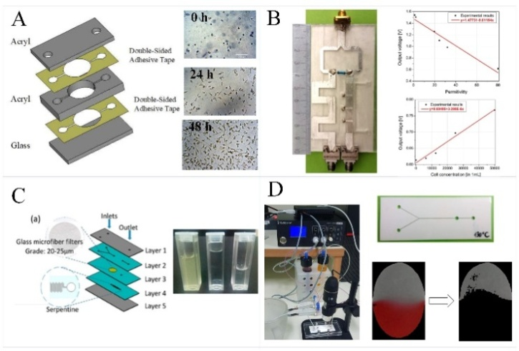

  - Reference:

- Mandic, M., V. Radonic, G. Kitic, N. Jankovic, N. Knezevic, V. Kojic, I. Gadjanski, Developing sensors for monitoring cell culture parameters: impedance-based biomass measurements in microbioreactors, 5. International Scientific Conference on Cultured Meat, Maastricht, 6-8 October 2019
- Radonic, V., S. Birgermajer, I. Podunavac, M. Djisalov, I. Gadjanski, G. Kitic, Microfluidic Sensor Based on Composite Left-Right Handed Transmission Line, Electronics, 8(12), 1475, 2019
- Kojic, S., G. Stojanovic, V. Radonic, Novel Cost-Effective Microfluidic Chip Based on Hybrid Fabrication and Its Comprehensive Characterization, Sensors, 19, 1719, 2019
- Jevremov J., I. Podunavac, J. Lazarevic, S. Kojic, V. Radonic, G. Stojanovic, Performances of Microfluidic Mixing Regulated using Active Pressure Controller, 6th International Conference on Electrical, Electronic and Computing Engineering, IcETRAN 2019, Silver Lake, Serbia, June 03 – 06, 2019, pp. 248-252

IV. Biography:

Ivana Podunavac finished Bachelor and Master studies in Physics (module Applied Physics - Nanosciences) at the University in Novi Sad, Serbia. She is a PhD student of Applied Physics at the Faculty of Sciences at the University of Novi Sad and employed at BioSense Institute as a Junior Researcher. Her field of interest includes microfluidics, simulations, fabrication, characterization, and testing of sensing devices.

    - Presenting author details


Full Name: Ivana Podunavac

Contact number: +381655092965

LinkedIn account: https://www.linkedin.com/in/ivana-podunavac-843137151/
Session name/ number: Microfluidics and immobilisation technology/3

Category: (Oral presentation/ Poster presentation): Oral presentation
Passport Number: 014234847
Figure 1. (A) MF bioreactor inside the acrylic chip, (B) Microwave MF sensor for measuring cell concentration (C) MF chip for pollen filtration, and (D) Active microfluidic micromixer.

Meetings International Pte Ltd

Phone/WhatsApp: +65 31581626

