Chronopotentiometric in vivo bioassay by using skin tattoo wearable diagnostic sensing smartphone analyzer皮膚紋身智能手機時間潛力生物特徵分析. 피부 문신스마트폰 대시간전위 생체 분석

Sihyun Jun, Min ji won, Jae Won Jang, Roma Seo, Seung il Jun, Junho Yeo, Kyung Lee, SuwYoung Ly.
전시현.민지원.장재원.서로마. 전승일, 여준호.이경.이수영.

Biosensor Research Institute Seoul National University of Science & Technology,Seoul 232 Korea. suwyoung@snut.ac.kr

Key word: skin tattoo, in vivo wearable, vital control, natural latex plant fibers. Chrono potentiometric assay

I. Abstract Body

Analytical in vivo diagnostics are require of the expensive instrumental systems such as highly sensitive x-ray imagination amplifier, sophistic NMR spectrometry, Mass spectroscopy and other separation chromatographic circuits demand. However, in this study, simplified electrochemical in vio and vitro chrono potentiometric bio assay was developed by using skin tattoo diagnostic sensors and wearable smartphone analyzer. Here of in vivo tattoo skin sensors were made by with printing ink painting paste of natural plant fibers. Which ink solutions used as an absorbable muscle stimulation enhancer. Coated film thickness was 0.5 ~ 3 mm paste working, counter and reference electrode, did not interfere with any muscle activity. Which diagnostic scanning potential windows was the redox to -2.0 V ~ 2.0 V cyclic anodic and cathodic. The amplification rate was in the range of 1.0×10⁻³ to 1.0×10⁻⁹A used on this conditions, chronopotentiometric redox stripping, cyclic vital current was obtained at real time on the skin muscle tissue, such as pulse rate, respiratory rate, body temperature and other in vivo neuro diagnostics so on. Which optimal variables are available for WiFi tele transmission and be used for remote human smartphone interfaced diagnostic telemetric controls. Results of final para conditions were determined to be capable of more sensitive detection than other common methods.
II. Image
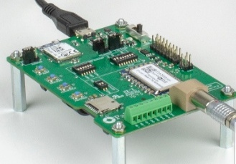
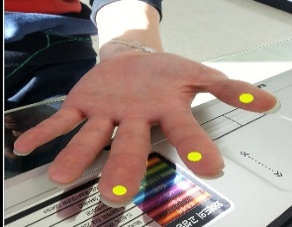

III. Reference
- Suw Young Ly, Hwa Jin Heo, Min Jung Kim. 2010. Real time analysis of neuroTransmitters in the brain using a micro electrode system, current neuro vascular research. 7: 1, 32-38.

Huck Jun Hong and Suw Young Ly. 2019. Voltammetric detection of tetrodotoxin realtime In Vivo of Mouse Organs using DNA immobilized carbon nanotube sensors, Current Analytical Chemistry.15: 5, 567-574

Suw Young Ly, Young Sam Jung, Myung Hoon Kim, In kwon Han, Woon Won Jung, Hyun Sook Kim. 2004. Determination of Caffeine Using a Simple Graphite Pencil Electrode with Square wave Anodic strip ping voltammetry, microchimica Acta.146: 3, 207-213.
IV Biography
Roma seo and all authors are the program director at biosensor research institute, and performed the voltammetric mathematical statistics of experiments, data interpretation and reviewed the manuscript,

V. Presenting author details
Full name : Roma seo
Contact number: 82 02 979 5510
Twitter account: http://m.facebook.com/profile.php?id=100002913315856
Linked account:http://biosensorlab.org
Session name / number:
Categore: (E poster prensentation)
Passport number

