An optimization of mediated biosensor systems based on hybrid material
Kuznowicz Maria¹, Jędrzak Artur^{1,2}, Rębiś Tomasz³, Jesionowski Teofil ¹
¹Instytute of Chemical Technology and Engineering, Faculty of Chemical Technology, Poznan University of Technology, Berdychowo 4,
PL-60965 Poznan, Poland;
²NanoBioMedical Centre, Adam Mickiewicz University in Poznan, Wszechnicy Piastowskiej 3, PL- 61614 Poznan, Poland;
³Instytute of Chemistry and Technical Electrochemistry, Faculty of Chemical Technology, Poznan University of Technology, Berdychowo 4, PL-60965 Poznan, Poland;

Keywords: biosensors, magnetite, polydopamine, mediators, glucose detection,

- Introduction

Biosensor is type of chemical sensor, which is using a biological recognition element. They are used to detect, transmit and record information that is processed into an analytical signal [1]. The observed dynamic development of chemical technology and consumer demand implies the design and acquisition of more effective materials. An example of measuring devices that are increasingly used due to their high sensitivity and selectivity are biosensors. A number of different materials are used for their construction, with different properties and characteristics [2].
Biosensors have many benefits, such as testing non-polar particles which do not react with most measuring devices, allowing for rapid and continuous monitoring while being distinguished by ease of use [3]. A mediator allows an exchange of electrons in the electrode, which is an important part of the second generation biosensor. Ferrocene, ferrocyanide and benzoquinone are well-known mediators based on the recent literature [3]. A properly chosen mediator stimulates the biosensor, and affects its sensitivity, selectivity and stability [4,5].
In the present study, amperometric biosensor platforms based on polydopamine-coated magnetite nanoparticles were fabricated for the detection of glucose. The conducted activity consisted of several stages. In the first stage, magnetite nanoparticles were obtained using the co-precipitation method. Secondly, a process of immobilization of glucose oxidase (from Aspergillius niger) adsorption was performed. Then, biosensor systems were designed based on glassy carbon electrodes, tailored for the used mediator. Suddenly, a series of physicochemical analyzes (Transmission electron microscopy, Atomic force microscopy, Bradford Protein Assay) were conducted to accurately characterize the collected systems. Finally, electrochemical tests were performed on glucose model extensions using various electrochemical techniques. In the next stage, selectivity for various types of interferents (ascorbic acid, uric acid, other sugars) were determined. Such analytical performances confirm that the fabricated biosensor used in this work has potential to be applied for development of redox enzyme based biosensors.

- Graphical abstract

Construction and operation of the Fe₃O₄/PDA/GOx system.

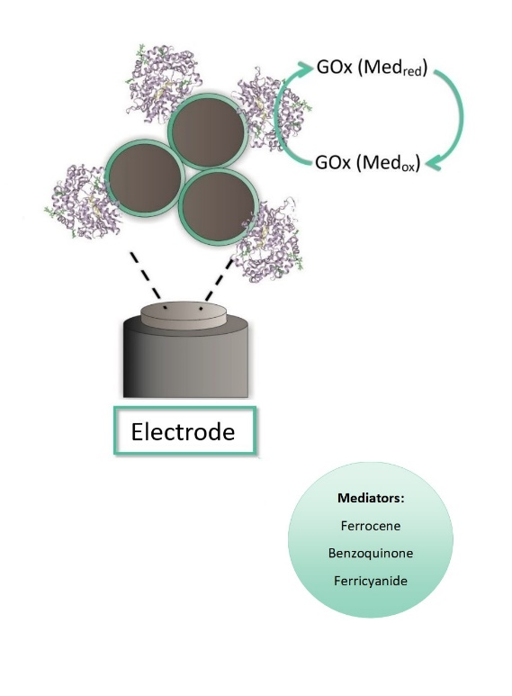
  - References:

- Rocchitta, G., Spanu, A., Babudieri, S., Latte, G., Madeddu, G., Galleri, G., Nuvoli, S., Bagella, P., Demartis, M., Fiore, V., Manetti, R., Serra, P., 2016. Enzyme biosensors for biomedical applications: strategies for safeguarding analytical performances in biological fluids, Sensors 16:780-801.

- Jędrzak, A., Rębiś, T., Klapiszewski, Ł., Zdarta, J., Milczarek, G., Jesionowski, T., 2018. Carbon paste electrode based on functional GOx/silica-lignin system to prepare an amperometric glucose biosensor, Sens. Actuator B-Chem. 256: 176–185.

- Jędrzak A, Rębiś T., Kuznowicz M., Jesionowski T., Bio-inspired magnetite/lignin/polydopamine-glucose oxidase biosensing nanoplatform. 2019. From synthesis, via sensing assays to comparison with others glucose testing techniques, Int. J. Biol. Macromol., 127: 677-682.

- Jędrzak, A., Rębiś, T., Nowicki M,, Synoradzki K., Mrówczyński R., Jesionowski T., 2018 Polydopamine grafted on an advanced Fe₃O₄/lignin hybrid material and its evaluation in biosensing, Appl. Surf. Sci. 455: 455–464.

- Hatada, M., Loew, N., Inose-Takahashi, Y., Okuda-Shimazaki, J., Tsugawa, W., Mulchandani, A., Sode,K.,2018. Development of glucose sensor employing quick and easy modification method with mediator for altering electron acceptor preference, Bioelectrochemistry, 121:185 – 190

Acknowledgments
This work is financed and prepared as part of research project supported by the National Science Center Poland, no. 2017/27/B/ST8/01506.

IV. Biography:

Maria Kuznowicz received the M.Sc., Eng. degree in Chemical Technology in 2019 at Poznan University of Technology. Since 2019 she is a Ph.D. student of Chemical Sciences at Poznan University of Technology. Her research interests include biosensors, hybrid systems and enzyme immobilization.

    - Presenting author details


Full Name: Maria Katarzyna Kuznowicz

Contact number: maria.m.kuznowicz@doctoraate.put.poznan.pl
Session name/ number:

Category: Oral Presentation

