Amperometric biosensor for glucose detection based on multicomponent hybrid system
Kuznowicz Maria¹, Jędrzak Artur^{1,2}, Rębiś Tomasz³, Jesionowski Teofil¹
¹Instytute of Chemical Technology and Engineering, Faculty of Chemical Technology, Poznan University of Technology, Berdychowo 4,
PL-60965 Poznan, Poland;
²NanoBioMedical Centre, Adam Mickiewicz University in Poznan, Wszechnicy Piastowskiej 3, PL- 61614 Poznan, Poland;
³Instytute of Chemistry and Technical Electrochemistry, Faculty of Chemical Technology, Poznan University of Technology, Berdychowo 4, PL-60965 Poznan, Poland;

Keywords: biosensors, magnetite, polydopamine, lignin, glucose detection,

- Introduction

The observed evolution and development of chemical technology and consumer demand involves the design and acquisition of materials that are increasingly effective [1]. Biosensors are an example of measuring instruments which are being used increasingly due to their high sensitivity and selectivity. Biosensor is a type of chemical sensor which uses an element of biological recognition [2]. They are used for the detection, transmission, and recording of information processed into an analytical signal. Several techniques are used to immobilize the enzymes, enabling an expansion into many new science and industry fields [3]. The use of enzymes can be a more effective and usable alternative for analyzing body fluids or samples from the environment. The carbon paste electrode belongs to heterogeneous carbon electrodes and in many applications finds wide use [4,5]. Such electrodes are currently one of the most common working electrode types. Their characteristic is carbon paste, i.e. a mixture prepared from carbon (graphite) powder and suitable material placed in a specially designed electrode. Due to the numerous beneficial features and properties of carbon paste electrodes are widely used, mainly for voltammetric measurements [6].
The purpose of this work was to synthesize and optimize the magnetite/lignin/polydopamine/glucose oxidase based multicomponent system. The components in the work are characterized by interesting properties, which together establish the impression of integrated operation. The obtained system is defined by sensitivity, thermal stability, selectivity and furthermore is made of relative cheap, natural or of natural origin materials. Due to its high sensitivity and selectivity for certain sugars, the Fe₃O₄/Lig/PDA/GOx platform has been shown to have very good properties for glucose detection. Depending on the biological layer, the development of a system with the necessary characteristics allows the detection of different substances. A number of physicochemical tests have confirmed the effectiveness of receiving the magnetite/lignin/polydopamine/glucose oxidase system. Electrochemical experiments conducted as part of this research have shown that immobilized on the surface enzyme is catalytically active, and analyzes performed on real solutions have also been distinguished by repeatability of tests.

II Graphical abstract:

Schematic representation of the activities carried out as part of the research

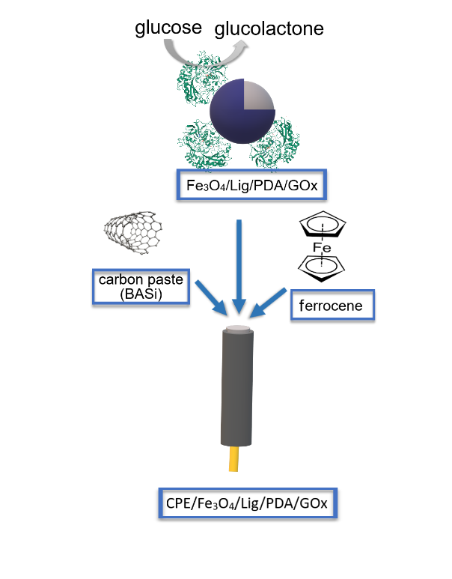
  - Reference:

- Mehrotra, P., 2016. Biosensors and their applications – A review. J. Oral Biol. Craniofac. Res., 6:153–159

- Bhalla, N., Jolly, P., Formisano, N., Estrela P., 2016. Introduction to biosensors, Essays Biochem., 60: 1–8

- Jędrzak, A., Rębiś, T., Klapiszewski, Ł., Zdarta, J., Milczarek, G., Jesionowski, T., 2018. Carbon paste electrode based on functional GOx/silica-lignin system to prepare an amperometric glucose biosensor, Sens. Actuator B-Chem. 256: 176–185.

- Jędrzak A, Rębiś T., Kuznowicz M., Jesionowski T., Bio-inspired magnetite/lignin/polydopamine-glucose oxidase biosensing nanoplatform. 2019. From synthesis, via sensing assays to comparison with others glucose testing techniques, Int. J. Biol. Macromol., 127: 677-682.

- Jędrzak, A., Rębiś, T., Nowicki M,, Synoradzki K., Mrówczyński R., Jesionowski T., 2018 Polydopamine grafted on an advanced Fe₃O₄/lignin hybrid material and its evaluation in biosensing, Appl. Surf. Sci. 455: 455–464.

- Girousi S., Stanić Z., The Last Decade of Carbon Paste Electrodes in DNA Electrochemistry, Curr. Anal. Chem., 7 (2011) 80-100.

Acknowledgments
This work is financed and prepared as part of research project supported by the National Science Center Poland, no. 2017/27/B/ST8/01506.

IV. Biography:

Maria Kuznowicz received the M.Sc., Eng. degree in Chemical Technology in 2019 at Poznan University of Technology. Since 2019 she is a Ph.D. student of Chemical Sciences at Poznan University of Technology. Her research interests include biosensors, hybrid systems and enzyme immobilization.

    - Presenting author details



Full Name: Maria Katarzyna Kuznowicz

Contact number: maria.m.kuznowicz@doctorate.put.poznan.pl
Session name/ number:

Category: Poster presentation

