Direct Electron Transfer of Glucose Oxidase and Biosensing for Glucose

Jędrzak Artur^{1,2}, Kuznowicz Maria¹, Rębiś Tomasz³, Jesionowski Teofil¹
¹Instytute of Chemical Technology and Engineering, Faculty of Chemical Technology, Poznan University of Technology, Berdychowo 4,
PL-60965 Poznan, Poland;
²NanoBioMedical Centre, Adam Mickiewicz University in Poznan, Wszechnicy Piastowskiej 3, PL- 61614 Poznan, Poland;
³Instytute of Chemistry and Technical Electrochemistry, Faculty of Chemical Technology, Poznan University of Technology, Berdychowo 4, PL-60965 Poznan, Poland;

Keywords: biosensors, magnetite, polydopamine,
β-cyclodextrin, glucose detection,

- Introduction

Biosensor systems have become one of the most active areas of research with the rapid development of chemistry, biology, physics, medicine and technology in the last few decades. The development of new hybrid based biosensors, which would be characterized by high sensitivity, selectivity and stability, is a significant challenge in the construction of biosensors [1-4]. Therefore, the biosensor designed should be independent of environmental constraints, i.e. pH or temperature [5].
Direct electron transfer between GOx and the electrode surface of biosensors has generated considerable interest in experimental and theoretical research over the decades, without the assistance of mediators. The lack of an external mediator is an advantage of such a sensor, it allows direct electron transport between the electrode and the active center of the enzyme. Moreover, direct transmission of electron to GOx is extremely difficult, as GOx's active site, flavin adenine dinucleotide (FAD), is deeply embedded within a protective shell. Therefore an increase in the number of publications is observed in which the direct transmission of electrons between GOx and the electrode is observed without the assistance of mediators [6].
In this work, the development and optimization of novel biosensors with glucose oxidase immobilized on Fe₃O₄/PDA/β-CD hybrid material is described. In addition, numerous electrochemical studies have confirmed the direct transfer of electrons between the enzyme's active center and the electrode surface. Moreover, the proposed system is characterized by a selective response to glucose additions in a relatively wide concentration range. After biosensor systems were provided, their operating environments (including pH, temperature, LOD, LOQ, range of determination) were optimized. However, studies were conducted on model and real glucose solutions. Several physicochemical and biochemical research were carried out. The proposed nanoplatform has interesting properties, i.e. increased thermal and mechanical stability, and excellent adhesion to both inorganic and organic materials. In the case of field measurements and in the food industry, the device produced may also be a substitute for larger equipment due to its size.

II. Graphical abstract:

Schematic design of biosensors based on GC/MWCNTs/Fe₃O₄/PDA/β-CD/GOx

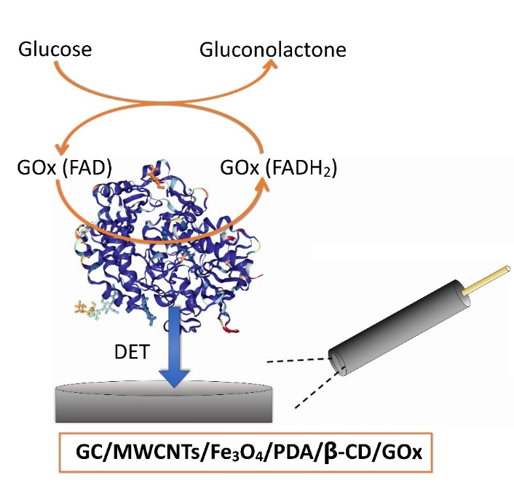

  - Reference:

- Jędrzak, A., Rębiś, T., Nowicki M,, Synoradzki K., Mrówczyński R., Jesionowski T., 2018 Polydopamine grafted on an advanced Fe₃O₄/lignin hybrid material and its evaluation in biosensing, Appl. Surf. Sci. 455: 455–464.

- Jędrzak, A., Rębiś, T., Klapiszewski, Ł., Zdarta, J., Milczarek, G., Jesionowski, T., 2018. Carbon paste electrode based on functional GOx/silica-lignin system to prepare an amperometric glucose biosensor, Sens. Actuator B-Chem. 256: 176–185.

- Jędrzak A, Rębiś T., Kuznowicz M., Jesionowski T., Bio-inspired magnetite/lignin/polydopamine-glucose oxidase biosensing nanoplatform. 2019. From synthesis, via sensing assays to comparison with others glucose testing techniques, Int. J. Biol. Macromol., 127: 677-682.

- Jędrzak, A., Rębiś, T., Nowicki M,, Synoradzki K., Mrówczyński R., Jesionowski T., 2018 Polydopamine grafted on an advanced Fe₃O₄/lignin hybrid material and its evaluation in biosensing, Appl. Surf. Sci. 455: 455–464.

- Metkar, S.K., Girigoswami K., 2019. Diagnostic Biosensors in Medicine - a Review, Biocatal. Agric. Biotechnol. 17:271-283.

- Turkmen, E., Bas, S.Z., Gulce, H., Yildiz, S., 2014. Glucose biosensor based on immobilization of glucose oxidase in electropolymerized poly(o-phenylenediamine) film on platinum nanoparticles-polyvinylferrocenium modified electrode. Electrochimica Acta, 123:93–102.

Acknowledgments
This work is financed and prepared as part of research project supported by the National Science Center Poland, no. 2017/27/B/ST8/01506.

IV. Biography:

Artur Jędrzak received the M.Sc., Eng. degree in Organic Chemistry in 2016 at Poznan University of Technology. Since 2016 he is a Ph.D. student of Chemical Technology at Poznan University of Technology and he is also a member of NanoBioMedical Centre in Poznan. His research interests are biosensors, enzymatic and catalytic systems, synthesis of hybrid/composite materials and receiving magnetic nanoparticles for medical application.

    - Presenting author details

Full Name: Artur Jędrzak

Contact number: artur.jedrzak@gmail.com
Session name/ number:

Category: Poster presentation

