Hybrid microplatform for glucose biosensor and its comparison with other testing techniques
Jędrzak Artur^{1,2}, Kuznowicz Maria¹, Rębiś Tomasz³, Jesionowski Teofil¹

¹Instytute of Chemical Technology and Engineering, Faculty of Chemical Technology, Poznan University of Technology, Berdychowo 4,
PL-60965 Poznan, Poland;
²NanoBioMedical Centre, Adam Mickiewicz University in Poznan, Wszechnicy Piastowskiej 3, PL- 61614 Poznan, Poland;
³Instytute of Chemistry and Technical Electrochemistry, Faculty of Chemical Technology, Poznan University of Technology, Berdychowo 4, PL-60965 Poznan, Poland.

Keywords: biosensors, magnetite, lignin, polydopamine, glucose detection, real samples

- Introduction

The main development of the biosensor systems began after Clark and Lyons (1962) created the first biosensor containing glucose oxidase [1]. Despite many enhancements to glucose sensors, many scientists are still working on new ways of designing and developing a more accurate, stable, and responsive biosensor [2].
Biosensor is a type of chemical sensor that consists of sensitive elements such as enzymes, genes, antibodies, etc. that are capable of regulating the interaction between the material and the sensitive layer and the processing element it generates [3]. Regardless of the need for inexpensive and efficient blood glucose monitoring, novel advanced materials for the glucose biosensor have gained considerable attention [4]. Because of the high selectivity they allow to be used in many areas such as environmental protection, medicine, food and drug industries etc. Glucose level determination is one of the most common and important assays in various media such as blood plasma, medications, juices, or dietary supplements [5,6]. Given the availability of commercial glucose biodetectors on the market, accuracy constraints and errors such as ageing, manufacturing variances, storage, temperature, coding or proper data measurement exist. The aim of the research conducted as part of this work was to discuss glucose measurements in real samples using various techniques (photometric, glucometers, proposed biosensor). The magnetite/lignin hybrid material was synthesized, followed by polymerization of the polydopamine precursor to obtain the magnetite/lignin/polydopamine system. On the obtained multi-component system the process of enzymatic immobilization was carried out by adsorbing glucose oxidase from Aspergillus niger.
Biosensor platforms with the addition of ferrocene and a dedicated carbon paste electrode (CPE/Fe₃O₄/Lig/PDA/GOx/Fc) were fabricated for glucose detection in actual, commercially available glucose-based samples. The platform proposed has interesting features such as improved thermal and mechanical stability, excellent adhesion for inorganic and organic materials, electron transferability, and photothermal properties. Greater reliability and durability of materials, and an improvement in their quality compared to existing commercial goods. The proposed microplatform for biosensing has promising features and applicability as a useful biodetector for the food industry.

II. Graphical abstract:

Various analytical techniques for the detection of glucose used in the conducted research

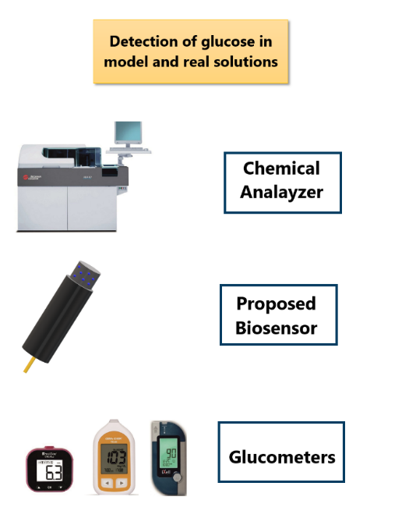

  - Reference:

- Jędrzak, A., W. Putzbach, N. J. Ronkainen ChemInform Abstract: Immobilization Techniques in the Fabrication of Nanomaterial-based Electrochemical Biosensors: A Review, Sensors (2013) 13 4811- 4840.

- Jędrzak, A., Rębiś, T., Klapiszewski, Ł., Zdarta, J., Milczarek, G., Jesionowski, T., 2018. Carbon paste electrode based on functional GOx/silica-lignin system to prepare an amperometric glucose biosensor, Sens. Actuator B-Chem. 256: 176–185.

- Jędrzak A, Rębiś T., Kuznowicz M., Jesionowski T., Bio-inspired magnetite/lignin/polydopamine-glucose oxidase biosensing nanoplatform. 2019. From synthesis, via sensing assays to comparison with others glucose testing techniques, Int. J. Biol. Macromol., 127: 677-682.

- Jędrzak, A., Rębiś, T., Nowicki M,, Synoradzki K., Mrówczyński R., Jesionowski T., 2018 Polydopamine grafted on an advanced Fe₃O₄/lignin hybrid material and its evaluation in biosensing, Appl. Surf. Sci. 455: 455–464.

- Rocchitta, G., Spanu, A., Babudieri, S., Latte, G., Madeddu, G., Galleri, G., Nuvoli, S., Bagella, P., Serra A. 2016 Enzyme biosensors for biomedical applications: Strategies for safeguarding analytical performances in biological fluids, Sensors 16:1-21.

- Jędrzak A, Rębiś T., Kuznowicz M., Jesionowski T., Bio-inspired magnetite/lignin/polydopamine-glucose oxidase biosensing nanoplatform. 2019. From synthesis, via sensing assays to comparison with others glucose testing techniques, Int. J. Biol. Macromol., 127: 677-682.

Acknowledgments
This work is financed and prepared as part of research project supported by the National Science Center Poland, no. 2017/27/B/ST8/01506.

IV. Biography:

Artur Jędrzak received the M.Sc., Eng. degree in Organic Chemistry in 2016 at Poznan University of Technology. Since 2016 he is a Ph.D. student of Chemical Technology at Poznan University of Technology and he is also a member of NanoBioMedical Centre in Poznan. His research interests are biosensors, enzymatic and catalytic systems, synthesis of hybrid/composite materials and receiving magnetic nanoparticles for medical application.

    - Presenting author details

Full Name: Artur Jędrzak

Contact number: artur.jedrzak@gmail.com
Session name/ number:

Category: Oral presentation

