Biosensors and Technologies: A Promise for Future

AJAY AGARWAL,
Coordinator, Smart Sensors Area, CSIR-Central Electronics Engineering Research Institute &
Professor, Academy of Scientific & Innovative Research, Pilani (Raj.) – 333 031 INDIA

Keywords: Biosensors, Micro/ Nano-technologies, Point-of-care, early diagnostics, CNT, Nano-gaps, Nanowires, MOX thin films

- Abstract

Innovative micro and nanoscale technologies are at the vanguard of the development of numerous biosensors for healthcare and environmental care. Biosensor being analytical devices it provides either qualitative or quantitative results. Both have their importance. A qualitative analysis is very useful for rapid screening test applications, as today the world is looking for such devices for COVID-19 suspects. On other hand biosensors provide quantitative analysis like in care of glucose monitoring devices. The future trend of biosensors development is for point-of-care and early diagnostics requirements, mainly for glucose monitoring, infectious diseases testing, cardio-metabolic monitoring, coagulation monitoring, urinalysis, cholesterol test strips, tumour/ cancer markers analysis, pregnancy and fertility testing and many other applications.
Nano-structures in consort with micro-fabrication and MEMS technologies have enabled novel Nano-dimensional materials, structures and eventually devices which can find frequent applications in the field of early-stage diagnosis and point-of-care analysis. Biosensors with innovative fabrication technologies along with data analytics and artificial intelligence are environmental monitoring.
Among various sensing materials Carbon Nano-Tubes, Nano-Gap, Nanowires and Metal-oxide thin films-based bio-chemical sensors are most exploited for the diagnostic applications [1-4]. The biosensors, their realization technologies and applications will be presented.

- Image: Few sensor platform devices

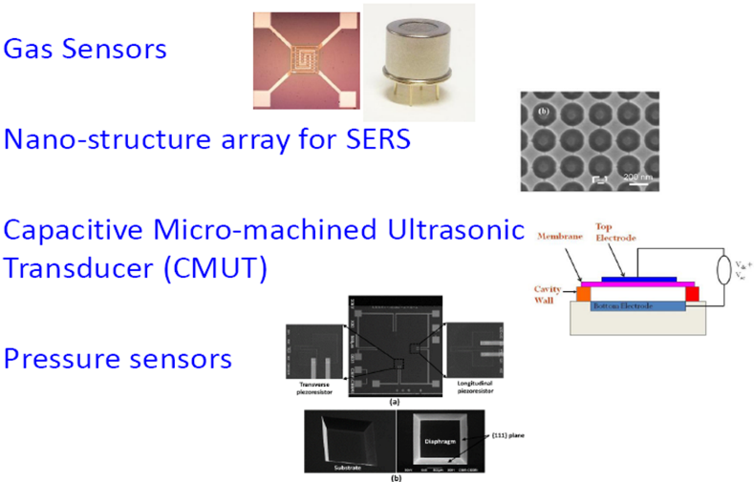

  - Reference:

- Agarwal P.B., B. Alam, D.S. Sharma, S. Mandal, A. Agarwal, Flexible NO₂ gas sensor based on single walled carbon nanotubes on PTFE substrate, Flex. Print. Electron. 3 (2018) 035001

- Fang, C., Agarwal A., Ji H., Karen, W. Y., Yobas, L., Preparation of a SERS substrate and its sample-loading method for point-of-use application, Nanotechnology, 20 (40) 2009 Article Number: 405604

- Ajay Agarwal, N. Ranganathan, W.L. Ong, K.C. Tang, L. Yobas, Self-sealed circular channels for micro fluidics, Sensors and Actuators – A, 142 (2008) 80–87

- Prajesh R., V. Goyal, Md. Nahid, V. Saini, A.K. Singh, A.K. Sharma, J. Bhargava, Ajay Agarwal, Nickel Oxide (NiOx) Thin Film Optimization by Reactive Sputtering for Highly Sensitive Formaldehyde Sensing, Sensors and Actuators B: Chemical, 2020 doi.org/10.1016/j.snb.2020.128166

IV. Biography:

Ajay Agarwal is Senior Principal Scientist, Coordinator-Smart Sensors Area and Head-Nano Biosensors group at CSIR CEERI, Pilani; involved in development of Nanotechnologies MEMS, micro fluidics and Micro-sensors. He is also Professor at Academy of Scientific & Innovative Research, New Delhi. Earlier, he served Institute of Microelectronics, Singapore. His engagement with semiconductor industries and research institutes is for over 3 decades. He has ~280 research publications in journals or international conferences, over 60 invited/ plenary/ keynote talks and over 35 patents (granted or filled). He is bestowed with various awards including 2008 NTA, Singapore; 2009 Excellence Award, IME Singapore, etc.

    - Presenting author details

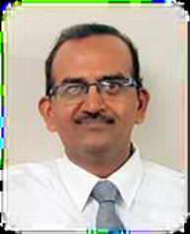

Full Name: Prof. Ajay Agarwal

Contact number: +91-1596-245078
Twitter account: @DrAjay123

Linked In account: linkedin.com/in/ajay-agarwal-72883431
Session name/ number: -

Category: Keynote
Passport Number: --

Meetings International Pte Ltd

Phone/WhatsApp: +65 31581626

