Abstract Template

Thread-paper based device for easy and fast glucose determinaton in whole blood samples.

Miguel M. Erenas¹, Kevin Cantrell², Isabel Maria Perez de Vargas-Sansalvador¹, Ignacio de Orbe-Payá¹ and Luis Fermin Capitan-Vallvey¹
¹Department of Analytical Chemistry, University of Granada, Granada Spain
² Department of Chemistry, The University of Portland, Portland, USA

Keywords: Thread-paper microfluidic device; Glucose determination; Whole blood; Reaction rate; Smartphone

- Abstract Body (up to 250 words)

In this study, we have developed a thread-paper microfluidic analytical device (µTPAD) for the determination of glucose directly in a whole blood sample. The analytical device is based on the enzymatic method for glucose in plasma using glucose oxidase and horseradish peroxidase combined with the chromogen TMB. Besides, all the analytical operations needed to perform the glucose determination have been included in the device itself, as it is red blood cell separation, conditioning, enzymatic recognition, and colorimetric transduction.

To be possible the use of whole blood samples directly, a piece of separation membrane was located at the extreme of the cotton thread, where 3 µL of sample is dropped, retaining the blood cells from the sample and reaching to the cotton thread the free of cells plasma from sample. Later, it will be buffered to pH 7.4 thanks to the dry buffer retained along the thread. Finally, the sensing area of the device will turn into blue, depending on the glucose concentration in the sample.

In order to register the analytical parameter, R/B from RGB color space, from the sensing area, a smartphone running a homemade app that is capable to analyze, in real time, the color of the sensing area was used. Consequently, the app analyzes the sensing area, determines when the R/B signal is steady and, finally, calculates the glucose concentration in the sample.

- Image:
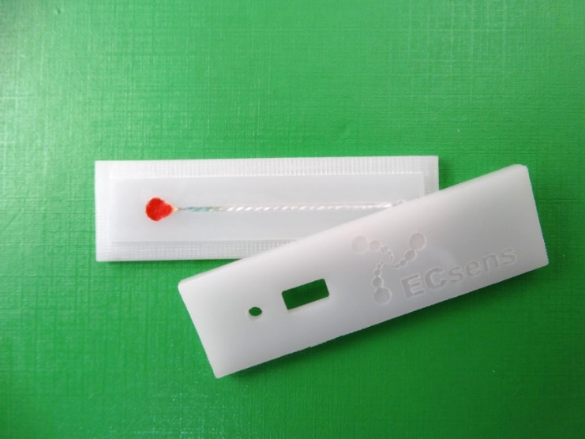

  - Reference:

- Erenas, M M, Carrillo-Aguilera, B., Cantrell, K., Gonzalez-Chocano, S., Perez de Vargas-Sansalvador, I.M., Orbe-Payá, I. de, Capitan-Vallvey, L.F., 2019, Real time monitoring of glucose in whole blood by smartphone. Biosens Bioelectron, 136: 47-52

- Weng, X., Kang, Y., Guo, Q., Peng, B., Jiang, H., 2019. Recent advances in thread-based microfluidics for diagnostic applications. Biosens Bioelectron, 132: 171-185

IV. Biography:

Miguel M. Erenas received the PhD degree in Analytical Chemistry (2011) from the University of Granada (Granada, Spain). He is currently working as a Researcher at the ECsens group, Department of Analytical Chemistry, University of Granada and his research interests include the use of imaging along with microfluidic disposable sensors based on thread and paper for bioanalysis and food quality analysis.

    - Presenting author details

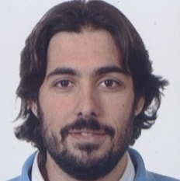

Full Name: Miguel M. Erenas

Contact number: +34 617468547
Twitter account: @obiblion

Linked In account: N/A
Session name/ number:

Category: (Oral presentation/ Poster presentation): Oral presentation
Passport Number:

Meetings International Pte Ltd

Phone/WhatsApp: +65 31581626

