Abstract Template

Title: Figure of merit analysis for different monometallic configurations and graphene layers on fiber-based SPR sensors

Jorge R Fernandez H¹, H E Hernandez-Figueroa¹
¹Department of Communications, School of Electrical and Computer Engineering, University of Campinas (UNICAMP), Campinas, Brazil

Keywords: Fiber optic sensor, SPR, Plasmonic sensor, sensitivity, Figure of merit

- Abstract

This work presents an analysis of different possible combinations of a monometallic layer (Au or Ag) with N-layers graphene coating for multimode-fiber based SPR sensors. We know that Au and Ag for plasmonic sensors present high sensibilities (S) and good Figure of merit (FoM) values (S/FWHM), some previous results show its advantages and applications (Shushama, et al., 2017, Gupta, et al., 2019). These sensors can be modeled using the multilayer reflection approach (transmission and reflection matrices or Fresnel matrices) with good agreement with experimental results (Mishra, et al., 2015). We have developed a numerical code able to assess the most efficient combination for N-sensors, in cascade configuration using different types of multimode fibers. Each sensor must exhibit a distinctive resonance frequency. We set two restrictions in order to get efficient cascade configurations: first, the FWHMs related to two consecutive resonance frequencies must be narrow enough to avoid resonance interference and second, the resonance’s dips have to be greater than 1dB so that can be clearly detected. As a result, we present the case of three sensors in cascade configuration: with silver and single-layer graphene, gold with no graphene layer and gold with four-layer graphene, which presents the higher potential of sensitivity, FoM and multiplexing sensing using a 105/125um (NA 0.10) multimode fiber.

- Image:
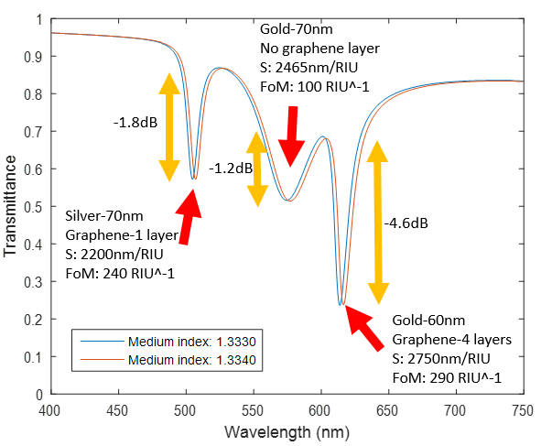

  - References:

- Shushama, Kamrun Nahar, et al. "Graphene coated fiber optic surface plasmon resonance biosensor for the DNA hybridization detection: Simulation analysis." Optics Communications 383 (2017): 186-190.

- Gupta, Banshi D., Anisha Pathak, and Vivek Semwal. "Carbon-based nanomaterials for plasmonic sensors: A Review." Sensors 19.16 (2019): 3536.

- Mishra, Akhilesh K., Satyendra K. Mishra, and Banshi D. Gupta. "SPR based fiber optic sensor for refractive index sensing with enhanced detection accuracy and figure of merit in visible region." Optics Communications 344 (2015): 86-91.

IV. Biography:

Jorge R. Fernández is a Telecom Engineer and obtained his MSc in Electrical Engineering at University of Campinas (UNICAMP-Brazil). Currently, he is pursuing his PhD on photonic design and sensors. He has published on topics related to coverage estimations from TV services, optical coupling measurements and fabrication tests. His research interests focus on Plasmonic design, fiber-based biosensors and new materials for sensing and telecom applications.

    - Presenting author details



Full Name: Jorge Rufino Fernández Herrera

Contact number: +5519982617214
Twitter account: -

Linked In account: https://www.linkedin.com/in/jorge-fern%C3%A1ndez-352b8592/
Session name/ number: Transducers and photonic sensor

Category: (Oral presentation)
Passport Number: -

Meetings International Pte Ltd

Phone/WhatsApp: +65 31581626

