Preparation of Sm, Gd and Fe Oxide Nanoparticle-Polydopamine Multicomponent Nanocomposites

KHOA ANH TON,¹ YU-WEI SYU, ¹ JUN-JIA XU,¹ AND TOYOKO IMAE*^{,1,2}
¹Department of Chemical Engineering, National Taiwan University of Science and Technology, 43 Section 4, Keeling road, Taipei 10607, Taiwan
²Graduate Institute of Applied Science and Technology, National Taiwan University of Science and Technology, 43 Section 4, Keelung Road, Taipei 10607, Taiwan

Keywords: Samarium oxide, Gadolinium oxide, Polydopamine, Theranostics.

- Abstract Body

Nanoparticles of Sm₂O₃, Gd₂O₃ and Fe₃O₄, which have different roles in biomedical applications, were synthesized and embedded in biocompatible polydopamine so as to fully exploit their features in human body. The nanosized particles (4-7 nm) of Sm₂O₃ and Gd₂O₃ synthesized by the polyol solvent method were protected by polyol to be dispersed in water. Separately, Fe₃O₄ nanoparticles (17 nm) fabricated by co-precipitation reaction. Each nanoparticle was successfully embedded into spheres of polydopamine. The co-embedding of three particles in a polydopamine sphere was also proved by the elemental analysis.

- Image:

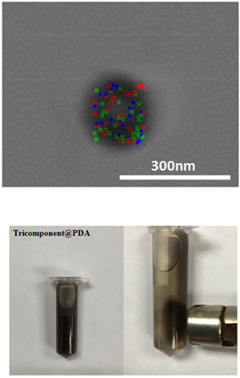
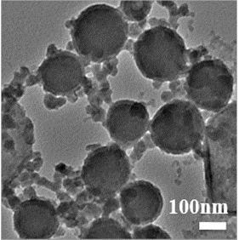
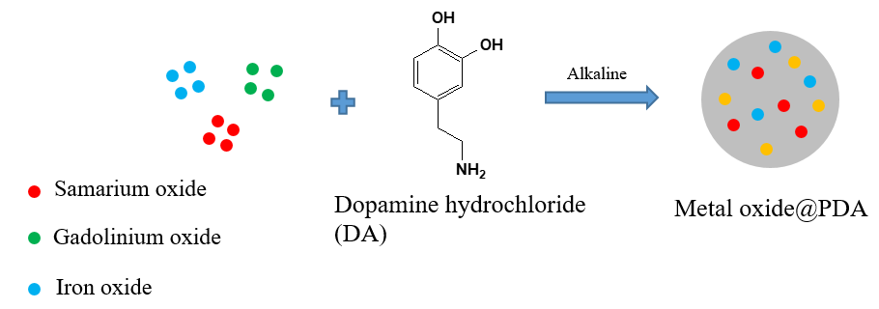

  - Reference:

- N. A. A. Hashikin, C.-H. Yeong, B. J. J. Abdullah, K.-H. Ng, L.-Y. Chung, R. Dahalan, A. C. Perkins, PLoS ONE 2015, 10 (9), e0138106.

- R. Di Corato, F. Gazeau, C. Le Visage, D. Fayol, P. Levitz, F. Lux, D. Letourneur, N. Luciani, O. Tillement, C. Wilhelm, ACS Nano 2013, 7 (9), 7500-7512

- N. Nishizawa, A. Kawamura, M. Kohri, Y. Nakamura, S. Fujii, Polymers 2016, 8 (3), 62

- J. H. Ryu, P. B. Messersmith, H. Lee, ACS Appl. Mater. Inter. 2018, 10 (9), 7523-7540

IV. Biography:

Dr. Khoa Anh Ton (Kevin Ton) has completed his PhD at the age of 28 years from National Taiwan University of Science and Technology (NTUST). His publication was prized as “Selected Paper” of Bulletin of the Chemical Society of Japan, 2019. Currently, as a Senior R&D Engineer at Tripod Nano Technology Corporation, Taiwan, he focuses on the fabrication of noble metal (Bi, Se, Pt, Ag…), metal oxide (SiO₂, Fe₃O₄, γ-Fe₂O₃…) or composite (Au/SiO₂, Pt/SiO₂…) nanomaterials utilized in a wide range of industrial applications by facile, green and low-cost methods. Patent acquisition is the next journey that he dedicates for scientific society.

    - Presenting author details



Full Name: KHOA ANH TON (KEVIN TON)
Contact number: +886-905-394423

Linked In account: KEVIN TON (孙英科）
Email: kevinton150691@gmail.com
Session name/ number:

Category: Speaker
Passport Number: N2056976

Meetings International Pte Ltd

Phone /WhatsApp: +65 31581626

