Design of Artificial Bio inspired Mechanosensor

SHASHIKANTH CHAKILAM¹, RIMVYDAS GAIDYS¹, AUDRONĖ LUPEIKIENĖ²
^{1Faculty} of Mechanical Engineering, Kaunas university of Technology, Kaunas, Lithuania
² Institute of Mathematics and Informatics, Vilnius University, Vilnius, Lithuania

Keywords: sensory receptor, artificial hair sensor, bioinspired sensor for flow and tactile.

I. Abstract
Nature is the inspiration for developing the artificial structures and innovation. This paper is focused on studying of the biological sensing mechanisms prevailing in insects and the parameters influencing the sensing mechanism such as the flow and tactile past the hair on their bodies. Study of the physiology of insect hair and its mechanism is the starting point of the research. The design of bio inspired artificial mechano-sensor for flow and tactile sensing is presented. Further, it is extended for development of the top layer cuticle and artificial seta as the sensory element with flow and tactile sensing mechanism using sensors based on piezoelectric effect. The design model of the developed bioinspired artificial mechanosensor are presented in this paper.
II Design of Artificial Hair
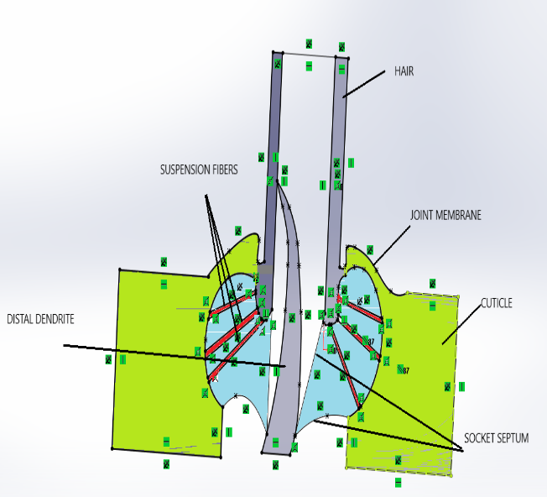

III. Reference:

[1]. Structure of Cuticular Mechanoreceptors of Arthropods Susan B. McIver Department of Parasitology, School of Hygiene, University of Toronto, Toronto M5S IAI, Canada.
[2] Artificial sensory hairs based on the flow sensitive receptor hairs of crickets,M Dijkstra et al 2005 J.Micromech. Microeng. 15 (2005) S132–S138
[3] Functional Morphology of Insect Mechanoreceptors THOMAS A. KEIL, MICROSCOPY RESEARCH AND TECHNIQUE 39:506–531 (1997)
[4] T. Shimozawa et al., “Structural scaling and functional design of the cercal wind-receptor hairs of cricket”, J. Comp. Physiol. A, 183 (1998), 171-186.

[5] G. J. M. Krijnen, J. Floris, M. A. Dijkstra, T. S. J. Lammerink, and R. J. Wiegerink, “Biomimetic micromechanical adaptive flow-sensor arrays”, Proceedings of SPIE Europe Microtechnologies for the New Millennium 2007, 2-4 May 2007, Maspalomas, Gran Canaria, Spain.

IV. Biography:
Shashikanth chakilam is a Research scholar doing his Doctoral schooling Ph.D. from Kaunas university of technology under the supervision of Dr. Rimvydas Gaidys how had a vast experience of 35years in teaching and had many conference papers and more than 65 papers in reputed journals whose impact factors are highly rated. Shashikanth also has the papers upto 14 including conferences and journals.

V. Presenting Author details
Full Name: SHASHIKANTH CHAKILAM

Contact number: +370 63626699
Twitter account: @chakilamshashik

Category: (Oral presentation/ Poster presentation): Oral presentation
Passport Number: J8964559

