High Performance Biosensors in the Presence of Magnetic Nanoparticles

Suna Timur*

*Department of Biochemistry, Faculty of Science, Ege University, 35100-Bornova/Izmir/Turkey

Keywords: Magnetic nanoparticles, Biosensors, Electrochemical Biosensors

- Abstract

Magnetic nanoparticles (MNPs) with paramagnetic or superparamagnetic features are able to response to an exterior magnetic field. Taking advantage of their magnetic properties, samples adhered to magnetic nanoparticles can be efficiently separated from the liquid suspension. The elimination of unwanted and nonspecific interferences can be easily applied by simple controlling the magnetic particles surface chemistry [1]. Furthermore, omission of the extra steps (sample pretreatment) such as chromatography and centrifugation not only cause to shorten the handling time but also prevents the samples damage. Owing to these advantages, and some other benefits like as low background interference compared to optical and electrical approaches [2,3] and facile functionalizability MNPs have been utilized in many biomedical and bioengineering applications such as such as signal markers, separation platforms, force transducers, and sensing devices, as imaging agents, heat generators, and drug carriers [2,4,5]. Here, after considering all the key parameters included starting materials, size, functionalization methods, and bio-conjugation strategies, we designed and prepared MNPs-based electrochemical biosensors (we used cobalt oxide nanoparticles and Iron(II, III) oxide nanoparticles, Fig.1) which utilized to diagnosis drug abuse such as cocaine, cannabinoids and even testosterone. These electrochemical biosensors are able to measure produced electrochemical signals (current, voltage, impedance) after combining target molecules to their receptors on the surface of a conducting electrode. The obtained results had shown a higher performance of the biosensor compared to traditional methods and also higher selectivity in the presence of different interferences. In conclusion, the designed biosensors propose great potential for portable and on-site substance abuse detection in addition to boasting a capability of reuse of the electrode materials, reducing the costs related to such applications.

- Image:
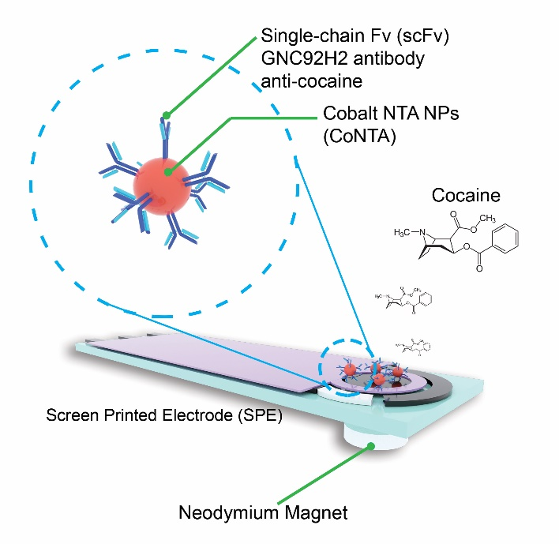

  - Reference:
[1] Bangs, L.B .; Pure Appl. Chem. 1996, 68, 1873.
[2] Krishnan, K.M. IEEE Trans. Magn. 2010, 46, 2523–2558.
[3] Colombo, M.; Carregal-Romero, S.; Casula, M.F.; Gutierrez, L.; Morales, M.P.; Bohm, I.B.; Heverhagen, J.T.; Prosperi, D.; Parak, W.J. Chem. Soc. Rev. 2012, 41,4306–4334.
[4] Lee, H.; Shin, T.-H.; Cheon, J.;Weissleder, R. Chem. Rev.2015, 115, 10690–10724.
[5] Yoo, D.; Lee, J.-H.; Shin, T.-H.; Cheon, J. Acc. Chem. Res. 2011, 44, 863–874.

IV. Biography:
She has received her Ph.D. degree in Biochemistry at Ege University in 2001. She is currently a full-time Professor in the Department of Biochemistry, at the same University. Her research is focused on the integration of biomolecules and other species with micro and nanoplatforms to create novel functional bio-based surfaces. She has published more than 200 SCI articles and supervised 40 M.Sc and Ph.D thesis.
Research Interests are; Nanomaterials as cell imaging and theragnostic applications; Paper based biosensors and lateral flow tests; Optical (bio)sensors.

    - Presenting author details



Full Name: Suna Timur

Contact number:+902323438624
Twitter account:@STResearchGroup

Linked In account:-
Session name/number:-

Category: (Oral presentation/ Poster presentation): Oral
Passport Number:-

Figure 1. Schematic representation of a MnP decorated disposible sensor

Meetings International Pte Ltd

Phone/WhatsApp: +65 31581626

