Title: Point-of-care assay for C-reactive protein using cavity enhanced absorption detection

Teggert, A.,¹, Datta, H., ¹ and Ali, Z²
¹South Tees NHS Foundation Trust, Middlesbrough, UK;
²Healthcare Innovation Centre, Teesside University, Middlesbrough, UK

Keywords: Cavity Enhanced Absorption, Point-of-care diagnostic, CRP, ELISA

- Abstract Body

We have previously demonstrated highly sensitive Cavity Enhanced Absorption (CEA) detection for low volume liquid assay [1-4]. In CEA, the high sensitivity recorded in the spectrometer is achieved through increasing the pathlength by locating the sample between two highly reflective dielectric mirrors. The light reflects between the two mirrors to form an optical cavity which magnifies the optical absorption effect. The CEA reader offers to potential of sensitivity approaching that of fluorescence but with lower reader cost - due to fewer optical elements – and the potential for being label-free.

We have developed a point-of-care reader with Cavity Enhanced Absorption (CEA) detection and a well type fluidic cartridge for implementation of immunoassay. We describe proof of concept CEA point-of-care assay for C-reactive Protein (CRP) based on enzyme linked immunosorbent assay (ELISA). Sample cartridges are assembled containing a polylysine coated glass side, onto which CRP capture antibodies were immobilised. Sample is then added to the sample wells, incubated and washed. A biotinylated CRP detection antibody solution of 90ng/mL is added, incubated and washed, followed by addition of streptavidin-horseradish peroxidase which is again incubated and washed. The final step is the addition of TMB substrate followed by sulphuric acid which quenches the reaction. The intensity of the colour product formed in the reaction is measured by the CEA reader at 450nm and 540nm.

- CEA reader and well-plate cartridge
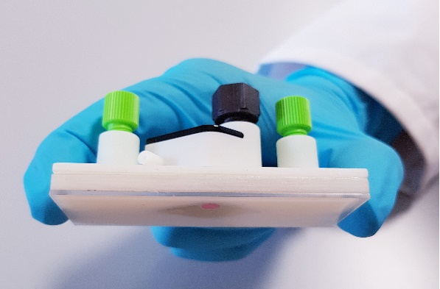
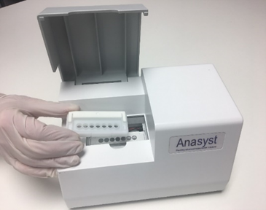

  - Reference:

[1] Z. Bajuszova, Z. Ali, S. Scott, L.N. Seetohul and M. Islam, Novel microtitre plate osteocalcin assay with vertical CEAS detection, Analytical Chemistry, 2016, 88(10), 5264-5270
[2] Z. Bajuszova, H. Naif, Z. Ali, j. McGinnis and M. Islam, Cavity enhanced liquid-phase stopped-flow kinetics, Analyst, 2018, 143(2), 493-502
[3] L.N. Seetohul, M. Islam and Z. Ali, ‘Broadband cavity enhanced absorption spectroscopy as a detector for HPLC’ Analytical Chemistry, 2009, 81 (10), 4106-4112
[4] M. Islam, L.N. Seetohul and Z. Ali, ‘Liquid-Phase Broadband Cavity-Enhanced Absorption Spectroscopy Measurements in a 2mm Cuvette’, Applied Spectroscopy, 2007, 61(6), 649-658

IV. Biography:
Zulfiqur has a BSc (Hons) Chemistry and PhD in instrumentation and analytical science from the University of Manchester. He in 1989 and has expertise in the development of smart miniaturised measurement systems. Zulfiqur has around 100 referred journals, book chapters and conference publications, with more than 3000 citations. He has coordinated numerous EC projects and most recently participated in the EC H2020 GateOne project. Zulfiqur currently has responsibility for the Healthcare Innovation Centre. He is on the Editorial Board for Micromachines and is member of the UK Research and Innovation Future Leaders Fellowships (UKRI FLF) Peer Review College.

    - Presenting author details

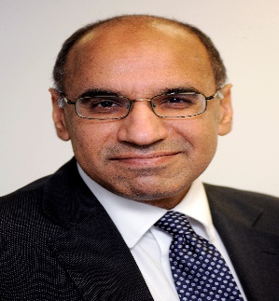

Full Name: Zulfiqur Ali

Contact number:+44-(0)7584-490236
Twitter account:@Zulf_Ali

Linked In account:zulfi

Category: Oral presentation

Meetings International Pte Ltd

Phone/WhatsApp: +65 31581626

