Title: Microfluidic bioreactor for batch and continuous cultivation

Ali, Z, Parekh, M, Aziz, A., Bateson S.M.,
Healthcare Innovation Centre, Teesside University, Middlesbrough, UK

Keywords: Microbioreactor, microfluidics, bioprocess, batch, continuous, optical sensors, 3d printing,

- Abstract Body

Fermentation is important within biotechnology for producing valuable products from microbial and mammalian cells including monoclonal antibodies, enzymes, biofuels [1] and involves many development stages including upstream, downstream and analytics. Microfluidic devices also offer potential for high-throughput screening which can be expensive for traditional macroscale systems. Different types of cells can be grown in microfluidic devices and where the nutrients and substrate can be delivered through microchannels in batch, fed batch and continuous mode [2,3]. We demonstrate p a 1 mL microbioreactor fabricated by 3D printing in VeroWhite and PMMA to culture microbial cells. A small magnetic stirrer bar is used to create chaotic mixing in microbioreactor, and fluorescent optical sensors are attached to the bottom of microbioreactor for real time measurement of pH and DO. Optical transmission measurements are used to measure cell biomass. The system used pressurised fluid driving system with flow switching to supply media and reagents to the microbioreactor element for both batch and continuous cultivation.

The batch cultivation of Escherichia coli is validated in the microbioreactor and shows good correlation between the optical density and the dissolved oxygen curves, OD started to increase, a drop in dissolved oxygen concentration was seen due to oxygen consumption by the cells. continuous cultures are performed for up to 400 hours in microbioreactor without contamination and effect of different dilution rates and glucose concentration demonstrated on growth rate.

- Microbioreactor element
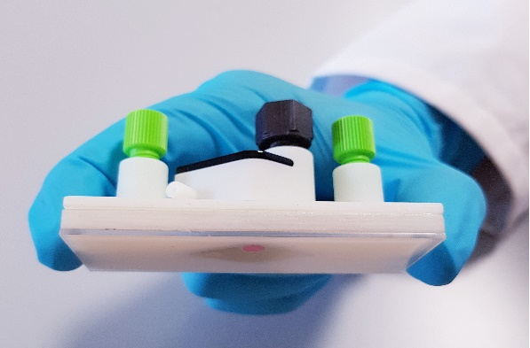

  - Reference:

[1] P. Panjan, V. Virtanen, A.M. Sesay, Towards microbioprocess control: an inexpensive 3D printed microbioreactor with integrated online real-time glucose monitoring, Analyst. 143 (2018) 3926-3933.
[2] M. Huang, S. Fan, W. Xing, C. Liu, Microfluidic cell culture system studies and computational fluid dynamics, Math. Comput. Model. 52 (2010) 2036-2042.
[3] G. Pasirayi, V. Auger, S.M. Scott, P.K.S.M Rahman, M. Islam, W.T.O’Hare and Z. Ali, ‘Microfluidic bioreactors for cell culturing: A Review’, Micro and Nanosystems, 2011, 3(2), 137-160

IV. Biography:
Zulfiqur has a BSc (Hons) Chemistry and PhD in instrumentation and analytical science from the University of Manchester. He in 1989 and has expertise in the development of smart miniaturised measurement systems. Zulfiqur has around 100 referred journals, book chapters and conference publications, with more than 3000 citations. He has coordinated numerous EC projects and most recently participated in the EC H2020 GateOne project. Zulfiqur currently has responsibility for the Healthcare Innovation Centre. He is on the Editorial Board for Micromachines and is member of the UK Research and Innovation Future Leaders Fellowships (UKRI FLF) Peer Review College.

    - Presenting author details



Full Name: Zulfiqur Ali

Contact number:+44-(0)7584-490236
Twitter account:@Zulf_Ali

Linked In account:zulfi

Category: Oral presentation

Meetings International Pte Ltd

Phone/WhatsApp: +65 31581626

