Title: Self-Healable Ultra-Stretchable Wearable Sensor Materials

Evan K. Wujcik¹
¹ Materials Engineering and Nanosensor (MEAN) Laboratory, Department of Chemical and Biological Engineering, The University of Alabama, P.O. Box 870203, Tuscaloosa, AL, 35487 USA

Keywords: wearable, stretchable, polymer, sensor, strain

- Abstract Body

Wearable strain sensors are essential for the realization of applications in the broad fields of remote healthcare monitoring, soft robots, immersive gaming, among many others. These flexible sensors should be comfortably adhered to skin and capable of monitoring human motions with high accuracy, as well as exhibiting excellent durability. However, it is challenging to develop electronic materials that possess the properties of skin. The presented skin-like electronic material exhibits ultrahigh stretchability, repeatable autonomous self-healing ability, quadratic response to strain, and linear response to flexion bending. This conductive polymer system, under ambient conditions, synergistically constructs a regenerative dynamic polymer complex crosslinked by hydrogen bonds and electrostatic interactions, which enables these unique properties. Sensitive strain-responsive mechanisms owing to the homogenous and viscoelastic nature provide omnidirectional tensile strain and bending deformations. Furthermore, this material is scalable and simple to process in an environmentally-friendly manner, paving the way for the next generation wearable sensors.

- Image:

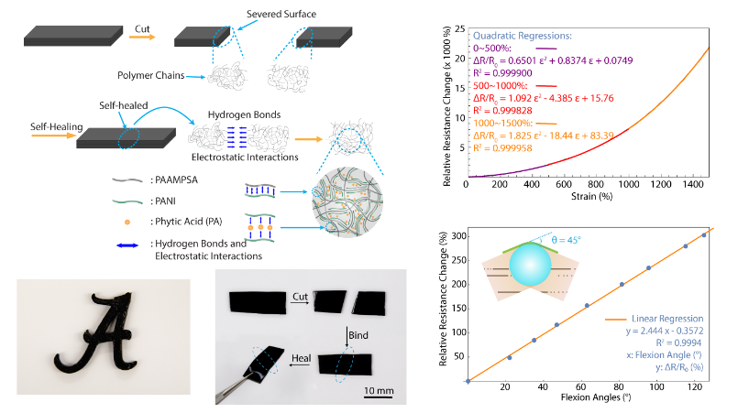
  - References:¹⁻⁴

1. Lu, Y.; Liu, Z.; Yan, H.; Peng, Q.; Wang, R.; Barkey, M. E.; Jeon, J.-W.; Wujcik, E. K., Ultra-Stretchable Conductive Polymer Complex as Strain Sensor with Repeatable Autonomous Self-Healing Ability. ACS applied materials & interfaces 2019.
2. Wujcik, E. K.; Jeon, J.-W.; Lu, Y. Self-Healing and Stretchable Polymeric Compositions. 2019.
3. Lu, Y.; Biswas, M. C.; Guo, Z.; Jeon, J. W.; Wujcik, E. K., Recent developments in bio-monitoring via advanced polymer nanocomposite-based wearable strain sensors. Biosensors and Bioelectronics 2018.
4. Horne, J.; McLoughlin, L.; Bury, E.; Koh, A. S.; Wujcik, E. K., Interfacial Phenomena of Advanced Composite Materials toward Wearable Platforms for Biological and Environmental Monitoring Sensors, Armor, and Soft Robotics. Advanced Materials Interfaces 2020, 7 (4).

IV. Biography:

Evan K. Wujcik is currently an Assistant Professor in the Department of Chemical and Biological Engineering and an Adjunct Professor in the Department of Civil, Constructions, and Environmental Engineering at the University of Alabama (Tuscaloosa, AL, USA), where he directs the Materials Engineering and Nanosensor (MEAN) Laboratory. He obtained his Ph.D. in chemical and biomolecular engineering from The University of Akron (2013) and his MBA in 2011, M.S. in chemical engineering (2009), B.S. in applied mathematics (2010), and B.S. in chemical engineering (2008) from The University of Rhode Island. His research interests include stretchable electronics. advanced materials, polymers, fibers, electrospinning, and sensors.

    - Presenting author details



Full Name: Evan K. Wujcik, Ph.D., M.B.A.

Contact number: 1-205-348-2216; evan.wujcik@ua.edu
Twitter account: https://twitter.com/Evan_K_Wujcik
Linked In account: https://www.linkedin.com/in/evankwujcik/
Session name/ number: Bioelectronics and Bioinstrumentation

Category: Oral presentation

Meetings International Pte Ltd

Phone/WhatsApp: +65 31581626

