Title: Novel biosensor methods in SARS-CoV-2 diagnosis

Saatci E¹
¹Erciyes University, Faculty of Science, Biology Department, Kayseri, TURKEY

Keywords: SARS-CoV-2, COVID-19, diagnosis

- Abstract Body

The emergence of SARS-CoV-2, responsible for COVID-19 disease, has caused a substantial worldwide pandemic and has become a significant public health problem. World Health Organization (WHO) has declared COVID-19 as a devastating health emergency for all countries. Public health officials continue to monitor the situation closely to control this new virus-related outbreak. In order to continue to manage this pandemic, a fast and sensitive diagnosis of COVID-19 is attempted. Emerging tests have become an essential part of the management of the COVID-19 crisis. In this webinar, current methods and biosensor-based methods will be given in methodic details.

- Image:

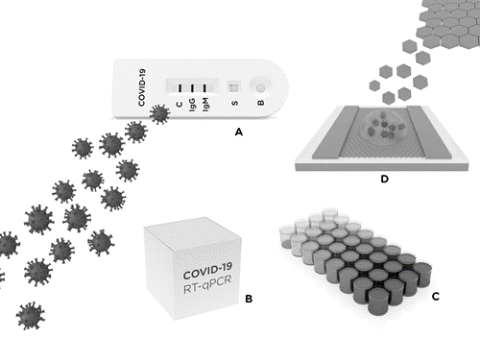

  - Biography:

Assit. Prof. Dr. Ebru Saatçi has completed his PhD at 2005 from Middle East Technical University, Turkey, and Postdoctoral Studies from Analytical Chemistry Department, Lund University, Sweden. Her research area is electrochemical enzyme and immnunosensors. She has two patent applications for this kind of biosensor development.

iV. Presenting author details


Full Name: Ebru Saatçi

Contact number:+905324812168
Twitter account:-

Linked In account: www.linkedin.com/in/ebru-saatci-ab85618/
Session name/ number: Printed Biosensors and microfabrication/8

Category: Oral presentation

Meetings International Pte Ltd

Phone/WhatsApp: +65 31581626

