Abstract

PDMS Microfluidic Chips Combined to SAW Biosensors for Ultra-Fast Biodetection of Antibodies and E. Coli bacteria

H. Tarbague¹, C. Dejous¹ et al.

¹ Université de Bordeaux, IMS, ENSEIRB, CNRS UMR 5218, Talence 33405, France

Keywords: Lab On a Chip, Biosensors, Microfluidics, Love wave, PDMS, E. Coli., SAW

- Abstract

We describe a biodetection platform (Fig.1) that combines microfluidic polydimethylsiloxane (PDMS) chips to biosensors based on surface acoustic waves (SAW), for detection of antibodies (GAM-g-Ab) and E. Coli bacteria (EC) with specific Ab-Anti-EC antibodies in liquid media within few seconds. The platform is composed of a test cell for removable SAW sensors and PDMS chips. The temperature is regulated (±0.05°C). The sensor surface is functionalized with a self-assembled monolayer (SAM) of (3glycidoxypropyl) trimethoxysilane (SBBB) to covalently graft bioreceptive GAM-g-Ab, specific for the target species to detect. Three PDMS chips were designed. The first one for a diffusive biodetection (DB) is called DBC: fluid samples are placed and removed with a micropipette. Second and third ones, with closed chambers, correspond to convective biodetection (CB), called CBC1 and CBC2: a syringe pump gets the fluid through microchannels above the microsensor (25μl/min). A same volume (250μl) was used to compare the kinetics of detections. On Fig.2, a typical response obtained with chip DBC, during protocol used for indirect EC detection: GAM-g-Ab (45μg/ml), SBBB to saturate non-specific sites, bacterial complex [EC (C0=10⁶ CFU/ml) pre-incubated with Ab-Anti-EC (2μg/ml)]. On Fig.3, a typical response obtained with CBC2, during direct EC detection: Ab-Anti-EC (20μg/ml), SBBB, EC (C0). Fig.4, typical response obtained with CBC2, for direct GAM-g-Ab detection. From chip DBC to CBC2, response time was greatly reduced, from hours to seconds, due to fast and homogeneous distribution of species on the surface. These results highlight the effectiveness of this versatile platform to achieve early detection of micro-organisms.

- Images

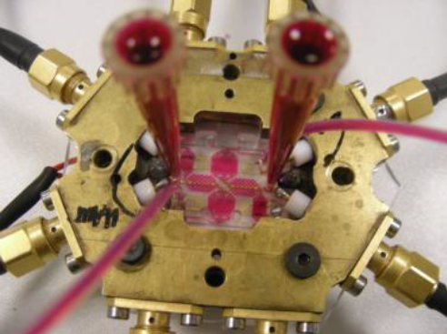
Fig. 1 Assembled biodetection platform (70 x 65 x 19mm)

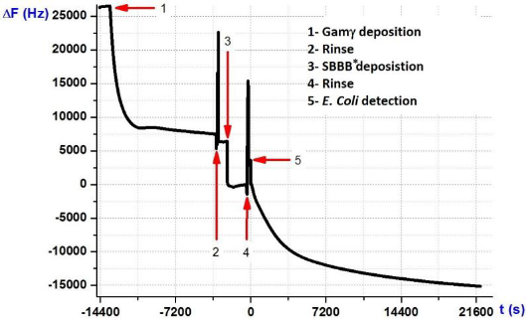
Fig.2 Real-time indirect EC detection with DBC
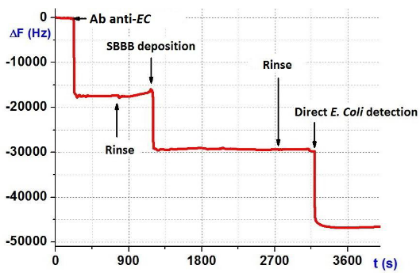
Fig.3 Real-time direct EC detection with CBC2

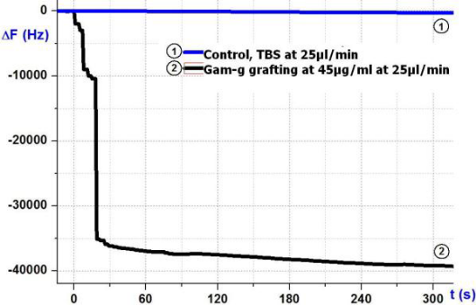
Fig.4 Real-time Gam-g with CBC2

- References

- A. Naillon, H. Tarbague, A. Gourbil, S. Geoffroy, M. Prat, P. Joseph. Proceedings of the 4th European Conference on Microfluidics (μFlu’14), Limerick, Ireland, 2014
- I.Gammoudi, V.Raimbaulta, H.Tarbague et al., 2014. Sensors and Actuators B: Chemical. Volume 198, 31 July 2014, Pages 278-284.
- N.Tekaya, I.Gammoudi, M.Braiek, H.Tarbague et al., 2013. Journal of Environmental Chemical Engineering. Volume 1, Issue 3, September 2013, Pages 609-619.

- Biography

Hakim Tarbague has completed his Phd at IMS Laboratory, Université de Bordeaux and postdoctoral studies at LAAS CNRS Toulouse, at CEA Grenoble (Commissariat à l’Energie Atomique) and at IBS Grenoble (Institut de Biologie Structurale). His skills are microfluidics, biosensors, Lab on a chip, PDMS chips. He imagines and realizes Lab on a chip prototypes for scientists working at the interface of several scientific disciplines.

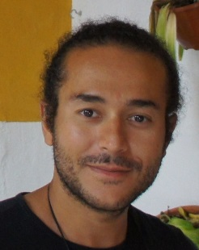
- Author

Full Name: Hakim Tarbague

Contact number: +33 751667228

Linked In account: Hakim Tarbague
Session name/ number:

Category: Oral presentation
Passport Number: 19DE0995

