Title: Production of marine inulinase using submerged fermentation isolated from a marine bacteria
Deblina Das^{1*}, Ramananda Bhat¹
1. Department of Biotechnology, Manipal Institute of Technology (MIT), Manipal Academy of Higher Education (MAHE), Manipal, Karnataka-576104.
Keywords: Inulin, Inulinase, Enrichment, Submerged fermentation, Fructose
I Abstract
The present study deals with the isolation and production of inulinase enzyme from a marine bacteria using submerged fermentation. Marine soil was aseptically collected from Mattu beach, Udupi. Enrichment was carried out by suspending 5ml of the sediment in 5.0 ml of yeast extract peptone dextrose (YPD) broth. The enriched suspension was serially diluted and plated on YPD agar slants. Morphologically different microbial colonies were selected from the plates and inoculated into an inulin medium containing inulin, yeast extract, MgSO₄.7H₂O, KCl and NaCl. After incubating at 37°C for 48hrs, cocci shaped isolates were obtained. SMF was then carried out by inoculating 4×10¹²cells ml⁻¹in 45ml of production medium containing (inulin, K₂HPO₄, yeast extract), pH 5 and incubated for 72hrs at 180rpm (37℃). The fermented broth was then centrifuged and the cell free supernatant used as crude inulinase was assayed for fructose using DNS method. One unit of inulinase activity is defined as the amount of enzyme which produces 1μmol of fructose per minute under the above conditions. The inulinases activity obtained was 0.65U/ml. The I/S ratio (relative activities with inulin and sucrose) determines the catalytic activities of inulinase (I) and invertase (S). When I/S ratio is greater than 10⁻² it shows higher inulinase production, while when I/S ratio is less than 10⁻⁴ it indicates invertase. The I/S ratio was calculated as 3, which shows higher inulinase production. Thin layer chromatography was done which confirmed the presence of fructose.

II Image:
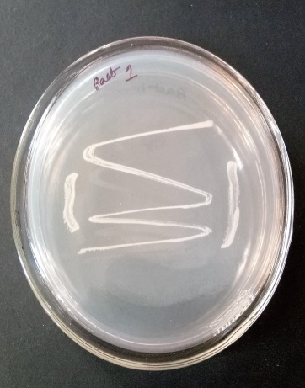
Fig 1-Bacterial growth on inulin media

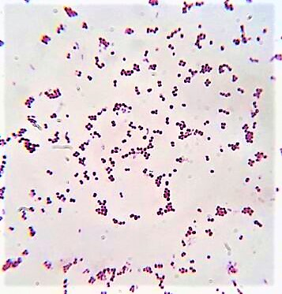
Fig 2- Determination of cocci under the microscope

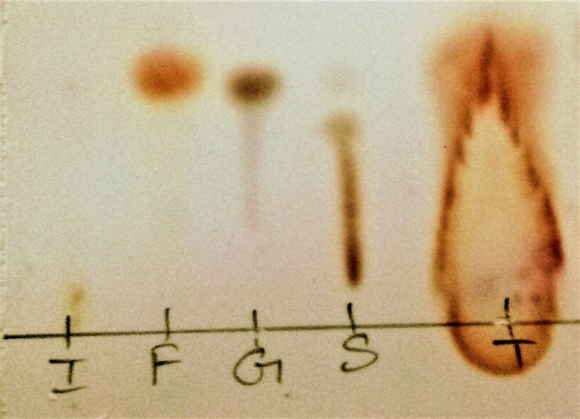
Fig 3- Lanes I- inulin, F- fructose, G- glucose, S- sucrose, T- test sample. TLC assay determination of fructose in the test sample which proves that inulinase enzyme is produced which has broken down inulin into fructose.
III References:
1. P. Singh and P. K. Gill, “Production of Inulinases : Recent Advances,” Food Technology and Biotechnology, vol. 44, pp. 151–162, 2006.
2. R. S. Singh, K. Chauhan, and J. F. Kennedy, “A panorama of bacterial inulinases : characterization and industrial applications,” International Journal of Biological Macromolecules, vol. 96, pp. 312-322, 2017.
3. S. Bharathi, D. Saravanan, and M. Radhakrishnan, “Bioprospecting of Marine Yeast with special reference to Inulinase production,” International Journal of ChemTech Research, vol. 3, pp. 1514–1519, 2011.
4. L. Gao, Z. Chi, J. Sheng, L. Wang, J. Li, and F. Gong, “Inulinase-producing Marine Yeasts: Evaluation of their Diversity and Inulin Hydrolysis by Their Crude Enzymes", Microbial Ecology, vol. 54, pp. 722–729, 2007.
IV. Biography:
Deblina Das is currently pursuing her PhD under Dr. Ramananda Bhat M. at the age of 28 years in the department of Biotechnology from Manipal Institute of Technology (MIT) under Manipal Academy of Higher Education (MAHE), Manipal, Karnataka, India. She has published a review paper named “Review of inulinase production using solid-state fermentation” in one of the reputed scopus indexed springer journal “ Annals of Microbiology”.
V. Presenting author details

Full Name: Deblina Das
Contact number: 8762150170
Twitter account: Nil
Linked In account: Deblina Das
Category: Poster presentation

