Bioremediation of Xenobiotic Pesticides by Bacterial Species Isolated from Flower Farm Soil around Lake Naivasha, Kenya

Saphan Ochieng Anode^{1*}, Gabriel Magoma², Justus Onguso¹ and Tesfamichael Abraha³

¹Institute of Biotechnology and Research, Jomo Kenyatta University of Agriculture and Technology, Kenya
²Department of Biochemistry, Jomo Kenyatta University of Agriculture and Technology, Kenya
³Department of Biotechnology, Hamelmalo Agricultural College, Eritrea

*Corresponding author: Saphan Ochieng Anode, Institute of Biotechnology and Research, Jomo Kenyatta University of Agriculture and Technology, Kenya, Tel: +254722247818; E-mail: saphanode@gmail.com

Keywords: Bioremediation; Lake Naivasha, Flower farms; Pesticides; Xenobiotics

I Abstract
Certain microorganisms especially bacteria and fungi are able to use xenobiotic organic compounds as their carbon and nitrogen source for metabolism. Flower farms around lake Naivasha basin uses several agrochemicals especially pesticides to control pests and improve flower production. The aim of this study was to isolate and characterize morphologically and biochemically the main bacterial species that are able to grow and tolerate the pesticide contaminated farm soils. Soil samples were collected from randomly selected five greenhouses from each five flower farms namely Crescent, Elsamere, Karuturi, Malewa and Sewage farms. The samples were processed for bacterial isolation using the nutrient agar, mac’ Conkey agar, blood agar, Luria-Bertani and Minimum Salt Media nutrient media. Pure colonies of isolates organisms were identified and characterized using standard microbiological technique. Morphological, cultural and biochemical characterization of bacterial species isolated from the flower farm soil samples identified mainly Pseudomonas auriginosa, Escherichia coli, Rhodococcus erythropolis and Bacillus subtilis species. Analysis for biodegradation of pesticide consortia was done every 2 days, 10 days, 15 days and 21 days at 15°C in vitro. All the bacterial species were capable of degrading the pesticide residues at different level. Bacterial growth in pesticide consortia was quantified by monitoring colony growth of the species in liquid culture over time. The viable cell counts were determined turbidimetrically at O.D_{696nm}. All the isolated bacterial species were able to grow in flower farm soil contaminated with organochloride and organophosphate pesticide residues. B. subtilis recorded the highest growth at 1.77±0.07 O.D_{696nm} in pesticide mixture consortia.

II Image

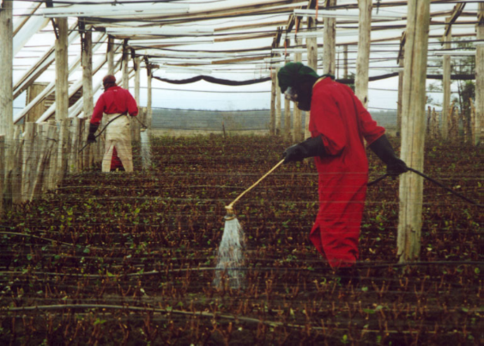

III References

- Saphan Ochieng Anode, Gabriel Magoma, Justus Onguso and Tesfamichael Abraha: Bioremediation of Xenobiotic Pesticides by Bacterial Species Isolated from Flower Farm Soil around Lake Naivasha, Kenya. J Bioremediat Biodegrad 2018, 9:5.

- Saphan Ochieng Anode, Justus Onguso and Gabriel Magoma: Qualitative and quantitative analysis of pesticide residues in flower farms soils around Lake Naivasha basin, Kenya. Intern Journ of Chemical Studies 2018; 6(6): 1615-1623

- Saphan Ochieng Anode, Justus Onguso, Gabriel Magoma and Tesfamichael Abraha: Isolation and Characterization of Xenobiotic Pesticide Degrading Bacterial Species in Flower Farms around Lake Naivasha, Kenya. Adv Envi Was Mana Rec, 2018. 1(6)
IV Biography
Dr. Saphan Anode graduated with PhD in Biotechnology (Bacterial Genetic Engineering) from Jomo Kenyatta University of Agriculture and Technology (JKUAT), Kenya in 2016. He also holds MSc in Biotechnology from JKUAT (2012), MSc in Analytical Chemistry from University of Nairobi, Kenya (2009) and BSc (Biochemistry and Chemistry) from Kenyatta University, Kenya (2000). He has published several articles in Bacterial bioremediation and degradation of xenobiotic chemicals, extraction of pesticide residues from farm soils and extraction of phytochemicals for medicinal uses. He is currently Senior Lecturer at the Department of Biotechnology, Hamelmalo Agricultural College, Eritrea.

V Presenting Author details
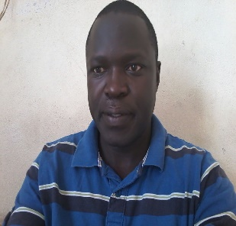

Full Name: Dr. Saphan Ochieng Anode
Contact number: +254722247818, +254736224592, +2917634154
Twitter account: @obewaturfimo2
Linked account:saphanode@gmail.com
Session name/number:
Category: Oral presentation
Passport Number: A2389905

