Study of Thermal Properties of Poly(phenylene sulfide)/Multi-Walled Carbon Nanotubes/Aluminum Nitride Composite.
Min Goo Jee, master course, Seoul National University, KOREA

Abstract (300 word limit)

The PPS/MWCNTs/AlN composite was prepared with poly(phenylene sulfide) (PPS), covalent functionalized multi-walled carbon nanotubes (fMWCNTs), and aluminum nitride (AlN) via melt-blending techniques. The AlN is a non-oxidizing ceramic material having the highest thermal conductivity among the ceramic materials. A silane coupling agent was used to introduce the functional groups on the surface of the AIN, as it is able to graft with the functional groups on the covalent functionalized MWCNTs. The silanization reaction of the AlN was characterized qualitatively and quantitatively by FT-IR (Fourier Transform Infrared Spectroscopy), and XPS (X-ray Photoelectron Spectroscopy). The grafting reaction of the AlN particles on the MWCNTs was observed using UV–Vis (Ultraviolet-Visible Spectroscopy), FE-SEM (Field-Emission Scanning Electron Microscopy) and FE-TEM (Field-Emission Transmission Electron Microscopy) images. The grafting reaction was accomplished by observing the change of the transmittance, the morphology of the AlN particle bonded to the MWCNTs. For the morphological changes of the fractured surface of the PPS/MWCNTs/AlN composites by FE-SEM, the hybrid filler was homogeneously dispersed on the PPS matrix when the AlN particle was grafted on the MWCNTs. The homogeneous distribution of the hybrid filler acts as a heat transfer path, which led the improved thermal properties, such as thermal conductivity, thermal resistance, and melting temperature than those of not grafted MWCNTs.

Image
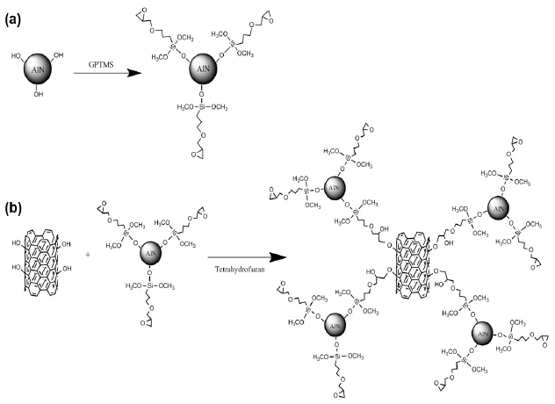
Recent Publications (minimum 5)

 Biography (150 word limit)
Min Goo Jee graduated from Kyungpook National University in 2017. He is master course student of Department of biosystems and biomaterials science and engineering, Seoul National University.
Email: aaajmg@snu.ac.kr

Notes/Comments:

