Preparation of hydrogels using various starch aldehydes
Jungmin Lee, Doctor’s course, Seoul National University, KOREA

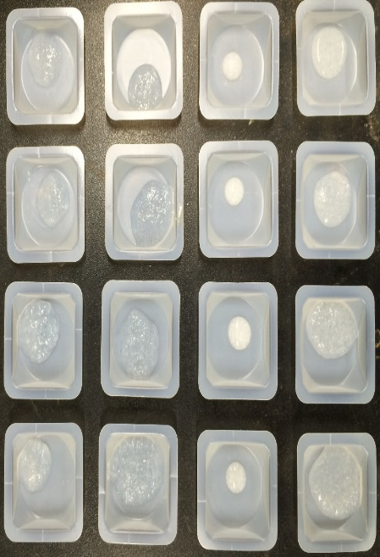

Abstract (300 word limit)
Hydrogels are hydrophilic, three-dimensional, and expandable matrices that are produced through chemical and/or physical crosslinking of certain polymers. In some cases, polysaccharide-based hydrogels have been prepared from a single polysaccharide such as carboxymethyl cellulose (CMC) and starch. CMC is an anionic water-soluble natural polymer derivative, which is widely used in detergents, oil exploration, and in the food, paper, and textile industries because of its viscosity-increasing properties. Starch is widely used in different fields such as food, environmental-friendly plastics, and medicine due to its low cost, biodegradability, and renewability. In this study, the polysaccharide hydrogels were prepared by esterification between hydroxyl groups of CMC and aldehyde group of modified starch. Epichlorohydrin and citric acid were used for crosslinker. The starches used in the experiments were corn starch, potato starch, and soluble starch. Sodium periodate was used as the oxidizing agent. The degree of aldehydes substitution (DS) of hydroxyl groups was varied with the amount of oxidizing agent, and the DS showed a minimum of 0.87 to a maximum of 2.79. As a result of analysis of the hydrogels, epichlorohydrin crosslinker showed a high swelling ratio when reacted with native starch. On the other hand, citric acid crosslinker showed good results when reacted with starch aldehydes. The maximum swelling ratio of hydrogel was about 50.

Image

Recent Publications (minimum 5)
- Lee JM et al. (2014) Preparation and Characterization of Polyurethane Foam Using a PLA/PEG Polyol Mixture. FIBERS AND POLYMERS 15:1349-1356.
- Kim SH et al. (2014) Effect of alkyl-chain-modified lignin in the PLA matrix. FIBERS AND POLYMERS 15:2458-2465.
- Kim SH et al. (2015) Potential of a Bio-disintegrable Polymer Blend Using Alkyl-chain-modified Lignin. FIBERS AND POLYMERS 16:744-751.
- Jeong HY et al. (2016) Low-temperature Pyrolysis on Jute Fibers as A Thermochemical Modification Method. FIBERS AND POLYMERS 17:540-552.
- Kim SH et al. (2016) Changes of Lignin Molecular Structures in a Modification of Kraft Lignin Using Acid Catalyst. MATERIALS 9:

 Biography (150 word limit)
Jungmin Lee graduated from Seoul National University in 2008. He received a master’s degree from Seoul National University in 2013. He is a PhD student of Department of Biosystems and Biomaterials Science and Engineering, Seoul National University. He has published more than 5 papers in reputed journals.
Email: archon04@snu.ac.kr

Notes/Comments:

