Preparation of polysaccharide hydrogels with different process methods
Jihyun Yeo, Master’s course, Seoul National University, KOREA

Abstract (300 word limit)
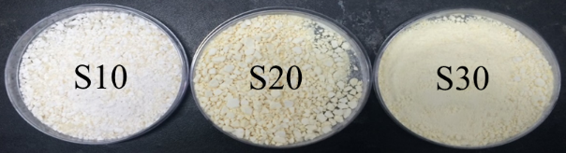
Polysaccharides derived from natural resources are widely used to develop superabsorbent polymers. Previous studies were grafting petroleum-based synthetic polymers onto polysaccharides. But, these products have a disadvantage that complete biodegradation is impossible. In this study, modified starch and CMC were used as main materials, and chemical bonding of two polysaccharides was tried by esterification. Starch modification and hydrogel preparation were conducted as follows. First, the oxidation of starch was carried out in order to improve the functionality of compound. The hydroxyl groups, primarily at C-2, C-3, and C-6 positions, were transformed to aldehyde and carboxylic acid by oxidation. And then, the polysaccharide hydrogels were prepared by esterification between hydroxyl groups of CMC (or CMC-g-itaconic acid) and aldehyde group of modified starch. The final product was prepared in the form of powder or film, and various characteristics were analyzed. FT-IR spectrometer was used to confirm the chemical structure of products. The FT-IR spectra of starch aldehydes showed the characteristic IR bands at ~1735 cm⁻¹, which confirm the oxidation of starch. In FT-IR analysis of hydrogels, the peaks related to ester bonding were observed. When hydrogel was prepared in powder form, it was confirmed that all samples showed two peaks at 1750 cm⁻¹ and 1660 cm⁻¹. In film form, two peaks were observed at 1710 cm⁻¹ and 1610 cm⁻¹ in all samples using CMC-g-itaconic acid. The maximum swelling ratio of hydrogel was about 25.

Image
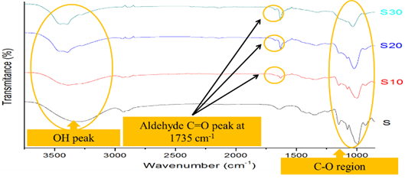
Recent Publications (minimum 5)

Biography (150 word limit)
Jihyun Yeo graduated from Kyung hee University in 2017. She is a master course student of Department of biosystems and biomaterials science and engineering, Seoul National University.
Email: jamong0109@snu.ac.kr

Notes/Comments:

