Influence of surface charge density and NaCl concentration on the intrinsic viscosity of cellulose nanocrystal suspensions
Qiang Wu, Xiuwen Li, Shenyuan Fu, School of Engineering, Zhejiang A&F University, China
Qian Li, Siqun Wang, PhD, University of Tennessee, USA

Abstract (300 word limit)
Cellulose nanocrystals (CNCs) with similar size and various surface charge densities were prepared by sulfuric acid hydrolysis and NaOH desulfation. The influence of surface charge density and NaCl concentration on the intrinsic viscosity of CNC suspensions and predicted aspect ratio were investigated by Ubbelohde viscometer. With decreased CNC surface charge density, the intrinsic viscosity initially decreased due to the electric double layers on the CNC surface and subsequently increased due to CNC aggregation. To screen electroviscous effect, NaCl was added into CNC suspensions. With increased NaCl concentration, the intrinsic viscosity of CNC suspensions first decreased and then increased. The aspect ratios of CNCs predicted by Batchelor equation from the minimum intrinsic viscosity were consistent with that measured by transmission electron microscopy (TEM). Suspensions of CNCs with higher surface charge density needed less NaCl to obtain minimum intrinsic viscosity. The NaCl content that should be added to the suspension to predict the actual physical aspect ratio of CNC can be estimated by Debye-Hückel theory, assuming that the Debye length is equal to the CNC diameter..

Image
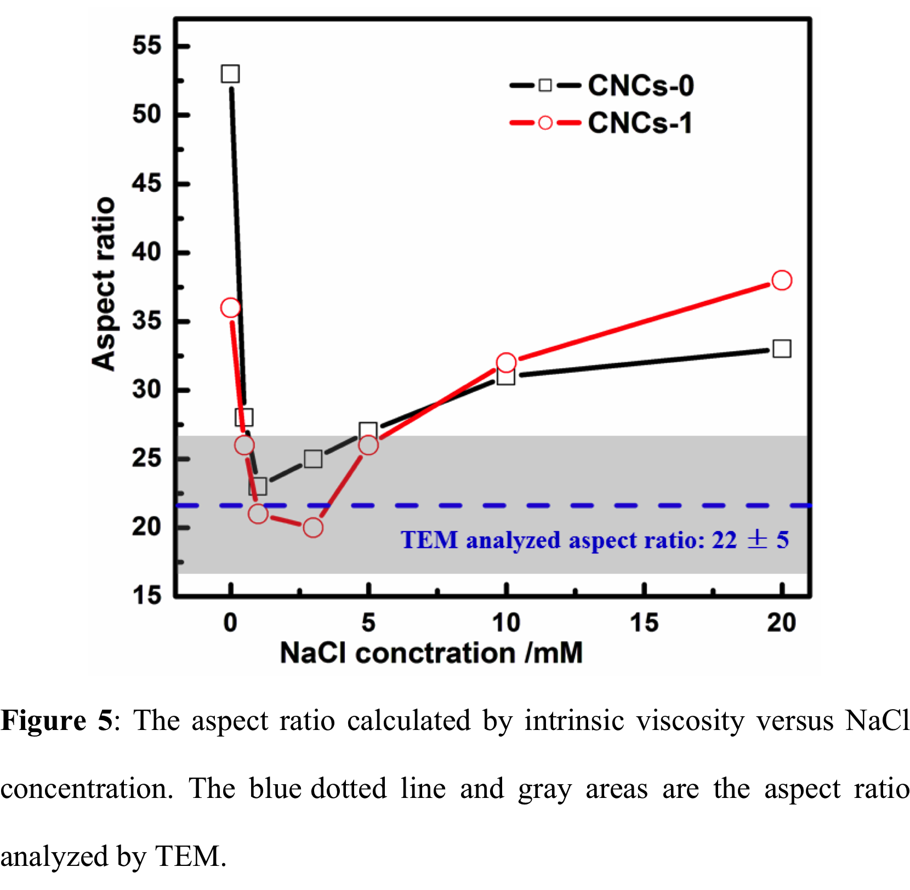
Recent Publications
- Huang J, Lyu S, Fu F, Wu Y, Wang S (2017) Green preparation of cellulose nanocrystals/polyvinyl alcohol composite superhydrophobic coating. RSC Advances 7: 20152-20159.
- Lu Y, Liu H, Gao R, Xiao S, Ming Z, Li J, Yin Y, Wang S, Zhu G, Yang D (2016) Coherent Interface Assembled Highly Porous Ag2O@Nanofibrillated Cellulose Aerogels for Iodine Capture. ACS Applied Materials & Interfaces 8 (42): 29179–29185.
- Ma L, Zhang Y, Wang S (2016) Modified treatment for carbonized cellulose nanofiber application in composites. Composites A 90: 786-793.
- Fu J, Wang S, He C, Lu Z, Huang J, Chen Z (2016) Facilitated Fabriction of High Strength Silica Aerogels Using Nanocellulosic Scaffolds. Carbohydrate Polymer 147: 89-96.
5. Wu Q, Meng Y, Concha K, Wang S, Li Y, Ma L, Fu S (2013) Influence of temperature and humidity on nano-mechanical properties of cellulose nanocrystal films made from switchgrass and cotton. Industrial Crops and Products 48: 28-35.

Biography
Dr. Siqun Wang is a Professor in the UT Center for Renewable Carbon. His research interests include Nano-mechanics, cellulose nano materials, bio-based carbon materials, manufacture and performance of wood-based composites, natural fiber-reinforced plastic composites, bio nanocomposites, wood adhesion, cellulose nano material impact on soil, soil recovery, heave metal removal from water, and wood quality. Dr. Wang has authored or co-authored more than 200 referred journal articles.
Email: swang@utk.edu

Notes/Comments:

