Effects of Rice Straw-Based Polyol on the Thermophysical Properties of Rigid Polyurethane Foam
Kriztine Magadan-Icalina¹, Rosal Jane M. Ruda,
Arnold A. Lubguban, PhD, MSU-IIT, Philippines

Abstract (300 word limit)
Statement of the Problem: Vegetable oils and lignocellulosic biomass are two major types of bio-based resources gaining interest for bio-based polyols for polyurethane (PU) production. However, the consumption of huge amounts of vegetable oils could result in a shortage of vegetable oils and will cause the increase in food prices. Therefore, lignocellulosic biomass is seen as a better alternative raw material for PU production. Various kinds of lignocellulosic biomass, have been used for the production of bio-based PU foams but the use of lignocellulosic rice straw is not yet explored. Thus, the study aims to develop a PU rigid foam from rice straw-based polyol and investigate the effect of isocyanate index on the thermophysical properties of the foam. Methodology & Theoretical Orientation: PU foams were prepared by reacting isocyanates in varying indices with polyols containing 15% of rice straw-based polyol and 85% petroleum-based polyol and their thermal conductivity, density and compressive strength were determined. Findings: PU foams with no biopolyol replacement has superior thermal and mechanical properties over the PU foams with biopolyol replacement. However, those with biopolyol replacement were significant less dense compared to the commercial formulation. This could indicate possible application in industries where lightweight materials is important. Thermal characterization of the foam samples at different isocyanate indices indicate that increasing the isocyanate content improves insulation property of the PU as evident with the decreasing conductivity. This is also true with compressive strength. The index is directly proportional to the compressive strength. Density, on the other hand, is directly proportional to the isocyanate content. Conclusion & Significance: Successful development of PU rigid foam products using biomass-based polyols obtained from a renewable feed stock rice straw offers a practical and economic procedure for potential scale-up and commercialization.

Image
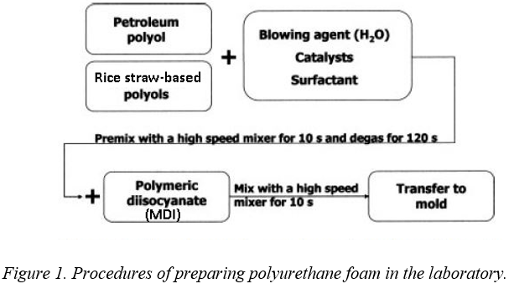
Recent Publications (minimum 5)
- Bernardini, J., Cinelli, P., Anguillesi, I., Lazzeri, A.(2015). Flexible polyurethane foams green production employing lignin or oxypropylated lignin. European Polymer Journal. 64, 147–156.
- Li, Y., Hu, S.(2014). Two-step sequential liquefaction of lignocellulosic biomass by crude glycerol for the production of polyols and polyurethane foams. Bioresource Technology. 161, 410–415.
3. 13) Li, Y., Hu, S.(2014). Polyols and polyurethane foams from base-catalyzed liquefaction of lignocellulosic biomass by crude glycerol: Effects of crude glycerol impurities. Industrial Crops and Products. 57, 188–194.
4. Tu, Y.-C., Kiatsimkul, P.-p., Suppes, G. J., Hsieh, F.-H. (2007). Physical properties of water-blown rigid polyurethane foams from vegetable oil-based polyols. Journal of Applied Polymer Science. 105, 453-459.
5. Xue, B., Wen, J., Sun, R.(2015). Producing Lignin-Based Polyols through Microwave-Assisted Liquefaction for Rigid Polyurethane Foam Production. Materials. 8, 586-599.

Biography (150 word limit)
Kriztine Magadan-Icalina is a licensed chemical engineer and is currently taking up Master of Science in Material Science and Engineering in Mindanao State University-Iligan Institute of Technology. Her master’s thesis is focused on the formulation and characterization of a water-blown rigid polyurethane foams from a lignocellulosic rice straw-based polyol. Her passion is on research and teaching.
Email: kriztinemagadan@gmail.com

Notes/Comments:

