Modeling of Phase Behaviors for Hydrogen Bonding Polymer Solution using PC-SAFT Equation of State
Bong-Seop Lee*, Associate Prof. Kuyngnam University, Republic of Korea

Abstract
Modeling of the phase behavior of polymer solutions is a crucial requirement to develop new polymer solution technologies and to design various polymer processes, such as purification, fractionation, devolatization and polymer production. In particular, the liquid-liquid equilibrium (LLE) calculation is essential for processes design of polymerization.
The hydrogen bonding in polymer solutions leads to deviate remarkably from normal solutions behaviors and is a major causes of different phase behaviors. The perturbed-chain statistical association Fluid Theory (PC-SAFT) equation of state (EoS) is applied to calculate the pressure–volume–temperature (PVT), infinite dilution weight fraction activity coefficient (WFAC), vapor-liquid equilibrium (VLE) and liquid-liquid equilibrium (LLE) of associating polymer mixtures with hydrogen bonding association such as self- and cross-association with various phase behaviors such as upper critical solution temperature (UCST), the lower critical solution temperature (LCST) and closed-loop of polymer solutions. The PC-SAFT model shows a satisfactory performance.

Image
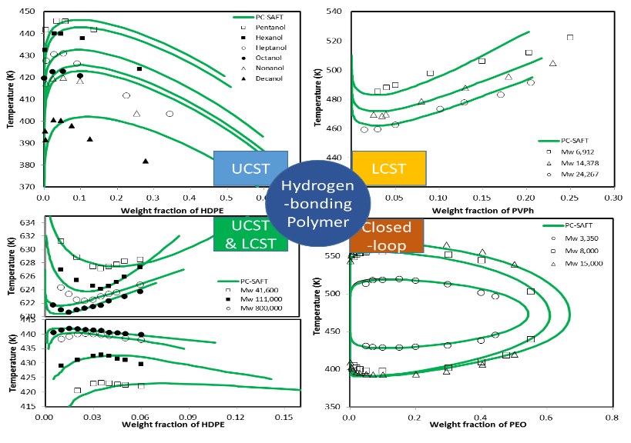

Recent Publications (minimum 5)
- B.-S. Lee, S.-T. Lin*, The Origin of Ion-Pairing and Redissociation of Ionic Liquid, J. Phys. Chem. B, 121 (2017) 5818-5823.
- B.-S. Lee, S.-T. Lin*, Prediction and Screening of Solubility of Pharmaceuticals in Single- and Mixed-Ionic Liquids using COSMO-SAC model, AIChE J., 63 (2017) 3096-3104.
- B.-S. Lee, H.-S. Byun, Phase behavior of binary and ternary mixture for the poly(TBAEMA) and TBAEMA in supercritical solvents, Korean J. Chem. Eng., 34 (2017) 2056-2064.
- H.-S. Byun, B.-S. Lee*, Liquid-liquid equilibrium of hydrogen bonding polymer solutions, Polymer, 121 (2017) 1-8.
- B.-S. Lee, W.-H. Yeo, H.-S. Byun*, Phase Behavior for the Poly(phenyl methacrylate) and Phenyl Methacrylate in Supercritical Carbon Dioxide and Dimethyl Ether, J. Chem. Eng. Data, 62 (2017) 1876–1883.
- C.-H. Bang, H.-K. Choi, B.-S. Lee*, Hydrogen Bonding in Polymer Solution, J. Chem. Eng. Data, 61 (2016) 3438-3447.
- C.-H. Bang, H.-K. Choi, B.-S. Lee*, Modeling of activity coefficients of amino acid and electrolyte in aqueous solutions, J. Mol. Liq., 223 (2016) 1-9.
- B.-S. Lee, S.-T. Lin*, A Priori Prediction of Dissociation Phenomena and Phase Behaviors of Ionic Liquids, Ind. Eng. Chem. Res., 54 (2015) 9005-9012.
- B.-S. Lee, S.-T. Lin*, Screening of ionic liquids for CO2 capture using the COSMO-SAC model, Chem. Eng. Sci., 121 (2015) 157-168.
- B.-S. Lee*, K.-C. Kim, Liquid-Liquid Equilibrium of Associating Fluid Mixtures Using Perturbed-Hard-Sphere-Chain Equation of State Combined with the Association Model, Ind. Eng. Chem. Res., 54 (2015) 540-549.
- B.-S. Lee, S.-T. Lin*, A priori prediction of the octanol-water partition coefficient (Kow) of ionic liquids, Fluid Phase Equilib., 363 (2014) 233-238.

Biography
Bong-Seop Lee has his expertise in modeling the phase behaviors on organic molecules, polymers, biological molecules (i.e., amino acid, peptide) and electrolyte solutions (i.e., inorganic salt, ionic liquids). In master course, he suggested the Perturbed Hard-Sphere-Chain Association (PHSC-AS) equation of state which is combined the association term in SAFT to PHSC equation of state. In PhD course, he developed the electrolyte-PC-SAFT equation of state by combining PC-SAFT and primitive mean spherical approximation. During post-doc period, he focused on the modeling of physical and chemical properties of ionic liquid mixtures. In particular, he has been studied deeply about the dissociation and association of ionic liquids. Recently, he is interested in dissociation phenomena of weak and strong acids, and the equilibrium of various materials (polymer, blend, organic solvent) at high pressure condition.
Email: bslee0425@gmail.com

Notes/Comments:

