Abstract Title: Preparation Of Intelligence Barrier Films Based On Low Density Poly Ethylene And Evaluation Of Its Properties

Author’s Name and Affiliation : B. Bahari Aban, P. Atabaki Pasdar
Islamic Azad University, Science and Research Branch

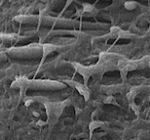

Abstract (300 word limit)
In this article, nanocomposite films based on low density polyethylene (LDPE), organoclay (OC) and ethylene vinyl alcohol (EVOH) copolymer were prepared and characterized through using scanning electron microscopy(SEM), transmission electron microscopy (TEM), X-ray diffraction (XRD), differential scanning calorimetry (DSC), oxygen permeation measurements, and tensile tests. The oxygen barrier properties of the LDPE/EVOH/OC film were better than those of the LDPE/OC film. In addition to barrier properties. Furthermore, from the TEM micrographs, the O2 permeability through the films was evaluated, which illustrated that adding both OC and LDPE to EVOH leads to a remarkable increase in the barrier properties of EVOH films. Also, a new colorimetric indicator sensor based on methyl red was sensitive to total volatile basic nitrogen (TVBN) released from red meat during storage which has been fabricated for real-time monitoring of meat quality. The methyl red as a freshness sensor worked based on pH increase as the basic spoilage volatile amines produced gradually in the package headspace, and subsequently, the colour of the sensor will change for spoilage indication, which is easily visible to the naked eye. The results reveal that the sticker sensor could be used to determine the degree of red meat cut freshness, as the relationship between the colour change of methyl red as a sensor response and the meat freshness follows a similar trend. Results have indicated that sensor response correlated well with microbial load of red meat, thus enabling the sensor for real-time monitoring of red meat spoils.

Related Image If Any
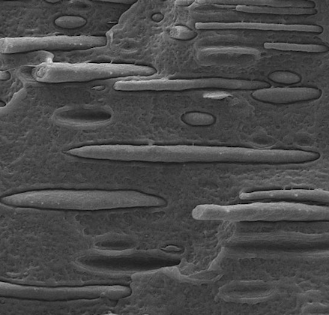

List of Recent Publications if any (Maximum 5)
1.
2.
3.
4.
5.



Biography (150 word limit)
Babak Bahari Aban was born in Tehran, Iran, in 1990. He received the bachelor degree in Polymer engineering from the Islamic Azad University, Science and Research branch, Tehran, Iran, in 2013, and he is studying the master of Polymer engineering in the same university since 2015. His current research is investigation on food packaging and bioplastics and nanotechnology in order to increasing the shelflife of food packages. Besides, he had cooperated with polymer and petrochemical institute since 2016 in terms of producing Antibacterial and Nano films packaging. Moreover, his bi-cultural background and focus on community collaboration has led him to a number of volunteer opportunities and community leadership roles.

Presenting author details
Full name: Babak Bahari Aban
Email: babak.bahari1990@gmail.com
Contact number: +989122790021
Twitter account:
Linked In account:
Session name/ number:
Category: (Oral presentation / Poster presentation)

Notes/Comments:

