Abstract Title: Preparation Of Intelligence Antibacterial Films Based On Low Density Poly Ethylene And Evaluation Of Its Properties

Author’s Name and Affiliation : P. Atabaki Pasdar, B. Bahari Aban,
Islamic Azad University, Science and Research Branch

Abstract (300 word limit)

In this article, antibacterial film based on low density polyethylene (LDPE), potassium sorbate (KS) and ethylene vinyl alcohol (EVOH) copolymer were prepared and characterized using scanning electron microscopy(SEM), transmission electron microscopy (TEM), X-ray diffraction (XRD), differential scanning calorimetry (DSC), and tensile tests. The oxygen barrier properties of the LDPE/EVOH/KS film were significantly better than those of the LDPE/KS film. In addition to barrier properties, the LDPE/EVOH/KS film also had better elastic modulus than their counterparts without EVOH. The antimicrobial film containing potassium sorbate decreased the growth rate and maximum growth of yeast, and extended the lag period before mold growth was apparent. Therefore, it can prevent or reduce the rate of microbial spoilage in low viscosity liquids and on the contacted surface area of solid food products and as the result may prolong the shelf life of food products when it is used as a packaging material. Also, a novel sticker sensor has been fabricated based on methyl red, and tests have been conducted to detect the freshness of meat by its color change in real time (when the red methyl red paper changed to yellow). These are prepared by entrapping within a pH sensitive dye that responds, through visible color changes to the spoilage volatile compounds that contribute to a quantity known as total volatile basic nitrogen (TVBN). Finally, the methyl red was successfully used as a sticker sensor for the real-time monitoring of meat freshness in ambient and chiller conditions.

Related Image If Any
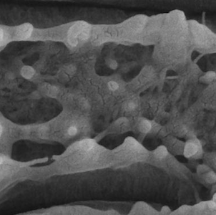
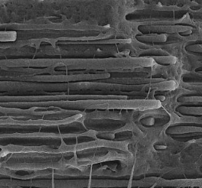

List of Recent Publications if any (Maximum 5)
1.
2.
3.
4.
5.

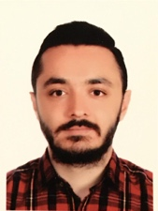
Biography (150 word limit)
Pouria Atabaki Pasdar was born in Orumiyeh, Iran, in 1989. He received the bachelor degree in Polymer engineering from the Islamic Azad University, Science and Research branch, Tehran, Iran, in 2013, and he is studying the master of Polymer engineering in the same university since 2015. His current research is investigation on food packaging and bioplastics and nanotechnology in order to increasing the shelflife of food packages. Besides, he had cooperated with polymer and petrochemical institute since 2016 in terms of producing Antibacterial and Nano films packaging. Moreover, he had invent a chemical car which are participated in chemicar competition in 2012.

Presenting author details
Full name: Pouria Atabaki Pasdar
Email: atabaki.p@gmail.com
Contact number: +989125497937
Twitter account:
Linked In account:
Session name/ number:
Category: (Oral presentation / Poster presentation)

Notes/Comments:

