Self-assembled Tripeptide Fibers as Prebiotic RNA Binders
Tony Z Jia, PhD, Earth-Life Science Institute, Tokyo Institute of Technology, Japan

Abstract (300 word limit)
Before the emergence of the first RNA polymerase ribozyme, sustained nonenzymatic replication of RNA was crucial to the development of early life. To that end, cationic peptides have been hypothesized to be able to assist in template-directed nonenzymatic RNA polymerization by binding to and selectively inhibiting the annealing of long, complementary RNA strands; these strands can then act as templates for free primer strands, resulting in progressive replicative turnovers. However, the geochemical scenarios that would allow for the accumulation of high concentrations of long, cationic peptide oligomers are not likely. Recently, it has been discovered that certain tripeptide systems can spontaneously self-assemble into hydrogels and fibrillar macrostructures. As the accumulation of high concentrations of peptide trimers is much more likely than longer oligopeptides on the early earth, we probed the self-assembly properties and RNA-binding affinities of six tripeptides, each containing a cationic residue in the N-terminal position followed by an aromatic or hydrophobic dyad. KYF and RFF showed the best fibrillar self-assembly propensity—RFF is the first purely-peptidic arginine-containing tripeptide to self-assemble—and microscopy and binding assays show that RNA indeed binds to the structures generated by these tripeptides. In fact, binding of a fluorescent RNA to cationic fibrillar macrostructures resulted in a direct label-free method of visualizing the kinetics of nanostructure assembly in real time. As these tripeptide assemblies are also reasonably heat-stable and do not prohibitively inhibit nonenzymatic RNA replication, our studies suggest that cationic tripeptide nanostructures could have been prebiotically-plausible RNA-binders, potentially possessing the ability to assist in the replication and eventual evolution of early genetic systems.

Image
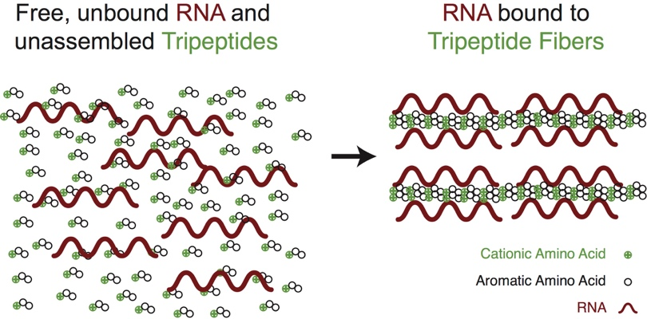
Figure 1 – Schematic of the assembly of tripeptide nanostructures, followed by RNA binding
Recent Publications
- Izgu EC; Björkbom KA, Kamat NP, Lelyveld VS, Zhang W, Jia TZ, Szostak JW (2016) N-Carboxyanhydride-mediated fatty acylation of amino acids and peptides for functionalization of protocell membranes. J. Am. Chem. Soc. 138(51):16669-16676.
- Xie XS, Shiroguchi K, Sims PA, Jia TZ (2016) Single cell nucleic acid detection and analysis. US Patent 9,260,753.
- Jia TZ, Hentrich C, Szostak JW (2014) Rapid RNA exchange in aqueous two-phase system and coacervate droplets. Orig. Life Evol. Biosph. 44(1):1-12.
- Shiroguchi K, Jia TZ, Sims PA, Xie XS (2012) Digital RNA sequencing minimizes sequence-dependent bias and amplification noise with optimized single-molecule barcodes. Proc. Natl. Acad. Sci. USA 109(4):1347-1352.
- Jaru-Ampornpan P, Shen K, Lam VQ, Ali M, Doniach S, Jia TZ, Shan S (2010) ATP-independent reversal of a membrane protein aggregate by a chloroplast SRP subunit. Nature Struct. Mol. Biol. 17(6): 696-702.

Biography (150 word limit)
Tony Z. Jia is a part of the Earth-Life Science Institute at the Tokyo Institute of Technology in Tokyo, Japan. There, we are interested in studying the origin and evolution of the Earth, of life on Earth, as well as life on other planets. As a part of this institute, Tony’s research interests include prebiotic and ancient biopolymer formation and evolution. Specifically, one of the most interesting topics in prebiotic chemistry involves supramolecular self-assembly of short peptide and nucleic acid polymers; these self-assemblies could possibly have facilitated the initial emergence of life on Earth.
Email: tzjia@elsi.jp

Notes/Comments:

