¹³C labeling gives insight into contribution of PHB precursors in Synechocystis sp. PCC 6803
Vaishali Dutt, ICGEB, India
Shireesh Srivastava, Ph. D., ICGEB, India

Abstract
The freshwater cyanobacterium Synechocystis sp. PCC 6803 is known to accumulate polyhydroxybutyrate when under nutrient stress. Many aspects of PHB accumulation have been studied in this cyanobacterium but there is no study to shed light on the contribution of PHB precursors. In nitrogen deprived cells, higher amount of PHB accumulates with acetate supplementation. However, the quantitative contribution of externally added acetate for PHB synthesis is not known. Similarly, the quantitative contribution of newly-fixed carbon for PHB synthesis is not clear, though a previous study has shown that the photosystem I (PS-I) shows detectable photosynthetic activity up to 350 h of nitrogen starvation and so the cells continue to produce ATP and the reducing equivalent NADPH. In this study, using labeled substrates, we show that (i) Externally added acetate, while increasing the intracellular PHB levels to over two-fold, contributes about 50 percent to PHB synthesis in either photo-autotrophic or mixotrophic growth, (ii) the newly-fixed C is also a big contributor to PHB synthesis and mixotrophic pre-growth significantly reduces the contributions of newly-fixed C to PHB. Indirectly, the labeling studies also show that intracellular C recycling is an important source of precursor for PHB synthesis, irrespective of the pre-growth mode. Thus, this study provides novel insights into PHB synthesis by cyanobacteria by identifying the quantitative contribution of precursors for PHB synthesis and the effect of pre-growth.

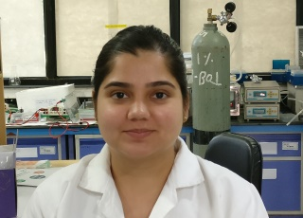
Biography

Image

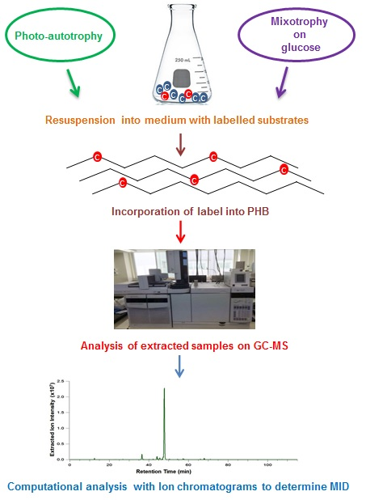
Recent Publication
Desai TS, Dutt V, Srivastava S. Systems biology and metabolic engineering of cyanobacteria for biofuel production. In: Marine Bioenergy: Trends and Developments, Se-Kwon Kim (Ed), CRC Press 2015; 163–178. DOI: 10.1201/b18494-13.

Vaishali Dutt has earned her B.S. and M.S. degrees in Zoology from University of Delhi, India. She qualified the CSIR-UGC National Eligibility Test in 2011 and was awarded fellowship to conduct research in the Life Sciences. She has been pursuing research under the supervision of Dr. Shireesh Srivastava at the International Centre for Genetic Engineering and Biotechnology since 2012. Her research revolves around understanding the PHB accumulation in photosynthetic bacteria, strategies to enhance the accumulation of this polymer and engineering of cyanobacteria to synthesize biofuel candidates.

Email: duttvaishali54@yahoo.com and shireesh1@gmail.com.

