Synthesis of Polyurethane Coating Using Castor Oil As A Bio-polyol and Its Characterization
Mr.Amol Sonawane
Department of Chemical Engineering, College of Engineering and Technology, Akola (M.S)-441004.
Abstract: India is the world largest producer of castor oil. Castor oil is a non-edible oil. Castor oil can be utilized for manufacturing polyurethane due to its inherent structural beauty in terms of presence of OH groups in its structure along with the functionality of 2.7. Hence an attempt has been made by utilizing castor oil as a renewable source of polyol for manufacturing PU coating. In the present work PU coating was prepared by varying the stoichiometric ratio of castor oil and toluene diisocyanate (TDI). The reaction was carried out without catalyst and by using DBTL catalyst separately. The prepared coating samples were characterized for mechanical properties like hardness, scratch resistance, pot life and chemical resistance.
Key words: castor oil, mechanical property, chemical resistance

1. Introduction
Due to various environmental and global issue in the present century polymer researches are giving momentous attention and emphasis in the regard of research based on the materials from renewable resources and finding their applications along with performance ^{[1]}. Nearly 90% of the petroleum polyol (polyether based) presently used for manufacturing of polyurethane ^{[10]}. Vegetable oils are considered to be the most important genre of renewable sources. Vegetable oils are relatively cheap, most abundant, renewable natural resources available in large quantities from various oilseeds, such as castor, palm, linseed, soya bean, coconut, sunflower, canola oils ^{[2]}. Polyurethane is seems to be a magic material as it found many applications starting from coating, paint, foam, thermosetting, thermoplastic elastomers to fiber. Polyurethane actually refers to the reaction product between a polyol and a diisocyanate or polyisocyanate. A polyurethane film may contain ester, ether, amide, urea and other groups. A polyurethane coating has gained ever-increasing importance in the coatings industry because of their structural beauty. The main reason for this is the high level of performance these coatings afford whilst crosslinking at room temperature. Initially the technology was aimed at countering the dominance of nylon fibres, but by the early 1940s it was recognized that it had potential in the adhesive, plastics, foam and coatings areas. Early applications of urethane coatings included impregnating paper to make mustard gas-resistant clothing and low-drag aircraft coatings ^{[3]}. Typical coatings are the paints and the diverse surface coatings used to protect houses, bridges, appliances, automobiles, etc. These coatings protect the surface from corrosion and degradation, and may provide other functional advantages such as making the materials waterproof or flameproof, and improving the appearance. Reasons for the use of polyurethane coatings include high performance characteristics such as flexibility, toughness, strength, abrasion, chemical, and stain resistance, good light stability and good low temperature properties. The latter factor is an important reason for use of polyurethane coatings on plastic substrates. PU coatings have emerged as coatings of choice for applications from industrial maintenance to automobile finishing to chemical resistant coatings ^{[11]} . PU resin designed primarily for automotive industry as an undercoating for steel frames, rocker panels, wheel wells, rail equipment, buses, ships, farm equipment. It is also useful coating for nonferrous articles, wood, fabrics, concrete, plastics, rubber, glass, ceramics, fibers, paper etc.
Hemul Patel et. al developed coating formulation by reacting various composition of soyabean oil phosphate ester(SOPE) and different poly ethylene Glycols(200,400, 600 mol wt) as chain extender with aromatics and aliphatic isocynate adducts in different NCO/OH ratios ^{[12]} .
Castor oil has inherent structural beauty in terms of carbon-carbon double bond, free hydroxyl group and carboxyl group. Utilization of these active sites of castor oil can lead to be a better polyurethane adhesive for various substrates. The castor oil possesses the required properties for production of valuable polymers such as polyurethanes, alkyd, polyester amide and epoxy resins ^{[13,14,15]} .
PU is a magic material due to its versatile chemistry. Polyurethane mainly contains urethane linkage along with this other linkages such as urea, aromatics, aliphatic hydrocarbon and allophanate. Castor oil based polyurethanes are extensively used in coatings, IPNs, telecommunications, as insulators in electrical industries, foams, adhesives, composites ^{[4, 5, 6, 7]}. Biopolymers using vegetable oil such as polyetheramide ^{[16]}, polyurethane ^{[17]}, epoxy ^{[18]}, polyesteramide ^{[19]}. Biopolymers impart the biodegradability, less volatile content, eco-friendly, nontoxic and cost effectiveness.
1.1 Castor Oil
Castor oil in itself has no drying properties but still it is interesting oil for the coating industry. Castor oil is the only commercially available source of natural hydroxylated triglycerides. This is to some extent due to the fact that its hydroxyl functionality allows the oil to be used, for example, in polyurethane coatings. Also the hydroxyl functionality imparts a high viscosity, stability and polar solvent (alcohol) Miscibility to this oil, making it useful as viscosity modifiers, plasticizers and wetting agents in various applications. ^{[8]}
It consists of triglycerides that contain 90% of ricinoleic acid, is one of the few naturally occurring glycerides that approach being a pure compound and 10% of non-functional acid and it has an effective functionality of 2.7.
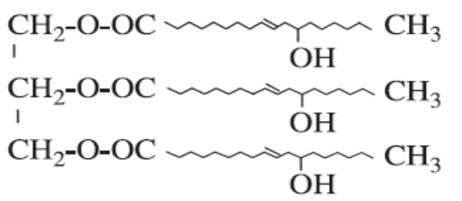
Fig.1 Structure of Castor oil
The trifunctional nature of castor oil contributes toughness to the structure, and the long fatty acid chain imparts flexibility. Castor oil possesses unique structural feature, higher solubility, lower hydrodynamic diameter and lower melt as well as solution viscosity compare to their analogous mass.
Table-1 Composition of castor oil ^{[9]}
Sr. No | Acid Name | Average % Range
1 | Ricinoleic acid | 95 to 85
2 | Oleic acid | 6 to 2
3 | Linoleic acid | 5 to 1
4 | Linolenic acid | 1 to 0.5
5 | Stearic acid | 1 to 0.5
6 | Palmitic acid | 1 to 0.5
7 | Dihydroxystearic acid | 0.5 to 0.3
8 | Others | 0.5 to 0.2

The reaction of the formation of polyurethanes included in polyaddition reaction so that the ratio between reactive groups in this case is the ratio of NCO to hydroxyl that to read groups that have a strong influence on the molecular weight of the resulting polyurethane. Aromatic diisocyanates are much more reactive than their aliphatic diisocyanate counterparts. Urethane products made from aromatic diisocyanate monomers oxidize more easily than those prepared from aliphatic diisocyanates, especially when exposed to UV light. The higher resistance to UV lightinduced degradation of products prepared from aliphatic diisocyanates make them more useful in high quality exterior coatings where gloss and color retention are most important. Whereas aromatic diisocyanate are more beneficial for protective coatings.
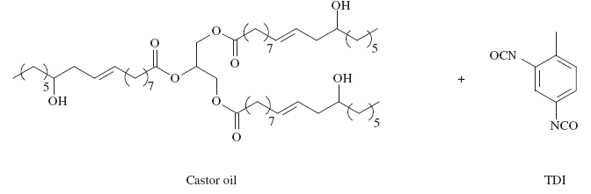
(Polyaddition Polymerization/ DBTL Catalyst/ 50 ⁰C)

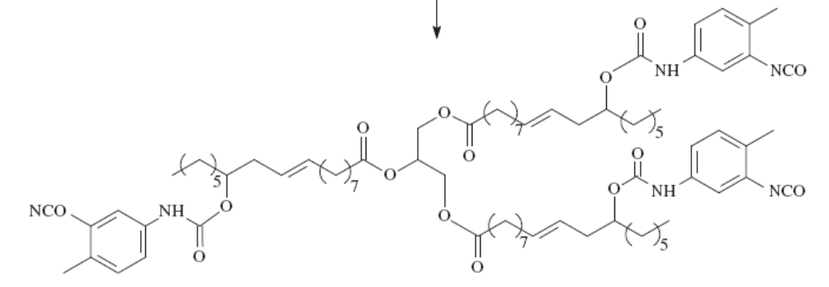
Fig.2 Reaction Scheme for Synthesis of PU
2. Experimental
2.1 Materials
Castor oil used as a source of polyol for PU coating were obtained from KR chemicals (India), Toluene diisocyanate (TDI) were procured from Akola Chemicals Pvt.Ltd (India), dibutyltin dilaurate (DBTDL) from Kemphasol, Mumbai (India). All other chemicals were of analytical grade (Loba Chemical)
2.2 Methodology
A calculated amount of Castor Oil and toluene diisocyanate was introduced in the reactor. The reaction was carried out in situ with and without catalyst separately. The reaction without catalyst was carried out at 50 ⁰C temperature and at ambient condition in presence of catalyst due to its high exothermicity. The catalyst loading was varied from 0.05 % to 0.15 %. The composition of castor oil and TDI was varied from 0.8 to 1.2 molar ratios by keeping the concentration of any one of the component constant and vice a versa. The quantity of castor oil and TDI for the 1:1 molar ratio (OH:NCO) was obtained by using the formulae:
Equivalent weight (isocyanate containing resin) $=\frac{42×100}{\%NCO}$
Equivalent Weight (polyols containing resin) $=\frac{17×100}{\%OH}$
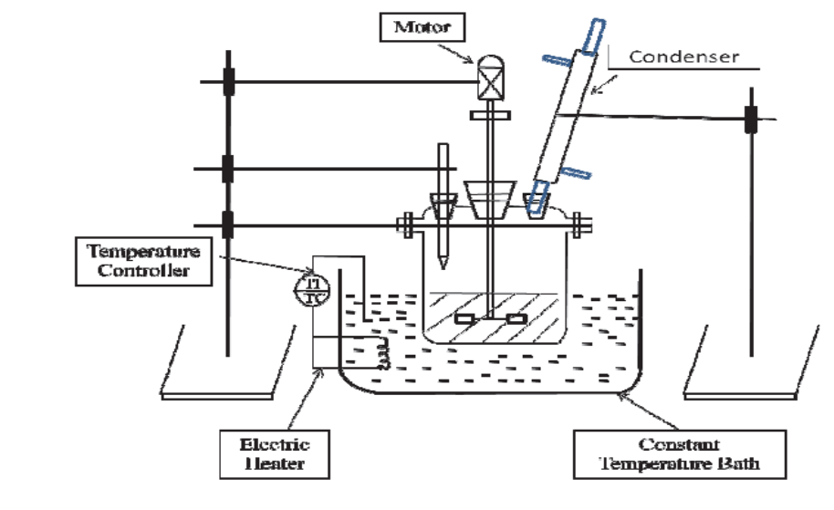
Fig. 3 Schematic diagram of experimental set-up

2.3 Batch Preparation
Batch 1 was prepared by varying the moles of the castor oil and keeping constant the moles of diisocyanate. In this batch quantity of pigment was 4% of castor oil and solvent was 30 ml.
Table.2 Composition of reactants for batch 1
Designation | Moles NCO/OH | Tio₂  (gm) | Solvent  (ml)
C1 | 1.0/0.8 | 4% | 30
C2 | 1.0/0.9 | 4% | 30
C3 | 1.0/1.0 | 4% | 30
C4 | 1.0/1.1 | 4% | 30
C5 | 1.0/1.2 | 4% | 30

Batch 2 was prepared by varying the moles of the isocyanate and keeping constant the moles of castor oil. In this batch quantity of pigment was 4% of castor oil and solvent was 30 ml.
Table.3 Composition of reactants for batch 2
Designation | Moles NCO/OH | TiO₂  (gm) | Solvent  (ml)
D1 | 0.8/1.0 | 4% | 30
D2 | 0.9/1.0 | 4% | 30
D3 | 1.0/1.0 | 4% | 30
D4 | 1.1/1.0 | 4% | 30
D5 | 1.2/1.0 | 4% | 30
Batch 3, 4 and 5 were prepared by varying the concentration of catalyst and keeping constant the moles of castor oil and diisocyanate. In this batch quantity of pigment was 4% of castor oil and solvent was 30 ml. The reaction was carried at ambient temperature.

Table.4 Composition of reactants for batch 3

Designation | Catalyst % | Wt. of catalyst (gm) | NCO:OH
CP1 | 0.05 | 0.043 | 0.8:1
CP2 | 0.10 | 0.087 | 0.8:1
CP3 | 0.15 | 0.131 | 0.8:1

Table.5 Composition of reactants for batch 4

Designation | Catalyst % | Wt. of catalyst | NCO:OH
CP11 | 0.05 | 0.043 | 1:1
CP12 | 0.10 | 0.087 | 1:1
CP13 | 0.15 | 0.131 | 1:1

Table. 6 Composition of reactants for batch 5

Designation | Catalyst % | Wt. of catalyst | NCO:OH
CP21 | 0.05 | 0.043 | 1.2:1
CP22 | 0.10 | 0.087 | 1.2:1
CP23 | 0.15 | 0.131 | 1.2:1

2.4 Sample preparation for performance study
Sample to be tested for polyurethane curing was coated onto MS steel test panels (15 cm x 5 cm) as follows. An excess of the sample was placed at one end of the test panel and using a rod applicator drawn across the substrate with even pressure pushing excess material off the edge. This method produced coating with average wet film thickness of 23-26 μm.
2.5 Measurements and Testing Method
Acid Number and hydroxyl value were determined according to ASTM D 1639-90 and ASTM D1957-90, respectively. Infrared spectra were obtained using Shimadzu FTIR, analyzer. The cured films of all above coating compositions were characterized for various mechanical properties like adhesion [ASTM D3359], scratch hardness and pencil hardness resistance [ASTM D-3363]. The films were also evaluated for their acid and alkali resistance. It was carried out in 5% NaCl, 5% HCl, 5% NaOH.
3. Result and Discussion
Several batches were prepared and characterize in order to obtain the optimal molar ratio between the reactants. Slight excess of one component drastically affects the molecular weight of polyurethane produced.
3.1 Characterization of Castor Oil and PU Coating
The castor oil was analysed for acid value, hydroxyl value, saponification value, specific gravity and infrared spectroscopy from Qualichem laboratories (NABL Approved) Nagpur (M.S) India. The details are given in the following table 7.
Table 7. Properties of Castor Oil
Sr. No. | Property | Value
1 | Acid Value (mg/KOH/g) | 2.0
3 | Hydroxyl index (mg/KOH/g) | 160-170
6 | Saponification Value (mg/KOH/g) | 176-178
7 | Specific gravity | 0.954-0.967
9 | Iodine Value (mg/KOH/g) | 84.8

A higher number of hydroxyl increases the ability of bond formation with isocyanates. The more networks formed in the polymer matrix, the harder is the resulting film coating. Following figure 4 gives the detail FTIR analysis of castor oil.
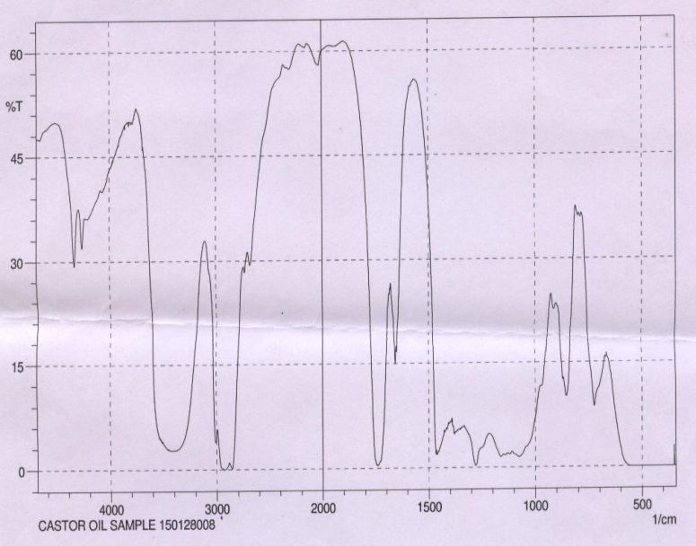
Figure-4 FTIR of Castor Oil
It was found that a absorption peak at 3400 cm⁻¹ represents a strong stretching band of primary –OH group. Absorption peak at 1740 cm⁻¹ represents stretching vibration of C=O group, also the peak at 2820 cm⁻¹ to 2980 cm⁻¹ represents bands of C-H stretching and the absorption band at 1480 cm⁻¹ indicates bending in CH₂ group. Following figure.4 gives the FTIR of PU having CO:TDI molar ratio 1:1.
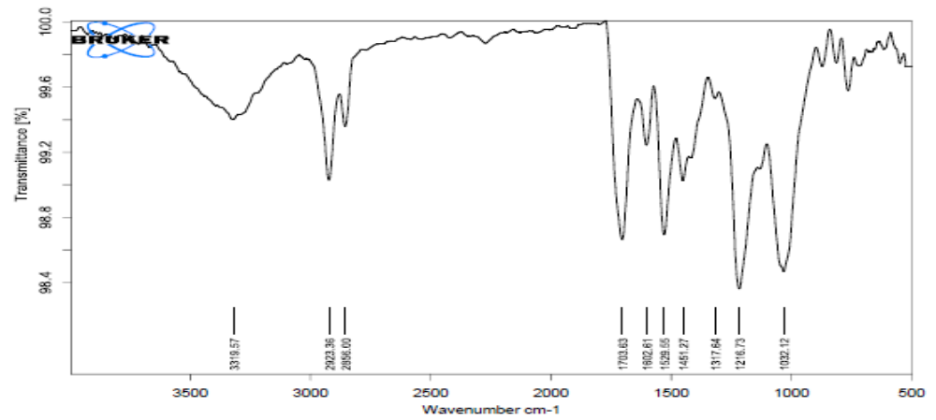
Figure 5 –The main IR peak of PU (CO:TDI-1:1)
Figure 5 showed that the presence of 3319.57 cm⁻¹, N-H stretching bands of urethane linkage whereas 1703 cm⁻¹ represents the N-H bending of urethane group. This was consistent with reaction between –NCO and –OH, showing the successful synthesis of PU coatings.
3.2 To study the effect of concentration of castor oil and TDI on the properties of PU coating
Table 8. The effect of concentration of castor oil on the properties of PU coating
NCO:OH | Scratch hardness  (gms) | Pencil hardness | Adhesion Test  % | Pencil thickness | Pot Life  (Min.)
1:0.8 | 900 | HB | 45 | 10 | 38
1:0.9 | 1200 | 2H | 85 | 10 | 42
1:1 | 1600 | 3H | PASS | 9.5 | 35
1:1.1 | 1300 | 2H | 75 | 10 | 44
1:1.2 | 1100 | 3H | PASS | 9.5 | 47

Table.8, shows that highest scratch hardness and adhesion were obtained at 1:1 (NCO : OH) molar ratio. The under crosslinking reaction has decreasing scratch resistance. Polyurethane film hardness increased with a larger hydroxyl number. Higher levels of hardness were due to higher crosslinking density formed in the polymer matrix.
Table-9 Effect of concentration of TDI on the properties of PU coating
NCO:OH | Scratch hardness  (gms) | Pencil hardness | Adhesion Test  % | Pencil thickness | Pot life  (Min.)
0.8:1.0 | 800 | 2H | 75 | 9.5 | 36
0.9:1.0 | 1300 | 2H | 85 | 10 | 40
1.0:1.0 | 1600 | 3H | PASS | 10 | 35
1.1:1.0 | 1700 | 3H | 85 | 9 | 42
1.2:1.0 | 1600 | 4H | PASS | 10 | 43

The effect of over-crosslinking the system will generally be to increase hardness and improve chemical resistance; in this case, the excess isocyanate groups react with atmospheric moisture. Reducing the ratio (under-crosslinking) will tend to give more flexible films with lower solvent and chemical resistance and reduced weathering performance. The pot life reduces with increase in molar concentration of TDI.
Table-10 Effect of % loading of DBTL on the properties of PU coating for undercrosslinking reaction
% Catalyst loading | NCO:OH | Scratch hardness  (gms) | Pencil hardness | Adhesion Test  % | Pencil thickness | Pot life  (min.)
0.05 | 0.8:1.0 | 800 | HB | 65 | 10 | 8
0.10 | 0.8:1.0 | 1000 | 2H | 85 | 10 | 7
0.15 | 0.8:1.0 | 1000 | 2H | PASS | 9 | 4

For the molar concentration 0.8:1.0 (NCO: OH) the pot life reduces due to increase in reaction rate. Also the scratch harness was reduces as compare to without catalytic reactions.
Table-11 Effect of % loading of DBTL when on the properties of PU coating for the stoichiometric reaction
% Catalyst loading | NCO:OH | Scratch hardness  (gms) | Pencil hardness | Adhesion Test  % | Pencil thickness | Pot life  (min.)
0.05 | 1.0:1.0 | 700 | HB | 90 | 10 | 8
0.10 | 1.0:1.0 | 1300 | 2H | PASS | 10 | 7
0.15 | 1.0:1.0 | 2000 | 3H | PASS | 10 | 5

For the molar concentration 1.0:1.0 (NCO : OH) the pot life reduces with respect to increase in % catalyst loading due to increase in reaction rate. Also the scratch hardness was increased as compare to without catalytic reaction coating.
Table-12 Effect of % loading of DBTL on the properties of PU coating for the over-crosslinking reaction
% Catalyst loading | NCO:OH | Scratch hardness  (gms) | Pencil hardness | Adhesion Test  % | Pencil thickness | Pot life
0.05 | 1.2:1 | 1200 | 2H | PASS | 9 | 6
0.10 | 1.2:1 | 1700 | 2H | 75 | 10 | 4
0.15 | 1.2:1 | 2000 | 3H | PASS | 9.5 | 2

3.3 To Study The Chemical Resistance Properties
Table-13 Effect of concentration of castor oil on the chemical properties of PU coatings
NCO:OH | Sample code | Acid resistance  5% HCl | Alkali resistance  5% NaoH | Salt resistance  5% Nacl
1:0.8 | C₁ | 3 | 5 | 5
1:0.9 | C₂ | 4 | 5 | 5
1:1 | C₃ | 5 | 5 | 5
1:1.1 | C₄ | 5 | 5 | 5
1:1.2 | C₅ | 5 | 4 | 5

Table-14 Effect of concentration of castor oil on the chemical properties of PU coatings
NCO:OH | Sample code | Acid resistance  5% HCl | Alkali resistance  5% NaOH | Salt resistance  5% NaCl
0.8:1.0 | D₁ | 5 | 5 | 5
0.9:1.0 | D₂ | 5 | 5 | 5
1.0:1.0 | D₃ | 5 | 5 | 5
1.1:1.0 | D₄ | 4 | 5 | 5
1.2:1.0 | D₅ | 5 | 3 | 5
Table-15 Chemical Resistance of coating when the NCO: OH molar ration is 0.8:1.0
% Catalyst loading | Acid resistance  HCL 5% | Alkali resistance  5% NaOH | Corrosion resistance  5% NaCl
0.05 | 3 | 4 | 5
0.10 | 5 | 4 | 5
0.15 | 3 | 3 | 5
Table-16 Chemical Resistance of coating when the NCO:OH molar ration is 1.0:1.0
% Catalyst loading | Acid resistance  HCL 5% | Alkali resistance  5% NaOH | Corrosion resistance  5% NaCl
0.05 | 5 | 5 | 5
0.10 | 5 | 5 | 5
0.15 | 4 | 5 | 5

Table-17 Chemical Resistance of coating when the NCO : OH molar ration is 1.2:1.0
% Catalyst loading | Acid resistance  HCL 5% | Alkali resistance  5% NaOH | Corrosion resistance  5% NaCl
0.05 | 5 | 5 | 5
0.10 | 5 | 5 | 5
0.15 | 5 | 4 | 5

0 | Film completely removed | 3 | Loss of gloss
1 | Film cracked & partially removed | 4 | Partially loss of gloss
2 | Film partially cracked | 5 | Film practically unaffected

The position of the hydroxyl group affects its reactivity with isocyanate. Polyols with primary hydroxyl groups are more reactive than polyols with hydroxyl groups in the secondary position. This difference in reactivity determines the type of polyurethane applications. ^{[21]}

4. Conclusion
Polyurethane coating material can be made from isocyanate and Castor oil polyol that synthesized by polyaddition reaction. Test results indicate the type of polyol affect the hardness and adhesion of formed polyurethane film layer, while the types of isocyanates gave less significant effect. The PU coating obtained using DBTL catalyst had minimum pot life and better hardness and adhesion at the 1:1 (NCO : OH) molar ratio. These results demonstrate that Castor oil is potential to be developed as a polyurethane coating raw materials. Higher hydroxyl content in the polyol translates into higher crosslinking density, higher film strength and higher resistance to chemicals. Lower hydroxyl contents give better film elasticity. The isocyanate/hydroxyl molar ratio may be off-stoichiometric and is determined by trial and error. At low NCO/OH ratios (less than 1) the coating displays higher elasticity but lower solvent and chemical resistance. It should be emphasized that in two-component coatings, not all isocyanate groups react with polyol, and almost one third reacts with moisture from the surrounding air. This fact should be taken into account when adjusting NCO/OH ratio.
References
1. Suman Thakur, Niranjan Karak, Castor oil-based hyperbranched polyurethanes as advanced surface coating Materials, Progress in Organic Coatings 76 (2013) 157– 164.
2. I. Javni, W. Zhang, Z.S. Petrovic, J. Appl. Polym. Sci. 88 (2003) 2912–2916.
3. Q Bell, Solvent Borne Urethane Resins, Surface Coatings, Vol-1, Third Edition, Springer Science+Business Media Dordrecht Publication, pp. 153.
4. Patel N, Kansara S, Somani K and Raxit A. Polyol from castor oil and epoxy resin for PU coatings. European Coating Journal. 2003; 11:34-40.
5. Athawale VD and Kolekar SL. Comparative studies of castor and hydrogenated castor oil urethane/pmma semi and full IPNs. Journal of Macromolecular Science A: Pure and Applied Chemistry A. 1998; 35(12):1929-1940.
6. Mitesh Ramanlal Patela, Jignesh Markandray Shuklab, Natvarbhai Khodidas Patelb, Ketan Haribhai Patelb, Biomaterial Based Novel Polyurethane Adhesives for Wood to Wood and Metal to Metal Bonding, Materials Research, Vol. 12, No. 4, 385-393, 2009.
7. Krushna Chandra Pradhan, P.L.Nayak, “Synthesis and Characterization of PU Nanocomposite from Castor Oil Hexamethylene Diisocynate” Advance in Applied Science Research, 2012, 3 (5): 3045-3052.
8. Harjono1, Purwantiningsih Sugita2*), and Zainal Alim Mas’ud2, Synthesis and Application of Jatropha Oil based Polyurethane as Paint Coating Material, Makara Journal of Science 16/2 (2012) 134 140.
9. www.oilworld.de.
10. Eid A Ismail, A.M Motawie, E.M Sadek, “Synthesis and Characterization of polyurethane coatings based on soybean oil polyester polyols, Egyptian Journal of Petroleum, Elsevier publication, (2011) 20, 1-8.
11. Wicks, Z.W., Jones, F.N., and Pappas, S.P., (1999), Organic Coatings Science and Technology, Wiley Interscience, 2nd Ed., p.180
12. Hemul V. Patel, Jignesh P. Raval and Pradip S. Patel Hybrid polyurethane coating systems based on Renewable material, International Journal of ChemTech Research, ISSN : 0974-4290, Vol.2, No.1, pp 532-542, Jan-Mar 2010
13. P.Knaub, Y.Camberlin, European Polymer Journal 22 (8) 1986, 633-635
14. G.Qipeng, F.Shixia, Z.Qingyu, European Polymer Journal 26 (11), 1990, 1177-1180.
15. Y.Hamid, R.M. Mohammad , European Polymer Journal, 40(6) 2004, 1233-1238.]
16. A Chaudhari, V.Gite, S.Rajput, P.Mahulikar and R. Kulkarni, “Development of eco-friendly polyurethane coatings based on neem oil polyetheramide, “Industrial Crop and Products, vol. 50, pp. 550-556, 2013.
17. E. Sharmin, S. M. Ashraf, and S. Ahmad, “Synthesis, characterization, antibacterial and corrosion protective properties of epoxies, epoxy-polyols and epoxy-polyurethane coatings from linseed and Pongamia glabra seed oils,” International Journal of Biological Macromolecules, vol. 40, no. 5, pp. 407–422, 2007.
18. S. Ahmad, S. M. Ashraf, E. Sharmin, F. Zafar, and A. Hasnat, “Studies on ambient cured polyurethane modified epoxy coatings synthesized froma sustainable resource,” Progress in Crystal Growth and Characterization of Materials, vol. 45, no. 1-2, pp.83–88, 2002.
19. P. D. Meshram, R.G. Puri, A. L. Patil, and V. V. Gite, “Synthesis and characterization of modified cottonseed oil based polyesteramide for coating applications,” Progress in Organic Coatings, vol. 76, no. 9, pp. 1144–1150, 2013.
20. N.Karak, S.Maiti, Dendrimers and Hyperbranched Polymers: Synthesis to Applications, MD Publication, New Delhi, 2008.
21. Harjono, Purwantiningsih Sugita, and Zainal Alim Mas’ud, Synthesis and Application of Jatropha Oil based Polyurethane as Paint Coating Material, Makara Journal of Science 16/2 (2012) 134 140.

