Cationic Porphyrin Induced B-Z Transition of AT-Rich DNA
Yun Jung Jang, Ph. D, College of Basic Education, Yeungnam University, Republic of Korea
Seog K. Kim, Ph. D. Department of Chemistry, Yeungnam University, Republic of Korea

Abstract (300 word limit)
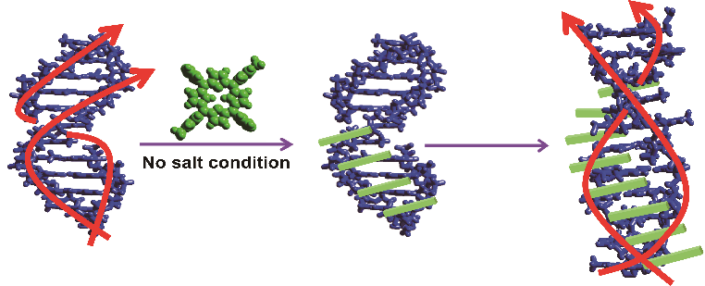
Cationic porphyrins interact with DNAs. Binding mode of porphyrins depends on various factors including nature of DNA sequences and the periphery substituents. Trans-bis(N-methylpyridium-4-yl) diphenyl porphyrin (trans-BMPyP) also bind to DNAs. Upon binding to poly[d(A-T)₂], typical circular dichroism (CD) spectrum in the DNA absorption region for B-form was reversed, suggesting formation of left-handed helical structure (Z-form). The formation of Z-form was confirmed by ³¹P NMR, in which a single ³¹P peak of B-form was split into two peaks, reflecting two distinctive environment for the DNA phosphate groups, which is typical for Z-form DNA. Trans-BMPyP-induce B-Z transition occurred specifically for polynucleotide having alternated AT sequences. No other combination of nucleobase sequence produced similar B-Z transition. This observation is in contrast with typical DNA sequence, alternating GC sequence (poly[d(G-C)₂]), that exhibits the B-Z transition. Cationic porphyrin has been known to intercalate between GC base pairs, while they stack along AT-rich DNAs. Pattern of stacking along DNA stem may be an important factor for this alternating AT sequence-specific B-Z transition. B-Z transition of alternating AT sequence requires at least 14 base-pairs, supporting the importance of porphyrin stacking along AT stem. The position of cationic ion on the periphery methyl pyridine ion also takes an essential role. When the methyl group locates at meta- or para-position, both cationic porphyrins similarly induce B-Z transition, while that at ortho-position, in which free-rotation of pyridine ring is sterically prevented, did not. This observation also indicated the importance of stacking of porphyrins along poly[d(A-T)₂] stem, because the former two porphyrins can be planar, therefore can stack each other. On the other hand, ortho-trans-BMPyP cannot be planar and stacking is inefficient.
Figure 1. Schematic diagram for B-Z transition of poly[d(A-T)₂] induced by stacking of porphyrins.

Image

Recent Publications (minimum 5)
- Hwang YM, Kwon N, Kim SK, Jang YJ (2017) Chiral selective stacking of a cationic porphyrin along poly[d(A-T)₂]. J. Phys. Chem. B 121: 2104-2110.
- Shin JH, Hwang YM, Jang YJ, Kim SK (2016) Length and sequence effect on the formation of Z-form [d(A-T)₂] oligonucleotide induced by a cationic porphyrin Biophys. Chem. 219: 38-42.
- Jang YJ, Lee C, Kim SK (2015) Formation of poly[d(A-T)₂] specific Z-DNA by a cationic porphyrin. Sci. Rep. 5: 9932; DOI: 10.1038/srep09943.
- Kim HJ, Kim K, Park J, Jin B, Kim SK (2014) Effect of various intercalators and minor groove binding ligands on the Fenton-type oxidative cleavage of double-stranded DNA. Chem. Asian J. 9: 1341-1348.
5. Choi J, Park J, Tabaka A, Park MJ, Jang YJ, Fujitsuka M, Kim SK, Majima T (2013) Hole-trapping of G-quarts in G-quadruplex. Angew. Chem. Int. Ed. 52: 1134-1138.

 Yoon Jung JangBiography (150 word limit)
Yun Jung Jang has her expertise in ligand-DNA interaction and synthesis of metal complexes that interact with DNA. Her main methodology to investigate drug-DNA interaction are polarized spectroscopies and various fluorescence techniques. She obtained her Ph. D. degree at Daedu Catholic University and worked for years in Yeungnam University as research assistant professor in the DNA-drug interaction field. She became assistant professor in the College of Basic Education, Yeungnam University.
Seog K. Kim has been investigating binding mode of various drugs, including cationic porphyrins with DNA and cleavage of DNA by various chemicals since his graduation from the Chemistry Department, New York University. His spemt three years in Chalmers University of Technology, Sweden as post-doc and assistant professor.
Email: drXXXXXXX@xxxmail.com

Notes/Comments:

