Powder cellulose nanocrystal (CNC) from industrial waste offcut cotton textile for a new sustainable nanofiller
Toshihiko Arita, PhD, Tohoku University, Japan

Abstract (300 word limit)
Nano-sized cellulose has been collecting tremendous attention from polymer industry because of its environmentally friendly and sustainable nature as an industrial material. In addition, the physical properties such as superior physical strength, light density, and large aspect ratio of nano-cellulose are quite attractive for application as a novel reinforcing filler for polymers. Recently, we have developed a new procedure to obtain fine cellulose nanocrystal (CNC) powder preventing strong cornification on drying to form an irreversibly aggregated solid film by simple solvent exchanging from water to nonpolar organic solvent before homogenization of cellulose hydrolysate [1].
In this study, we have studied more eco- and sustainability friendly raw material for CNC powder. That is offcut cotton textile, an industrial waste from shirts production. Offcut cotton textile was acid hydrolysed by hydrochloric acid and obtained cellulose hydrolysate is immersed in toluene. A slurry-like suspension was obtained via a homogenization. After simple air-drying of the slurry, fine powder similar to degreased cotton was employed as a raw material was successfully obtained. The newly developed CNC powder can be sustainable, eco-friendly, promising nanofiller for polymers.

Image
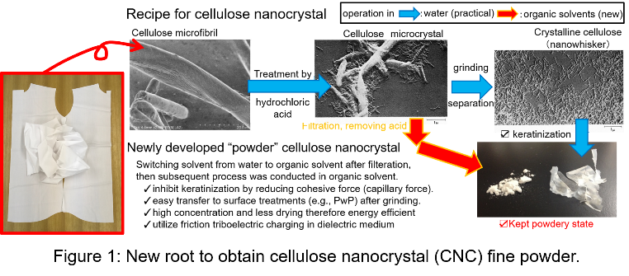
Recent Publications (minimum 5)
- Araki J, Arita T (2017) Production of Ultrafine Dry Powders of Surface-intact and Unmodified Cellulose Nanowhiskers via Homogenization in Nonpolar Organic Solvents. Chemistry Letters 46:1438-1441.
- Shito K, Matsui J, Takahashi Y, Masuhara A. Arita T (2018) Proton Conductivity of Poly(acrylic acid)-b-Polystyrene-coated Silica Nanoparticles Synthesized by Reversible Addition-Fragmentation Chain Transfer Polymerization with Particles. Chemistry Letters 47:9-12.
- Arita T, Kanahara M, Motoyoshi K, Higuchi T, Yabu H (2013) Localization of polymer-grafted maghemite nanoparticles in a hemisphere of Janus polymer particles prepared by a self-organized precipitation (SORP) method. Journal of Material Chemistry C 1:207-212. Journal Cover Article
- Arita T (2013) Efficient Production of Block-copolymer-coated Ceramic Nanoparticles by Sequential Reversible Addition-Fragmentation Chain-transfer Polymerizations with Particles (SqRAFTwP). Chemistry Letters 42:801-803. Selected as an Editor’s Choice
- Arita T, Manabe N, Nakahara K (2012) Instant and supersaturated dissolution of naproxen and sesamin (poorly water-soluble drugs and supplements) nanoparticles prepared by continuous expansion of liquid carbon dioxide solution through long dielectric nozzle. Journal of Nanoparticle Research 14:Artice Number 1251.
- Arita T (2010) Coating and dispersion of ceramic nanoparticles by UV-ozone etching assisted surface-initiated living radical polymerization. Nanoscale 2:2073-2076

Biography (150 word limit)
Dr Arita completed his doctorate in physical chemistry at Kyoto University in 2003. After his graduation of Kyoto University, he started physical chemistry of polymers in Goettingen University as a postdoc fellow. He also spent his days in Institute for Chemical Research of Kyoto University as a post doctoral fellow. Dr. Arita currently belongs to Institute of Multidisciplinary Research for Advanced materials of Tohoku University as an Assistant Professor from 2007. He have been mainly studying polymer-surface-functionalized fillers produced by Polymerzation with Particles (PwP) technique[4] invented by himself.
Email: tarita@tohoku.ac.jp

Notes/Comments:

I had received an invitation letter for Keynote Speaker from Mr. Michael Koch on 31st. July. Please accept my abstract as a Keynote Speaker or at least, an Invited speaker.

