Novel Eco-Pallets Based on Natural Plant System
Xiaobin Zhao, PhD, CAMBOND LTD, Cambridge, UK

Pallets have been called the single most important object in the global economy [1]. More than four billion pallets are in use across the world with 1.8 billion manufactured annually. Nowadays, wood has more than 90% of the world pallet market, while plastics account for 10%, according to industry estimates. Pallet manufacture uses more than 100 million tonnes of wood per year, which is a considerable drain on forest resources. For plastic pallets, it consumes oil and also very expensive. Cambond has patented a technology platform to develop a plant based, formaldehyde-free bio-adhesive for wood panel industry [2-4]. In addition to apply the technology for wood composite materials, Cambond has extended its technology to a detailed research on making plant-based bio-composite using various agricultural ‘waste’ biomass. The bio-composite material can be used to produce an innovative lightweight, high performance, and CO₂ negative sustainable Eco-Pallet products from this green adhesive and bio-renewable wastes [Fig.1]. The products demonstrate a smooth surface, light weight, high performance and microbial and moisture resistance structure. The selected plant material wastes for this study include bamboo, jute, wheat fibers, rice straw fibers and reed fibers. The end products will be a low cost and environmental-friendly alternatives to traditionally used synthetic plastic pallets and wood pallets to meet industrial standards [5].

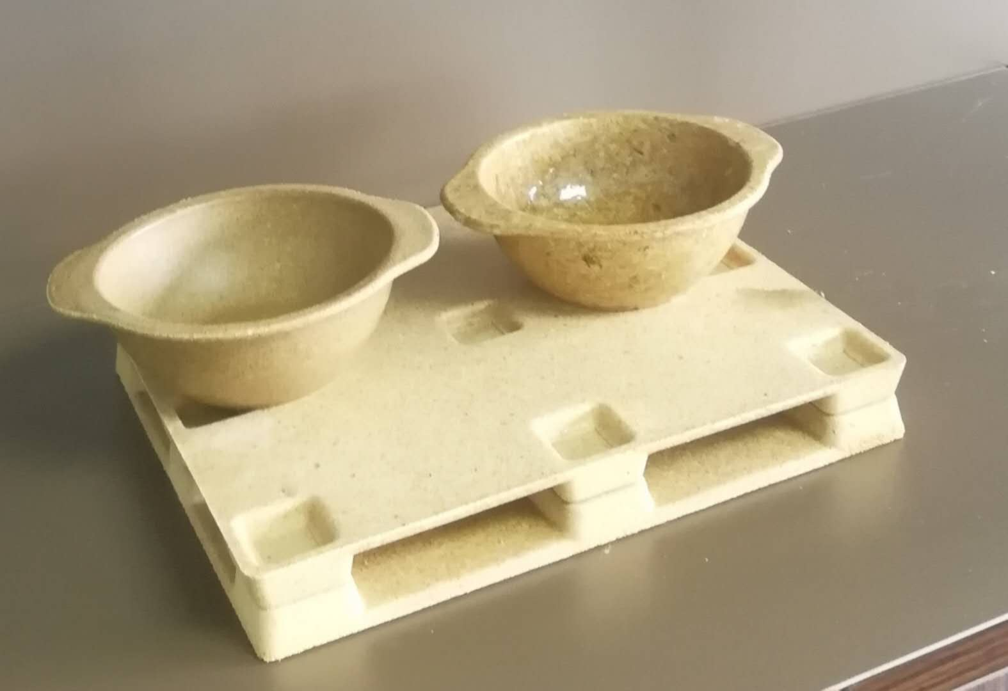
Figure1 Bio-composite products based on natural plant system
Recent Publications
- https://slate.com/business/2012/08/pallets-the-single-most-important-object-in-the-global-economy.html
- Xiaobin Zhao, Biomass‐Based Formaldehyde‐Free Bio‐Resin for Wood Panel Process, in Chapter 6, Handbook of Composites from Renewable Materials, eds by Vijay Kumar Thakur, Manju Kumari Thakur, Michael R. Kessler, Published by Scrivener Publishing & Wiley. 18 July 2017, PP129-149.
- Xiaobin Zhao , Green glue – biomass based formaldehyde-free bio-resin for wood panel processes, PP41-51, International Panel Products Symposium 2015 (IPPS2015), Bangor University, United Kingdom 2015.
- Xiaobin Zhao, Application of Formaldehyde-free rein-enforced bio-composite materials in manufacturing no-added formaldehyde wood panel-CAMBONDTM formaldehyde-free bio-composite, International Wood Industry， 9, 2016 PP 52-53
- MA Test report on Cambond pallet against Industrial Standard, Tianjin CPRTC, 17, 07,2017

 Prof. Xiaobin Zhao: Co-Founder/CEO for Cambond Ltd. Obtained his BSc in Polymer Chemistry and MSc in Biomaterial Science in Nanjing University, China and PhD in Bioengineering Unit, University of Strathclyde in Glasgow. He has been working in the UK biomaterial industry since 1998. He is the inventor of Double X-Linking Technology (DXLTM) for Mentor Corporation, J&J and bio-adhesives for wood panel industry in Cambond. He has successfully commercialized more than 10 products globally. He is a UK chartered chemist and a Fellow of Royal Society of Chemistry, Fellow of Institute of Materials in UK and Society for Biomaterial in USA. He has published more than 60 scientific papers, book chapters and gained more than 30 patents on his name worldwide. He holds visiting professorship at University of Strathclyde and visiting professorship in both Changzhou and Lanzhou University in China.

Email: xzhao@cambond.co.uk

