Effect of HPMC and ethyl cellulose polymeric granules and its combinations in press coated tablets of Lornoxicam: fabrication and in vitro characterization:
Dr. V Rama Mohan Gupta, Principal & Professor, Pulla Reddy Institute of Pharmacy, Jawaharlal Nehru Technological University, Hyderabad, India- 502313.

Abstract (300 word limit)
The main objective of the present exploration was to formulate and evaluate chronomodulated press-coated tablets to deliver the NSAID lornoxicam, when a pain in the joints, functional disability persist in the early morning time is typically observed in most Rheumatoid arthritis (RA) patients. Pre formulation studies and drug excipient compatibility studies were carried out for lornoxicam and excipients. Core tablets containing lornoxicam was prepared by direct compression method and the tablets were subjected to various pre-compression and post-compression parameters (C1-C4 formula) based on the above result best core tablet batch was selected and used for press coating processes. HPMC and EC granules were used as controlled release polymers in the outer layer. These tablets were subjected to pre and post compression parameters, finally the tablets were evaluated for lag time and in vitro dissolution.
Results of preformulation studies were acceptable limits. No interaction was observed between lornoxicam and excipients by FTIR. The results of pre and post compression studies were within limits. Formulation code CC3 was identified as best formulation that extends a release profile with 6 h lag time followed by complete lornoxicam release after 8 h. From the graphical representation it can be well perceive that this is perfectly fit in to Korsemeyer which had a Regression coefficient (R2 ) of 0.9431. The results of the in-vitro release data of this layer were fitted to the Korsemeyer-Peppas equation to examine the release pattern of the drug from the polymeric system. The drug release was identified as super case II transport as the “n” value found to be more than 0.89.

Image
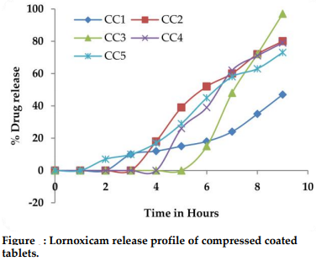
Recent Publications (minimum 5)
- Nikunja B Pati, Velivela S, Mayasa V and Dr. Gupta VRM. Formulation and Evaluation of Chronomodulated Press-Coated Tablets of Tapentadol HCl. Asian Journal of Pharmaceutical Sciences; 2018; 12 (1):S66.
- Swapna Velivela, V. Ramamohan Gupta. Spherical crystallization: A novel technique in drug particle designing. World Journal of Pharmacy and Pharmaceutical Sciences; 2018; 7 (10):363-76.
- Nikunja B. Pati, Dr. V. Ramamohan Gupta, Swapna Velivela. Formulation and Evaluation of Press-Coated Tablets of Tramadol. Research J. Pharm. and Tech 2018; 11(9): 4129-4134.
- Dr. V. Ramamohan Gupta. A Novel Pharmacological approach of herbal mediated cerium oxide and silver nanoparticles with improved biomedical activity in comparison with Lawsonia inermis. Colloids and surfaces B: Biointerfaces. January 2019. 174:199.
- Dr. V. Ramamohan Gupta. Recent Approaches in the Development of Phytolipid Complexes as Novel Drug Delivery. Current Drug Delivery. 2018; 15(6):755.

Biography
Dr. V. Rama Mohan Gupta, has his expertise in the development of “Spherical agglomerates, Proniosomes, microspheres and different types Nanocarriers systems to target different organs. He has worked on many solubility enhancement techniques, formulation development and in vitro-in vivo characterization studies for various drugs during his Ph.D. research work. Presently he has guiding many research scholars who are working on Chronotherapeutics, Targeted and various controlled release drug delivery systems.
Apart from this he is serving as Principal and HOD of Pharmacy colleges from past 15 years. He is serving as president-elect of India-Telangana ISPOR Regional chapter, involved in disseminating the knowledge of Pharmacoeconomics, drug use and patient centered outcomes. He has published nearly 94 research publications in various national and international journals.
Email: vrmgupta_05@yahoo.co.in

