Novel Carbon Nanotubes Material in Amperometric Glucose Biosensor
Soheli Farhana, PhD
MIIT, UniKL, Kuala Lumpur, Malaysia

Abstract
The development and the performance of biosensors depend on a large degree on the materials employed for their construction. They also depend on the physicochemical characteristics of the materials employed for the construction of the transducer, the matrices used for the enzyme immobilization, the stabilizers and the mediators. It is well known that one of the limiting factors impeding the large-scale employment of biosensors, is the unacceptably low sensor-to-sensor reproducibility and bad signal stability. On the other hand, carbon nanotubes (CNTs) are one of the novel materials with nano-structure. They are promising as an immobilization substance because of their significant mechanical strength, high surface area, excellent electrical conductivity and good chemical stability. In this paper, an amperometric glucose biosensor is developed that is based on immobilization of glucose oxide (GOD) in a composite film of poly (o-aminophenol) (POAP) and Carbon nanotubes (CNT), which are electrochemically co-polymerized at gold (Au) electrode. Because of the high surface per volume ratio and excellent electrical conductivity of CNT, the biosensor based on an Au/POAP/CNT/GOD electrode has lower detection limit (0.01mM), larger maximum response current (0.24mAcm-2) and higher sensitivity (11.4mA M-1cm-2) than the values of the biosensor based on an Au/POAP/GOD electrode.
Additionally, the sensor exhibits excellent performance, including relatively low detection limit, large current density, fast response time, high sensitivity and good stability.
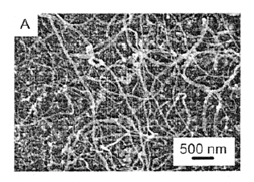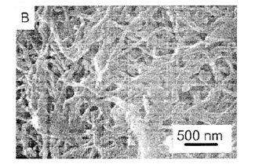
A.SEM image of CNT B. POAP/CNT modified electrode
Figure 1: CNT synthesis by chemical vapor deposition method (CVD.
Recent Publications
- Zhang, E., Xie, Y., Ci, S., Jia, J., & Wen, Z. (2016). Porous Co3O4 hollow nanododecahedra for nonenzymatic glucose biosensor and biofuel cell. Biosensors and Bioelectronics, 81, 46-53.
- Devasenathipathy, R., Mani, V., Chen, S. M., Huang, S. T., Huang, T. T., Lin, C. M., ... & Chen, B. J. (2015). Glucose biosensor based on glucose oxidase immobilized at gold nanoparticles decorated graphene-carbon nanotubes. Enzyme and microbial technology, 78, 40-45.
- Lai, J., Yi, Y., Zhu, P., Shen, J., Wu, K., Zhang, L., & Liu, J. (2016). Polyaniline-based glucose biosensor: A review. Journal of Electroanalytical Chemistry, 782, 138-153.
- Soni, A., & Jha, S. K. (2015). A paper strip based non-invasive glucose biosensor for salivary analysis. Biosensors and Bioelectronics, 67, 763-768.
- Jiang, B., Zhou, K., Wang, C., Sun, Q., Yin, G., Tai, Z., ... & Zhang, L. (2018). Label-free glucose biosensor based on enzymatic graphene oxide-functionalized tilted fiber grating. Sensors and Actuators B: Chemical, 254, 1033-1039.
- Liu, A., Lang, Q., Liang, B., & Shi, J. (2017). Sensitive detection of maltose and glucose based on dual enzyme-displayed bacteria electrochemical biosensor. Biosensors and Bioelectronics, 87, 25-30.

Biography
Dr. Soheli Farhana has completed her PhD in engineering from International Islamic University Malaysia and postdoctoral fellowship from International Islamic University Malaysia, Malaysia. She was the visiting researcher at ONE Lab, MIT, MA, USA. She has published several articles in reputed journals and has been serving as an editorial board member of reputed journals. Dr. Farhana is also serving as the committee member in several conferences. She is the reviewer of IEEE Transaction on Power Electronics and some relevant journals in Springer publication. Currently, Dr. Farhana is working as a visiting research professor at MIIT, UniKL, Kuala Lumpur, Malaysia.
Email: farhanas@unikl.edu.my

Notes/Comments:

