The Role of Solar activities on the Earth’s atmosphere and Global Climate Change
R. K. Mishra¹ and S.C.Dubey²
¹Department of Physics, A.P.S. University, Rewa(M.P.) Pin-486003, India.
E-mail ~ rakesh_response@rediffmail.com
²Department of Physics, S.G.S. Govt. P.G. College, Sidhi (M.P.) Pin-486661, India.
E-mail ~ subhas1236@rediffmail.com

Abstract
The role of Sun in recent global warming and projections for its future influence in the context of man-made climate change has been analyzed. Energy receiving from Sun, in the form of electromagnetic radiation is the fundamental driver of the Earth’s climate system. The total solar energy hitting the Earth depend on its distance from the Sun and therefore on the ecliptically, but the distribution of the radiation over the globe depends on the tilt and precession. The amount of energy arriving in summer at high latitudes determines whether the winter growth of the ice cap will recede or wetter the climate will be precipitated in to an ice age. Thus change to seasonal irradiance. The total solar energy hitting the Earth depends on its distance from the Sun.The Sun has an effect on climate byits radiation and the main energy source of our Planet. Space weather may also in long term effect the Earth climate. Solar ultraviolet, visible and heat radiation are primary factor for Earth’s climate. Sunspots have been recorded through several hundreds of year and many scientists observed correlation between the solar magnetic activity, which reflected in the sunspot frequency, and climate parameter at Earth. 70-90 year oscillation in global mean temperature is correlated with corresponding oscillation in solar activity. The role of Sun also had been providing the Earth with energy for billions of years.
Introduction
The Sun is the major source of energy for Earth’s ocean, atmosphere, land, and biosphere, averaged over an entire year approximately 342 watts of solar energy fall upon every square meter of Earth. As a comparison, large electric power plants produce about 1 billion watts of power to be exact. The total amount of energy Earth receives from the Sun and then subtract the total amount of energy each reflects and emits back to space, arrive solar energy is called energy budget. Sun’s energy enter Earth’s atmosphere make it to the surface. The atmosphere reflects some of the incoming Solar energy back to space immediately and absorbs still more energy before it can reach the surface. The remaining solar energy strikes Earth and warms the surface.

The amount of change from season to season varies depending on the planet’s surface. Near the equator, the amount of solar energy received stays fairly constant throughout the year and there is not much difference between summer and winter. In contrast, areas near the poles experience significant differences between summer and winter. In the hemisphere where it is summer, the pole points toward the Sun and receives almost as much energy as the equator. Meanwhile, in the winter hemisphere, the pole points away from the Sun, and high latitudes receives little if any solar energy, given enough time and bearing outside influences, Earth’s climate system will naturally distribute heat evenly over Earth’s surface. Winds and ocean currents help to achieve this balance.in the winter hemisphere, there much more heat energy concentrated in the tropics than there is at pole.
The Sun and Climate
The solar activity has disastrous impact on Earth space environment. The most direct influence would come if the change meant a rise or fall in the total energy the Sun radiated upon the Earth, called “Solar Constant”. The solar energy flow from Sun’s surface to Earth’s enables our life by heating the planet, fueling photosynthesis to plant and powering the interaction among Oceans, Land and atmosphere. Sun energy flow from the solar surface enables our life to generate weather and climate.

Solar ultraviolet (UV) light is absorbed above the Earth’s surface and causes increasingly larger variations in the atmosphere. Light emitted from the Sun’s outer atmosphere, creating within it the ionosphere, layer of ionized gases. Light emitted from the Sun’s lower atmosphere is absorbed in the Earth’s middle atmosphere where it creates the ozone layer. Ozone layer protects us from UV radiation that can damage cells in the plants and animals an in us. Ozone layers absorption of solar UV light heat the atmosphere there making it warmer and reversing its cooling trends with altitude away from the surface. The ozone layer protects us from UV radiation that can damage cells in plants and animals and in us. Space between the Sun and Earth empty, but charged particles and magnetic field are there called heliosphere. A solar wind of plasma by expanding atmosphere,can dramatically affect the geo-space region around the Earth. Sometimes, the solar wind can made geo-space so, complex that fewer particles from the galaxies reach tree rings and ice cores. The changed over the past 10,000 years, solar constant is often called the solar constant or the total solar irradiance(TSI). It is 1362W/m² is space environment shows us that the total brightness changes in harmony with sunspot number. Onaverage, when the sunspot number is larger, the energy from the Sun is also larger the change together through –out the Sun’s 11-year activity cycle. The bright faculae more than compensate the reduction by dark sunspots. The change in the total brightness between the maximum and minimum of the sunspot number is about 0.1% this value depends strongly on the wavelength. The variability of solar UV light is much than 0.1% fluctuation in the Sun’s energy ceaselessly agitate the Sun-Earth system with condense near 11 years, when solar activity increases, the total energy out but increases and the terrestrial responses to solar activity increases naturally with altitudes, the global temperature near Earth’s surface increased by about 0.1˚ C during the Sun’s 11-year activity cycle, however, the larger cycles of UV produces temperature changes of 1º at an altitude of 50 km near 400 kmthe temperature increase a 500º response to fluctuations in UV Light. Solar activity models can only roughly reproduce their response to solar variability, drought and rainfall also seem related to solar variability these phenomena may also affected by the Sun. Changes in the ocean circulation that can occur with solar cycle. The upper atmosphere beyond the Earth’s surface is susceptible to more immediate effects of Sun-Earth variability. Solar flare eruptions, energetic particles can damage space-based technological systems and threaten the health of astronauts and airplane passenger over Polar Regions. Solar–driven atmosphere-density fluctuation can alter the orbits of satellites in low-orbits of satellite in low-earth orbit. Solar flares also interrupt wireless navigation and communication by altering the electron density in the ionosphere. Induced ground currents can weaken the electric grid and oil pipeline-potentially causing serious failure.
Anthropogenic Influence
The anthropogenic influence on global change, first the influence of the natural factors can be internal (volcanic eruption, atmospheric modes of variability) or external (solar variability, distant stars bursts, passage of the solar system through clouds of galactic dust). Sun is the only big external source of energy which could affect the climate. It well known that the eccentricity, axial tilt, and precession of the Earth’s orbit lead to long–term (~100,000 year) variation of total energy received from the Sun (Milankovich cycle) and respectively in the terrestrial temperature. On shorter time scale, from decades to centuries: the reason for solar-induced changes in different manifestation of solar activity and their relation to global change. The most obvious solar parameter influencing the Earth’s climate is the solar irradiance. Direct measurements in the last 30 years have shown that the total solar irradiance solar cycles (Frohlich, 2005).The Sun has an effect on climate since its radiation is the main energy source for the outer envelope of our planet. There is a long standing controversy on weather solar variability can generate climate change the role of solar activity in climate change – such as the Quatermary glaciations or the present global warming- remains unproven and most probably represents a second order effect. That solar change have contributed to small climate oscillation occurring on time scale of few centuries , similar in type to the fluctuation s classically described for the last millennium ; the so called Medieval warm period (900-1400 A.D.) followed on by the Little Ice age (1500-1800A.D.)
Anthropogenic activity may affect higher atmosphere layer in the mesosphere, thermosphere and ionosphere. The global electric circuit is closed by current flowing in the ionosphere, at high latitudes; within the polar cap, these currents are strongly influenced by parameter of the solar wind, particularly the direction of interplanetary magnetic field.in the aurorral zone, the ionosphere is markedly disturbed when the magnetosphere is buffeted by cloud of solar wind of enhancing density which associated with huge coronal mass ejections events from the Sun. as a result, the potential difference across the polar cap ionosphere can vary markedly. The measurement techniques applied in magnetosphere and ionosphere research enable the detection of strong, intrinsic effects of the solar wind/ionosphere on the electrical potential disturbances and conductivity of the atmosphere (Michnowski, 1998). Price and Rind (1990) first proposed the possibility that changes in the Earth’s climate could result in more lighting activity and the global electric circuits have been shown to be closely related to important climate parameters.
Sunspot and Climate
Sunspots are cool dark regions on the solar surface with strong magnetic fields. There have been few direct measurements of changes in the physical parameters of sunspots, but there have been few direct measurements of changes in the physical parameters of sunspots, but sunspots becoming warmer and have weaker magnetic fields. The number of sunspots visible on the Sun normally shows an 11-year periodicity, and the sunspot cycle had maximum and is entering a minimum phase with few sunspot currently visible. The 11 year periodicity vanished and there were virtually no sunspots visible on the solar surface. Recent studies of the appearance rate and the latitudinal drift of sunspot (Hathway et al, 2004) and of the solar magnetic field(Svalgaard et al, 2005). Sunspot during 1861-1989 shows a remarkable parallelism, with the simultaneous variation in northern hemisphere means temperature (Friss-christensen et al, 1991). There is an even better correlation with length of the solar cycle, between years of the higher numbers of sunspots. Sunspot affects the Earth’s climate by total solar irradiance received by Earth. Intuitively one may assume the total solar irradiance would decrease as the number of (optically dark) sunspots increased. However, direct satellite measurements of irradiance have shown the opposite to be the case. This means that more sunspots deliver more energy to the atmosphere, so that global temperature should rise. According to current theory, sunspots occur in pairs as magnetic disturbances in the convective plasma near the Sun’s Surface. Magnetic field lines emerge from one sunspot and re-enters at the other spot. Also, there are more sunspots during periods of increased magnetic activity at that time more highly charged particles are emitted from the solar surface, and the Sun emits more UV and visible radiation. Polar auroras are magnificent in years with numerous sunspots, and the aurora activity varies in phase with number of sunspots. Auroras are faint and rare when the Sun magnetically quiescent, as during Maunder minimum. the periodicity of sunspot number, and hence that of the circulation in the solar plasma, relates to the rotation of the Sun about the center of gravity of visible solar system, taking 11.1 years on average. Sometimes the Sun is up to a million kilometers from the center, and sometimes it more or less coincides, leading to different conditions of turbulences within the photosphere. The transition from one condition to the other affects the number of Sunspots. The increased brightness of the Sun tends to warm the Earth, but also the Solar wind shields the atmosphere from cosmic rays, which produced 14C. So there is more14C when the Sun is magnetically quiescent. Recent satellite measurement of solar brightness, analyzed by (Wilson ,1997) show increase from the previous cycle of sunspot activity to current one, indicating that the Earth is receiving more energy from the Sun. Wilson indicates that if current rate of increase of solar irradiance continues until the mid 21thcentury, then the surface temperatures will increase by about 0.5 ºC.
Total Solar Irradiance
The total solar irradiance (TSI) is the amount of solar radiative energy incident on the Earth’s upper atmosphere. The total solar irradiance (TSI) is integrated solar energy flux over the entire spectrum which arrives at the top of the atmosphere at the mean Sun-Earth distance. The TSI observations show variations ranging from a few days up to the 11-year SC and longer timescales (Lockwood and Fröhlich, 2008). TSI has been monitored from 1978 by several satellites, e.g. Nimbus 7, Solar Maximum Mission (SMM), the NASA, Earth Radiation Budget Satellite (ERBS), NOAA9, NOAA 10, Eureca and the UARS (Upper Atmospheric Research Satellite) etc. The Solar Radiation and Climate Experiment (SORCE), a NASA-sponsored satellite mission was launched to measurements of TSI. SORCE carries four instruments including the Spectral Irradiance Monitor (SIM), Solar Stellar Irradiance Comparison Experiment (SOLSTICE), Total Irradiance Monitor (TIM), and the XUV Photometer System (XPS). The TIM is TSI measurements monitor the incident sunlight to the Earth’s atmosphere using an ambient temperature active cavity radiometer. The historical reconstruction of TSI absolute value is described by Kopp and Lean (2011) based on new calibration and diagnostic measurements by using TIM V.12 data on 19th January 2012, and is updated annually. TSI are known to be linked to Earth climate and temperature. The historical reconstruction of TSI and their association with 11-year sunspot cycle from 1700 onwards are shown in Figure 1. From the plot, it is find that TSI variation trend follows with SSN within a limit but centurial variation trends of TSI have not shown clear association. Linear variation of TSI for last 311 years shows continuously increasing trend. It is find that decadal TSI variation trend follows with SSN within a limit, except Maunder Minimum period. The centurial variation trends of TSI have not shown clear association. Surface temperatures and solar activity both increased during the past 400 years, with close associations apparent in pre- and post-industrial epochs (Lean et al., 1995; Reid, 1997). However, the inference from correlation studies that Sun-climate relationships can account for a substantial fraction of global warming in the past 150 years is controversial.

Figures 1 Shows the long-term variation of TSI and yearly mean SSN, during 1700 onwards.

TSI are known to be linked to Earth climate and temperature. Accurate TSI measurements from the last 25 years are correlated with sunspots and faculae. These correlations can then be used to extrapolate the TSI to time periods prior to accurate space-borne measurements, since the solar records extend back 100 years for faculae and 400 years for sunspots. Proxies of the TSI based on sunspot observations, tree ring records, ice cores, and cosmogenic isotopes have given estimates of the solar influence on the Earth that extend back thousands of years, and correlate with major climatic events on the Earth. This extrapolation is important for understanding the relationship between TSI and the Earth’s climate. The variation of TSI from 1976 onwards and their association with yearly mean SSN is shown in Figure 2. We find that variation trend of TSI follows with 11-year SC’s.

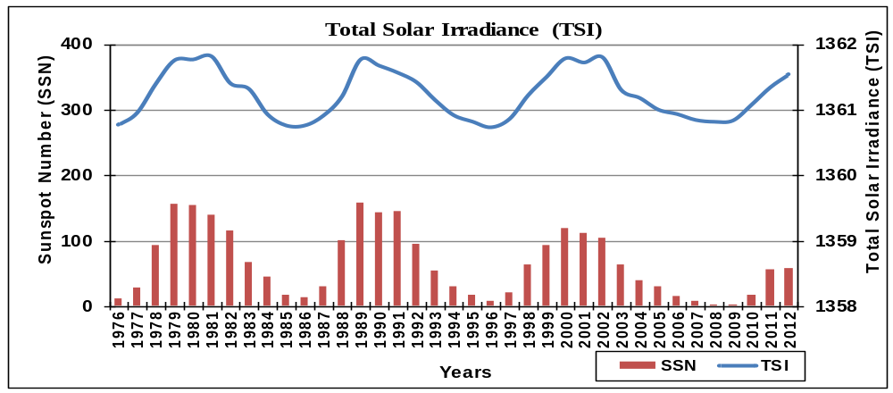
Figure 2 Showsthe variation of TSI measured by several satellites (composite) from 1976 onwards and their association with yearly mean sunspot number.
Solar Radio Flux (SRF)
The SPEs events are the energetic outbursts as a result of acceleration and heating of solar plasma during SFs and CMEs. SPEs events associated with SFs are called impulsive where as those associated with CMEs are gradual. SPEs events occur when high-energy protons are ejected from the Sun’s surface during fast solar eruptions and causes geomagnetic and ionospheric disturbances on large scale. These effects are similar to auroral events, the difference being that electrons and not protons are involved. These events typically occur at the north pole, south pole, and South Atlantic magnetic anomaly, where the Earth’s magnetic field is lowest. The Sun emits radio energy with slowly varying intensity. Solar radio flux (SRF), which originates from atmospheric layers high in the Sun’s chromosphere and low in its corona, changes gradually from day to day in response to the number of sunspot groups on the solar disk. SRF from the entire solar disk at a frequency of 2800 MHz has been recorded routinely by radio telescope near Ottawa since February 1947. Associations of SRF with annual mean SSN for the period 1976 onwards are plotted in Figure 3. We find that the yearly occurred value of SRF varies with 11-year SC as similar as variation of other solar transients. A difference between the first and second maxima for SC on the one hand and SRF on the other is intriguing. If the radio emission is associated with SSNs, the relative values of the first and second maximum should be similar, at least qualitatively, for both. However, decimetric frequencies would be from bremsstrahlung and may not follow SSNs. Between the radio emissions themselves, there is no consistency.
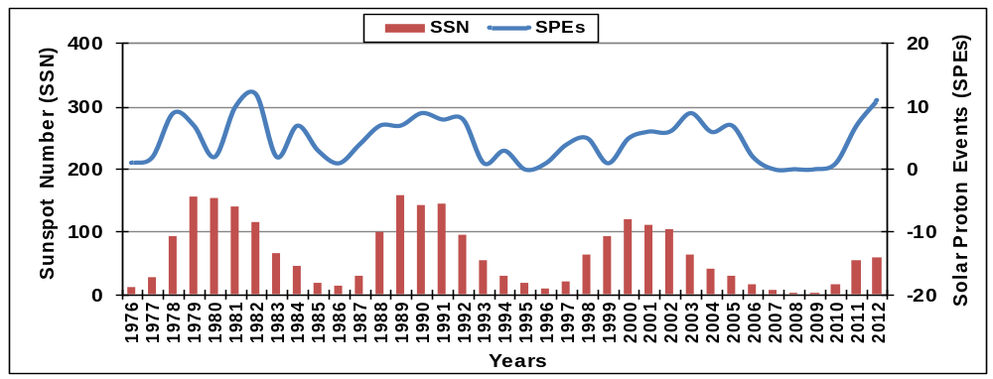
Figure 3 Shows the association of SPEs Events (E ≥10 MeV) and their association with 11-year sunspot cycle, observed during the period 1976 onwards.
Climate Change and Global Warming
The basic components that influence the Earth’s climatic system can occur externally (from extraterrestrial systems) and internally (from ocean, atmosphere and land systems).The external change may involve a variation in the Sun’s output. Internal variations in the Earth’s climatic system may be caused by changes in the concentrations of atmospheric gases, mountain building, volcanic activity, and changes in surface or atmospheric albedo. The basic causes of increase in global temperature can occur from variation in TSI and human made activities (mainly emission of Co₂). Atmospheric carbon dioxide (Co₂) is an important kind of greenhouse gas which influences global temperature. Its concentration variation could indicate the distribution of human and natural activities in various regions. The amount of Co₂ that can be held in oceans is a function of temperature. Co₂ is released from the oceans when global temperatures become warmer and diffuses into the ocean when temperatures are cooler. Initial changes in global temperature were triggered by changes in received solar radiation by the Earth through the Milankovitch cycles. The increase in Co₂ then amplified the global warming by enhancing the greenhouse effect. The long-term climate change represents a connection between the concentrations of Co₂ in the atmosphere and means global temperature. Certain atmospheric gases, like Co₂, water vapor and methane, are able to alter the energy balance of the Earth by being able to absorb long wave radiation emitted from the Earth’s surface. Without the greenhouse effect, the average global temperature of the Earth would be a cold -18° Celsius rather than the present 15° Celsius. Co₂ concentrations in the atmosphere have increased from about 280 ppm in pre-industrial times to 395 ppm at present. The variation of atmospheric Co₂ (in ppmv) collected at Mauna Loa, Hawaii and their association with global surface temperature (GSTemp) during 1976 onwards are plotted in Figure 4. From the plot, it is find that that the rate of concentration of atmospheric Co₂ and GSTemp both are increasing continuously during above mentioned periods. A scatter plot between GSTemp and variation in Co₂ for aforesaid period is shown in Figure 4.6, that shows a strong correlation (r=0.875) between them.

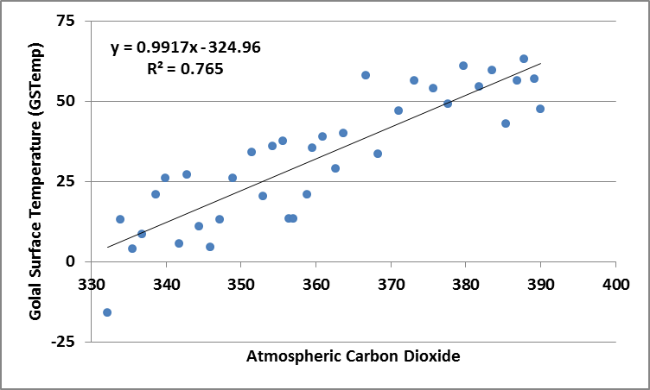
Figure 4 Scatter plot between yearly average value of concentrations of atmospheric Co₂and global surface temperature (GSTemp) during 1976 onwards.
Global Surface Temperature
Climate has changed when the planet received more or less sunlight due to subtle shifts in its orbit, as the atmosphere or surface changed, or when the Sun’s energy varied. But in the past century, another force has started to influence Earth’s climate. Global warming and climate change have the potential to alter biological systems. More specifically, changes to near-surface air temperatures will likely influence ecosystem functioning and thus the biodiversity of plants, animals, and other forms of life. The current geographic ranges of plant and animal species have been established by adaptation to long-term seasonal climate patterns. As global warming alters these patterns on timescales considerably shorter than those that arose in the past from natural climate variability, relatively sudden climatic changes may challenge the natural adaptive capacity of many species. Warmer temperatures are also likely to affect the spread of infectious diseases, since the geographic ranges of carriers, such as insects and rodents, are often limited by climatic conditions. Severe weather conditions conducive to rodents or insects have been implicated in infectious disease outbreaks—for instance, the outbreaks of cholera and leptospirosis. The environment include the destruction of many coastal wetlands, salt marshes, and mangrove swamps as a result of rising sea levels and the loss of certain rare and fragile habitats that are often home to specialist species that are unable to thrive in other environments. Surface warming in temperate regions is likely to lead changes in various seasonal processes: earlier leaf production by trees, earlier greening of vegetation, altered timing of egg laying and hatching, and shifts in the seasonal migration patterns of birds, fishes, and other migratory animals. In high-latitude ecosystems, changes in the seasonal patterns of sea ice threaten predators such as polar bears and walruses; both species rely on broken sea ice for their hunting activities. Also in the high latitudes, a combination of warming waters, decreased sea ice, and changes in ocean salinity and circulation is likely to lead to reductions or redistributions in populations of algae and plankton. As a result, fish and other organisms that forage upon algae and plankton may be threatened. On land, rising temperatures and changes in precipitation patterns and drought frequencies are likely to alter patterns of disturbance by fires and pests. Forecasts of climate extremes can improve awareness and reduce adverse effects. Focusing attention on extreme events also may help countries to develop better means of dealing with the longer-term impacts of global climate change. Conversely, the pressures on the biosphere that drive climate change may cause critical thresholds to be breached, leading to shifts in natural systems that are unforeseen and rapid. Studying historical extremes of climate cannot forewarn on the consequences of such events. Extreme changes in climate may be more stressful than slowly developing changes due to the greenhouse effect.
Conclusion
Astrophysical data demonstrate that the Sun has been variable in activity and radiative output. Solar variability of the total irradiance with the 11-yr activity solar cycle shows good correlation. Several studies clearly suggest that solar output has varied on a time scale longer than 11-yr sunspot cycle. It appears to causing wide spread but limited climate Change. The solar radiations vary with time and affect accordingly the environment of the Earth. At the course of solar cycle, the total energy output of the sun changes by only 0.1%. The ultraviolet radiation from the Sun can change by several percent but the largest changes, however, occur in the intensity of the solar wind and interplanetary magnetic field. Finally, it is claimed that cosmic ray could provide the mechanism by which changes in solar activity affect the climate. The Sun powers Earth’s climate radiating energy at very short wavelengths, predominately in the visible or near-visible (ultraviolet) part of the spectrum. Roughly one-third of the solar energy that reaches the top of Earth’s atmosphere is reflected directly back to space, the remaining two thirds is absorbed by the surface and, lesser extent, by the atmosphere. To balance the absorbed incoming energy Earth radiates the same amount of energy back to space.

References
- Friss-Christensen, E. and K. Lassen, 1991, Length of the solar cycle, an indication of solar activity closely associated with climate, Science 254, 698-700.
- Frӧhlich, C. and Lean J, 2004, Solar radiate output and its variability: evidence and mechanisms, Astron. Astrophys. Rev., 12(4), 373-320.
- Haigh, J.D., 2004, The effect of solar variability on Earth’s climate, Philos. Trans. R. Soc. Lond., A361, 95-111.
- Hathway, D.H. and Wilson R.M., 2004, Solar Physics, 224, 5.
- Kopp, G. and J.L. Lean, J.L., 2011, Geophys. Res. Letters, Frontier article, Vol. 38, L01706.
- Lean, J., Beer, J. and Bradley, R., 1995, Geophys. Res. Lett., 22, 3195.
- Lockwood M. and Fröhlich, C., 2008, Proc. Roy. Soc., Lond.
- Michnowski, S., 1998, Solar wind influences on atmospheric electrical variables in Polar Regions, Journals of Geophysical Research, 103(13), 948.
- Price, C., Rind, D.,1990, The effect of global warming on lighting frequencies in proceedings of the 16th conferences on severe storms and atmospheric electricity, AMS, Kannaskis Park, Alberta, Canda, P.748-751.
- Svalgaard, L., Cliver, E., Kamide, Y., 2005, Geo Res.Let., 32, 01104.
- Wilson, R.C., 1997, Total Solar Irradiance trend during solar cycle 21 and 22, Science, 277, 1963-5.

