Electric and dielectric properties for bioplastic films
Mika Kawai^{1,3}, Tatsuo Kaneko^{2,3} and Tetsu Mitsumata^{1,3}
¹Graduate School of Science and Technology, Niigata University, Niigata 950-2181, Japan
² School of Materials Science, Japan Advanced Institute of Science and Technology, Ishikawa, Japan
³ALCA, Japan Science and Technology Agency, Tokyo 102-0076, Japan

Abstract
The development of biobased polymers is indispensable for the establishment of a sustainable low-carbon society. A number of aliphatic biobased polymers such as polyesters; poly(lactic acid) [1], poly(hydroxyalkanote)s [2], and poly(butylenes succinate) [3], and polyamides (polyamide 11 and polyamide 66) have been developed, but their low glass transition temperature, T_{g}, and only a small percentage of their substitutes limited their use for various applications as superengineering plastic. We have developed so far biobased PIs from bioavailable aromatic diamines, which were photodimers of 4-aminocinnamic acid (4ACA) derived from genetically manipulated Escherichia coli [4-6]. These biobased PI films showed ultrahigh thermal resistance with the temperature at 10% of mass loss, T₁₀, values over 425 °C and no T_{g} values under 350 °C, which is the highest value of all biobased plastics reported thus far. This advanced thermal property can be useful for electric devices such as flexible polymeric electrodes that can be annealed at high temperature. On the application for electric devices, the electric properties such as resistivity, dielectric constant or dielectric breakdown voltage are very important. However, the electric properties for these films are not fully understood.
In this paper, we prepared biobased PI copolymer films (ATA/CBDA) of 4,4'-diamino-α-truxillic acid (4ATA) and 1,2,3,4-tetracarboxycyclobutane dianhydride (CBDA) and measured the electric resistance (volume resistivity) and dielectric constant for these films. We discuss the relationship between the electric properties and the molecular structure for biobased PIs. We also succeeded to synthesis water soluble BPI with various counterions. The electric properties for the water soluble BPIs are also presented.

[1] K. Okano, A. Kondo, H. Noda, Eco. Ind. (2006) 11, 43.
[2] M. Vert, Biomacromolecules (2005) 6, 538.
[3] I. Taniguchi, Y. Kimura, Biopolymers (2001) 3b, 431.
[4] T. Kaneko et al, Nature Mater. (2006) 5, 966.
[5] A. Kumar, S. Tateyama, T. Kaneko et al, Polymer (2016) 83, 182.
[6] P. Suvannasara, S. Tateyama, T. Kaneko et al. Macromolecules (2014) 47, 1586.

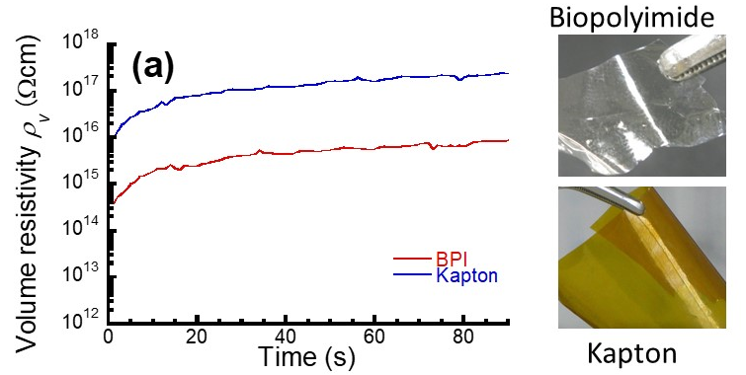
Figure 1. Time profiles of volume resistivity for BPI and Kapton films at room temperature (left). Photographs for BPI and Kapton films (right).

Recent Publications
- Dwivedi S, Mitsumata T, Kaneko T et al. (2018) Effects of biopolyimide molecular design on their silica hybrids thermo-mechanical, optical and electrical properties. RSC Adv. 8: 14009.
- Sasaki S, Kawai M, Mitsumata T et al. (2018) Time-dependent electric conductivity and dielectric breakdown for magnetic soft composites at high-electric fields. Aeron Aero Open Access J. 2: 80‒83.
- Ito W, Yamaki M, Kawai M, Mitsumata T et al. (2016) Extraordinary Swelling of Hydrogels Physically Crosslinked by Megamolecular Chain Sacran. Chem. Lett. 45: 339-340.
- Okajima MK, Mitsumata T, Kaneko T et al. (2015) Anisotropic swelling in hydrogels formed by cooperatively aligned megamolecules. RSC Adv. 5: 86723.
- Mitsumata T, Kawai M, Okajima MK, Kaneko T et al. (2013) Ionic state and chain conformation for aqueous solutions of supergiant cyanobacterial polysaccharide. Phys. Rev. E 87: 042607.


She has studied polymer science at laboratory of soft and wet matter by Profs. Y. Osada and J. P. Gong in Hokkaido University. She works currently at the Graduate School of Science and Technology, Niigata University as a researcher since 2014. She has published more than 25 scientific papers dedicated to soft materials, especially polysaccharides and biopolymers.
Email: tetsu@eng.niigata-u.ac.jp

Notes/Comments:

