Magnetorheological effect for polysaccharide magnetic hydrogels
Tetsu Mitsumata^{1,2} and Mika Kawai^{1,2}
¹Graduate School of Science and Technology, Niigata University, Niigata 950-2181, Japan
²ALCA, Japan Science and Technology Agency, Tokyo 102-0076, Japan

Abstract
Biological tissue, such as dermis of sea cucumbers, exhibits stimuli-responsive properties that the elasticity alters in response to a physical stimulus. Materials that physical property changes responding to a stimulus have been extensively investigated, particularly in the field of soft materials such as polymer gels, rubbers, or elastomers. Polymer gel containing magnetic particles is a stimuli-responsive gel that viscoelastic properties can be controlled by applying magnetic fields. We have fabricated magnetoelastic soft materials with various polymer matrices [1-3]. The elastic modulus of magnetic gels is enhanced by forming a chain structure of magnetic particles, similarly to magnetic fluids. Few years before, we have succeeded to fabricate a new class of magnetoelastic gel that demonstrates drastic and reversible changes in dynamic modulus without using strong magnetic fields [4,5]. At zero magnetic field, the storage modulus of the magnetic gel is low with ~10⁴ Pa although the gel contains large amount of particles as much as 0.30, resulting from random dispersion of the magnetic particle in the gel. The magnetic particle, under magnetic field, aligns to the magnetic lines of force and forms a chain structure contributing to high storage modulus exceeding 4 MPa. Followed to the magnetic gel mentioned above, it was also succeeded to synthesize polyurethane elastomers showing drastic change in dynamic modulus by a factor of 277 [6].
In this paper, we present the magnetoelastic response and morphological properties of carrageenan magnetic hydrogel that underwent wide modulation of dynamic modulus (500 times higher than off-field modulus). In addition, we show new evidence that the relationship between carrageenan-concentration dependent particle morphology and the increase in the storage modulus. The origin of the giant magnetoelastic behavior for carrageenan magnetic gels is discussed.
[1] T. Mitsumata, M. Kawai et al, J. Phys. Chem. B (2012) 116, 12341.
[2] T. Mitsumata, M. Kawai et al, Soft Matter (2013) 9, 904.
[3] T. Mitsumata, M. Kawai et al, Soft Matter (2013) 9, 10108.
[4] T. Mitsumata, N. Abe, Chem. Lett. (2009) 38, 922
[5] T. Mitsumata, M. Kawai et al, J. Phys. Chem. B (2012) 116, 12341.
[6] T. Mitsumata, S. Ohori, Polym. Chem. (2011) 2, 1063.

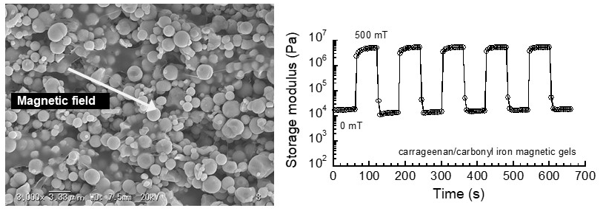 Figure 1. SEM photograph (left) under a magnetic field and magnetic response of storage modulus (right) against a pulsatile magnetic field for carrageenan magnetic hydrogels.

Recent Publications
- Tsujiei Y, Kawai M, Mitsumata T et al. (2018) Particle Dispersibility and sound propagation of ultrasounds for magnetic soft composites. React. Funct. Polym. 130: 1–7.
- Watanabe M, Kawai M, Mitsumata T et al. (2018) Effect of Sonication Time on Magnetorheological Effect for Monomodal Magnetic Elastomers. Gels 4: 49.
- Endo H, Kawai M, Mitsumata T et al. (2018) Magnetically Tunable Vibration Transmissibility for Polyurethane Magnetic Elastomers. Polymers 10: 104.
- Oguro T, Kawai M, Mitsumata T et al (2017) Magnetically-tunable rebound property for variable elastic devices made of magnetic elastomer and polyurethane foam. Mater. Res. Express 4: 126104.
- Sasaki S, Kawai M, Mitsumata T et al (2017) Electric Conductivity and Dielectric-Breakdown Behavior for Polyurethane Magnetic Elastomers. J. Phys. Chem. B 121: 1740-1747.

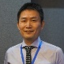
He received his PhD degree in Polymer Science from Hokkaido University in 1999 under the supervision of Profs. Y. Osada and J. P. Gong. In this year, he moved to Graduate School of Science and Engineering, Yamagata University as an assistant professor. He works currently at Graduate School of Science and Technology, Niigata University as a research professor since 2016. He has published more than 110 scientific papers (including reviews and books) and 11 patents dedicated to soft materials, especially magnetic responsive gels or elastomers.
Email: tetsu@eng.niigata-u.ac.jp

Notes/Comments:

