TiO₂ Nanocomposite in Starch-Poly (Acrylamide) Copolymer and Its Application as a Plant Growth Regulator
Nandkishor Shirsath¹, Vikas Gite¹, and Jyotsna Meshram^{1,2*}
¹School of Chemical Sciences, North Maharashtra University, Jalgaon-425 001 (India)
²Department of Chemistry, Rashtrasant Tukadoji Maharaj Nagpur University, Nagpur 440 033 (India)
Corresponding Author E-mail: drjsmeshram@gmail.com

Abstract:
The present study describes the development of nano-TiO2 based composite of starch-co-poly(acrylamide) copolymer. The graft copolymer was characterized by Fourier transform infrared (FT-IR), thermal gravimetric analysis (TGA), scanning electron microscopy (FE-SEM), and X-Ray Diffraction (XRD) confirmed that acrylamide (AM) was grafted onto starch successfully. The effects of pH, initiator dosage, temperature, and time on grafting percentage (GP) and grafting efficiency (GE) were also investigated. The synthesized TiO2 nanoparticles were successful to enhance the thermal and biological properties of a native copolymer which was confirmed by TGA and biological assay. This synthesized nanocomposite starch-co-poly(acrylamide) was used as a superabsorbent polymer (SAP) with great thermal property and antibacterial activity which regulates the growth of the mung bean plant.
Graphical Abstract:

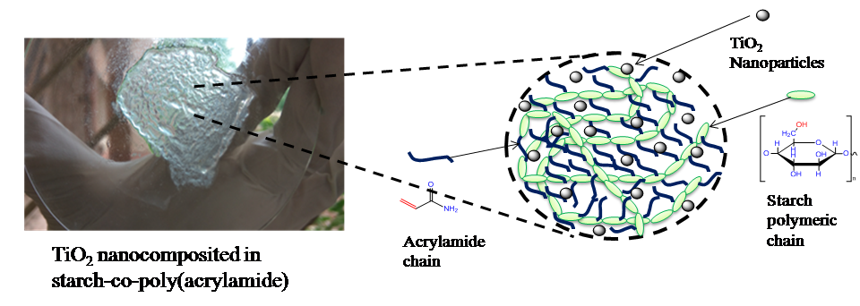

Keywords: Starch-co-poly(acrylamide) copolymer; TiO2 nanoparticles; Antibacterial activity; Superabsorbent polymer; Plant growth regulator.
Acknowledgements: One of the authors, Mr. Nandkishor Shirsath acknowledges Shri. GH Raisoni Doctoral Fellowship for financial support

