Quantitative analysis of molecular interactions in DNA-carbon nanotube hybrids

Fuyou Ke, Donghua University, China
Xiangyun Qiu, the George-Washington University, USA

Abstract (300 word limit)
Single-stranded DNAs with specific sequence not only effectively disperse single walled carbon nanotubes (SWCNT), but also enable chiral separation of SWCNT, but their sorting mechanism has not been clarified yet. Here, we chose SWCNT (6,5) and single-stranded DNA (GT)₂₀ as an example, DNA-SWCNT hybrids were prepared and their structures were characterized. Quantitative measurements of intermolecular forces in DNA-SWCNT hybrids were conducted at different salt concentrations by using osmotic method in combination with X-ray diffraction. Data analysis showed that the intermolecular forces of DNA-SWCNT hybrids could be well described by using long-range electrostatic repulsion and short-range hydration repulsion at low salt concentrations; while at high salt concentrations, non-electrostatic attractions were observed, which we think were attributed to the hydrophobic interactions of exposed SWCNT surface. This study not only helps us understand DNA conformation on SWCNT surface as well as their sorting mechanism of SWCNT, but also has great significance in the assembly of SWCNT-based functional materials.

Image
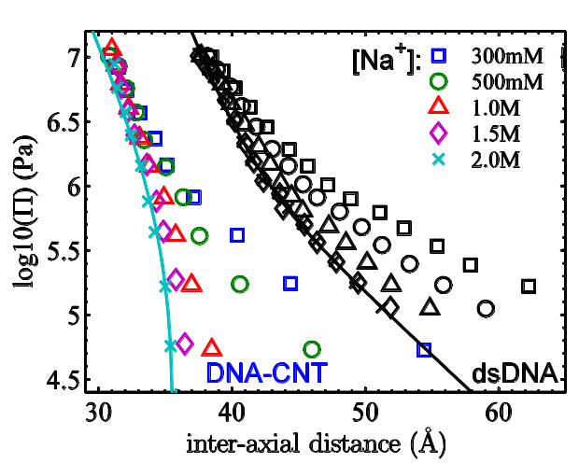
Figure 1: Force-distance curves of the DNA-CNT hybrid and dsDNA at different salts. Solid lines are guides to the eye to illustrate the “concave” and “convex” shapes respectively.
Recent Publications (minimum 5)
- Tu X, Manohar S, Jagota A, Zheng M (2009) DNA sequence motifs for structure-specific recognition and separation of carbon nanotubes Nature 460: 250-253.
- Qiu X, Khripin CY, Ke F, Howell SC, Zheng M (2013) Electrostatically driven interactions between hybrid DNA-carbon nanotubes Physical Review Letter 111:048301
- Ke F, Qiu X (2015) Nanoscale structure and interaction of condensed phases of DNA−carbon nanotube hybrids 119:15763-15769.
- Qiu X, Ke F, Timsina R, Khripin CY, Zheng M (2016) Attractive interactions between DNA−carbon nanotube hybrids in monovalent salts 120:13831-13835.
- Salem DP, Gong X, Liu AT, Koman VB, Dong J, Strano MS (2017) Ionic strength-mediated phase transitions of surface-adsorbed DNA on single-walled carbon nanotubes 139: 16791-16802.


Biography (150 word limit)
Fuyou Ke obtained the PHD at Peking University (China) in 2010. In 2012, he worked with Dr. Xiangyun Qiu at the George-Washington University (USA) as a postdoctoral researcher for one year. Now he is working at Donghua University (China) as an assistant professor. His research focuses on DNA and its hybrids with single-walled carbon nanotubes. He has published more than 30 papers in international peer-reviewed journals.
Email: kefew@dhu.edu.cn
Notes/Comments:

