The direct isolation of chitin nanowhiskers on assimilation of crustacean shell waste and crude extract from pineapple fruit waste

Devi Ramamoorthy and Dhamodharan Raghavachari, Department of Chemistry, I.I.T. Madras, Chennai 600 036, India

Abstract
Statement of the Problem: Chitin is the second most abundant biopolymer. It is found in crustacean shell waste as one of the major components (15-40 %) along with protein (20-40 %) and CaCO₃ (20-50 %).¹ Isolation of high purity chitin is challenging and strictly recommended for biomedical applications.² Chitin nanowhisker (CNW) is an important derivative of chitin produced by hydrolysis of amorphous domain of chitin. They find various applications due to its low density, high surface area, greater strength and biological activity.³ Here, we have demonstrated a facile, direct isolation of CNW using two waste materials namely, prawn shell waste and crude extract from pineapple fruit waste (PWE). The crude PWE is a rich source of water, sugars, lactic acid bacteria (Lactobacillus plantarum), bromelain (proteolytic enzyme) and chitinase. It contains the mixture of appropriate ingredients that are specifically required for direct isolation of CNW. The crude PWE serves as a reaction medium as well as a multifunctional reagent mixture for simultaneous deproteinization, demineralization, and depolymerization in a single-pot. The quality of CNW was evaluated by removal of protein and minerals.⁴ The absence of residual protein in CNW was confirmed by solid-state NMR, UV-Visible and, FT-IR spectroscopies. Additionally, the qualitative tests were also performed to confirm the elimination of proteins. Interestingly, very low residual mineral contents were observed (0.005 % Ca²⁺ and 0.026 % Mg²⁺) as evaluated by AAS. The microscopic analysis using HR-SEM and TEM demonstrated the nanocrystalline structure of CNW isolated by the current method. The pH during the process was observed to fluctuate within acidic range (4.05 to 4.83) that aided the dissolution of minerals and fibrillation of chitin nanowhiskers.⁵ The high quality of CNW prepared by the current method was consistently proved by various analytical techniques. Hence, the current methodology would be promising for sustainable production of CNW.
.

Image

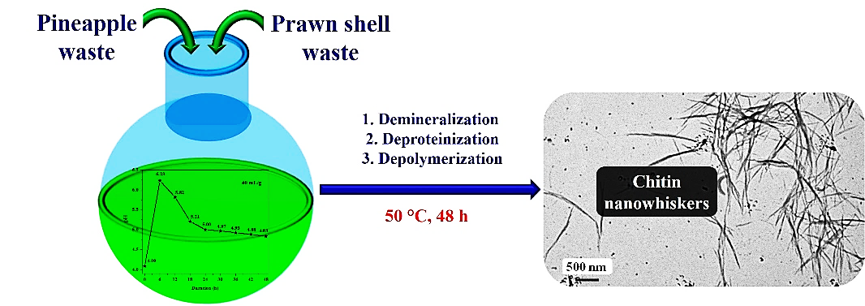
Recent Publications (minimum 5)

- Yan N, Chen X (2015) Don’t waste seafood waste. Nature 524: 155-157.
- Gotar M C, Hours R A (2013) Biotechnological processes for chitin recovery out of crustacean waste: A mini review. Electronic Journal Biotechnology 16: 1-18
- Goodrich J D, Winter W T (2006) α-chitin nanocrystal prepared from shrimp shells and their specific area measurement .Biomacromolecules 8:252-257.
- Devi R, Dhamodharan R (2018) Pre-treatment in hot glycerol for facile and green separation of chitin from prawn shell waste ACS sustainable chemistry and Engineering 6: 846-853
- Ifuku S, Saimoto H (2012) Chitin nanofibers: Preparations, modifications and applications. Nanoscale 4:3308-3318.

Biography
Devi Ramamoorthy with a master in chemistry from Bharathidasan University, India is currently specializing in the separation of chitin from seafood waste for her ph.D dissertation. Prof. R. Dhamodharan teaches and carries at research in polymer chemistry in the department of chemistry IIT Madras, India. He obtained his ph.D in polymer science and engineering from UMASS, Amherst, USA.
Email: dharshini.amr@gmail.com

Notes/Comments:

