Discussion of Green manufacturing and manufacturing green key technology in chemical fiber industry
Xiiangling Chen,Doonghua Unniversity，Songjiang,Shanghai
Ye Chen, Doonghua Unniversity，Songjiang,Shanghai
Peng Ji, Doonghua Unniversity，Songjiang,Shanghai
Huaping Wang*, Doonghua Unniversity，Songjiang,Shanghai

Abstract (300 word limit)

Accompanying with the continuous development of global industry economy, the problems about environment, resource, and climate becoming more serious to us. Green economy based on renewable energy sources is the inevitable trend for global economic developing. Green fiber manufacture can promote structural adjustment of Chinese chemical fiber and textile raw materials, improve competitive power of Chinese chemical fiber, and realize its sustainable development. It is a very important development strategy for changing our country economic development pattern, and also a significant component of Chines energy conservation and emission reduction. In addition, it can satisfy the demands for changing our citizens’ life style, production and consumption concept. In this paper, we start from the seriousness of our chemical fiber green manufactures, and discuss the key technical issues for our chemical fiber green manufacture and manufacturing environmentally, focus on the raw material source, use procedure, manufacture processes, and ecological evaluation. At the end, we prospect the development direction of Chinese chemical fiber industry, which may provide a reference for its overall life-cycle ecological development and its industrialization sustainable development.
Image

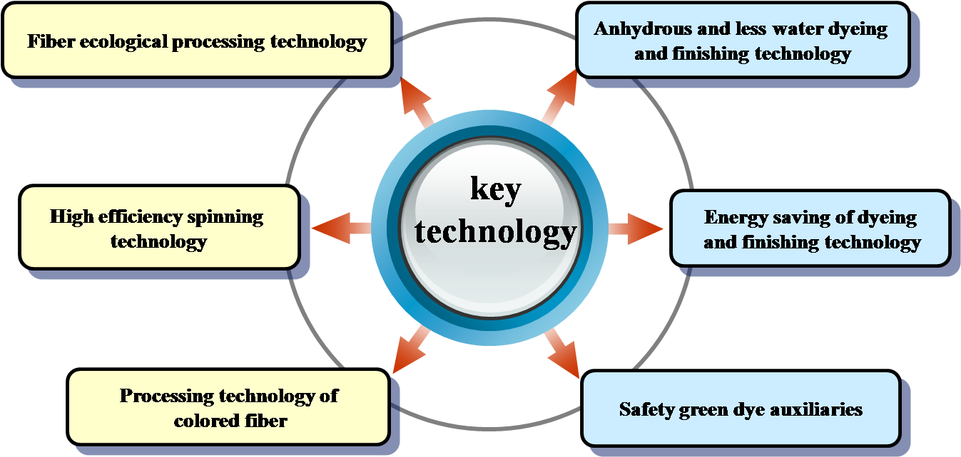
Fig1. Manufacturing technology of green textiles
Recent Publications (minimum 5)
- Patrick B. Smith(2015)Bio-Based Sources for Terephthalic Acid. ACS Symposium Series 27:453-469.
- James H.Wang and Aimin He(2010)Bio-based and Biodegradable Aliphatic Ployesters Modified by a continuous Alcoholysis Reaction: ACS Symposium Series 29:425-437.
- Mrityunjay Singh, Tatsuki Ohji and Rajiv Asthana(2012)Green and Sustainable Manufacturing of Advanced Material, ISBN: 978-0-12-411497-5
- Vista Alegre, Amorim (2013)Green Design, Material and Manufacturing Processes:2nd international Conference Sustainable Intelligent Manufacturing
- Cai Tao, Wang Yi Man; Yang Yu Rong, Wei Min, Wang Ming Kui(2013)Regenerated Bamboo fiber from green solvent: Mechanics and Materials, 423-426: 370-372
- Chen, Chiou-Chua and Lee Chuan-Chen(2014)Research of waste recycling nature fiber material at green roof: Mechanics and Materials, 496-500: 2407-2410

 Biography (150 word limit)
Xiangling Chen has completed his Mater Dgree from Donghua University in China at 2011. After then ,she joined into College of Material Science and Engineering in Donghua University as an engineer. Her research is about biomaterials science, the preparation of function fiber and its application. Now she participated in a National key R & D Program of Ministry of Science and Technology of China. She has got more than 15 patents.

Email: chenxl@dhu.edu.cn

Notes/Comments:

