A Study of biopackaging from Agricultural products for food

Napatsorn Leabwan, Charuwan Rattanasakultham,
Kanoksak Loylerd and Siriporn Tengrang
Department of Agricultural, Thailand

Abstract

Agriculture such as fruit and vegetable pomaces have been studied as potential film forming materials to be used as food biopackaging because of their chemical composition of polysaccharide such as pectin and cellulosic substance. This research aims to select potential fruits and vegetables and develop to biomaterial for food packaging. Selected fruits and vegetables were processed to puree and used them as raw materials for film processing. Chemical compositions and film properties were determination. Among the purees, carrot showed the highest pectin, could produce the best film. The film’s properties was Improved by adding hydrocolloids, pectin and alginate at 1.5, 3 and 4.5% w/w of puree. The results showed that increasing concentration of both hydrocolloids were increased thickness, L*, tensile strength and water barrier (WVTR decreased) of film (P<0.05) while oxygen barrier of film were reduced (OTR increased). Film containing 3% Alginate had better properties than other films. However, both of hydrocolloids could not improve elongation of films. So, xylitol at 1.25, 2.5, 3.75, 5 and 6.25% w/w of carrot puree were added to increased film’s elongation. The results showed increasing concentration of xylitol that increased thickness, water solubility, moisture content and elongation of film (P<0.05). On the other hands, tensile strength, water vapor barrier, L* and oxygen barrier of film were reduced (P<0.05). The higher levels xylitol caused the increased discolored of carrot film between storage. Afterward, carrot with 3% alginate and 3.75% xylitol was selected to form peanut toffee wrapper. During 6 weeks at 65% RH, peroxide value of samples that wrapped with carrot-based film was slower increasing than samples that wrapped with wax paper and unwrapped
Image
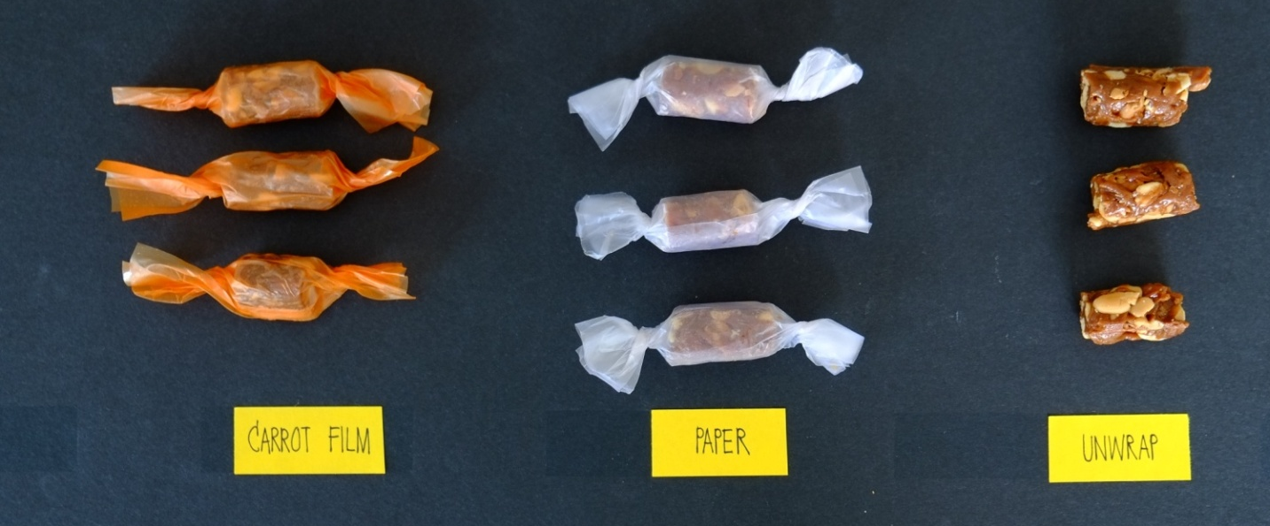

Figure 1: Appearance of Thai Peanut Toffee in different packaging
Recent Publications

Biography
NAME: Charuwan Rattanasakultham. PRESENT POSITION: Scientist. ORGANIZATION: Crop Processing Research and Development Group, Postharvest and Processing Research and Development Office, Department of Agriculture, Chatuchak, Bangkok, Thailand, www.doa.go.th. TYPE OF BUSINESS: Agricultural Research.Recent Research: Flavoring production from herb and spice for health. Effects of Package and Storage Conditions on Dried Longan Flesh Quality

Email: ch_rttn@yahoo.com

Notes/Comments:

