Bioplastic packaging from banana pseudo-stem (Musa spp.)
Siriporn Tengrang*, Wimonwan Wattanawichit,
Charuwan Rattaansakultham, Kanoksak Loylerd and Napatsorn Leabwan,Department of Agricultural, Thailand

Abstract
The aim of this study was to produce the bioplastic packaging from banana pseudo-stem (Musa spp. cv. Nam-Wah). The cellulose of banana pseudo-stem was extracted with sodium hydroxide and then lignin removed with hydrogen peroxide. The cellulose powder was then synthesized to biopolymer: carboxymethyl cellulose (CMC) by chloroacetic acid in alkaline condition. The percent yield of cellulose from banana pseudo-stem was 20.25% whereas the yield of CMC was 140.89%. The obtained CMC powder had 95.33% purity and a degree of substitution (DS) at 0.768. It was water soluble with low viscosity at 114 cPs and appeared in pale yellow color. CMC solutions were added with 3 different additives viz. glycerol, sorbitol and polyethylene glycol at 10, 20, 30 and 40% (w/v) concentrations to form bioplastic film. The higher content of all additives resulted to the thicker film, greater elongation (%), poorer water solubility and lower tensile strength. Film without any additives had the highest tensile strength. The films formed with 40% sorbitol had the highest elongation while oxygen could transmit through film with 40% polyethylene glycol at greater rate than other films. Besides, films with 10% glycerol had the highest water solubility. All CMC-based bioplastic films could be degraded within 24 hours by burying it in high moisture content soil. Afterward, CMC films were processed to sachets for storing dry coffee powder. CMC-20% polyethylene glycol sachets could maintain quality of dry coffee powder if stored in refrigerated condition whereas CMC-30% polyethylene glycol could retain quality of dry coffee as similar as the coffee packed in aluminum foil bags at ambient air. The results indicated that bioplastic derived from the pseudo-stem of banana could be a potential material for dry food packaging.

Image
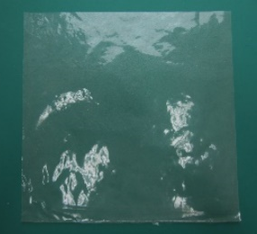
Figure 1 Bioplastic film from CMC- banana pseudo-stem.
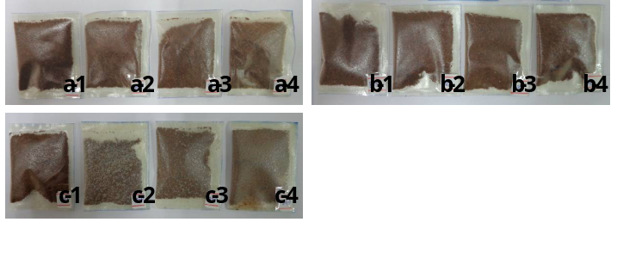
Figure 2 Effect of additive types and concentrations on appearance of coffee in CMC film packages, (a1-a4) CMC film with 10-40 wt% glycerol, (b1-b4) CMC film with 10-40 wt% Sorbitol and (c1-c4) CMC film with 10-40 wt% polyethylene glycol.
Recent Publications
- Tengrang S, Wattanawichit W, Rattanasakultham C, Enmak P and Sukhasem S (2017) Ethylene Absorber Paper from Durian Husk for Prolonging the Storage life of Fruit. J Food Process Technol 8:9 (Suppl).
- Tengrang S, Leabwan N, Loylerd K, Enmak P, Changprasert S and Korppiboon A (2017). Observations of the effect of different bioplastic packaging on prolonging the storage life of rambutan and biodegrability of the packaging. Acta Horticulturae 1186: 177-184.
- Tengrang S, Leabwan N, Wattanawichit W, Loylerd K, Vichitcholchai T, and Sukhasem S (2017). Research and development of bio-plate from durian husk. Acta Horticulturae 1186: 157-163.

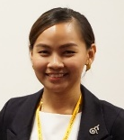 Biography
Siriporn Tengrang is presently the Scientist of the Organization: Crop Processing Research and Development Group, Postharvest and Processing Research and Development Office, Department of Agriculture, Chatuchak, Bangkok, Thailand. Her recent research revolves around: bioplastic from agricultural residue, bio-packaging from cassava starch and antimicrobial packaging.
Email: aom153@hotmail.com

Notes/Comments:

