BIOpolymer-Compounds with High-Strength Properties
Polymer and Composite Engineering (PaCE) group, Institute of Materials Chemistry and Research, Faculty of Chemistry, University of Vienna, Währinger Straβe 42, 1090 Vienna, Austria
Franz S. Huemer GmbH (FSH), Wienerbergstraße 11/B16, 1100 Vienna, Austria

Abstract
“BigBags”, made of stretched standard polymer tapes (e.g. iPP, PE-HD, PET, and PA), are suitable packaging materials with the required mechanical properties for heavy loads, e.g. fertilizers in agricultural applications. Based on environmental aspects, synthetic highly-stretchable polymer tapes should be replaced by resource-saving Biopolymer tapes with high-strength properties. Thus, the goal of this study was to avoid polymer-waste, especially in agricultural applications. It is known that linear, unbranched polymer chains allow for a high stretchability, but unfortunately Biopolymers usually have a more complex structure compared to synthetic polymers. Until now no Biopolymer-compounds with high-strength properties are known and basic know-how about correlations between stretching parameters and materials properties is very scarce, especially for Biopolymers.
Compounds of starch and Biopolyesters are promising materials for production of biodegradable products, because of their availability, renewability and biodegradability. However, compared to stretchable films made of synthetic polymers elongations at break of starches are lower by a factor of 100. Plasticizers are used to increase flexibility and stretchability of starch. Starch compounded with plasticizers is termed “thermoplastic starch” (TPS). The most common plasticizer is glycerol, which reduces the intermolecular bonding forces by increasing the inter(macro)molecular distance.
In this study the influence of different starch pretreatments (e.g. acid degradation) and starch sources (potatoe, maize, …) to the strechability and mechanical properties were investigated. The aim was to develop high-strength TPS-Biopolyester-compounds, which allow for a high stretchability and stiffness as required in BigBag-applications.
Furthermore, correlations between material properties and stretching parameters of Biopolymer-compounds were evaluated. It was found that parameters, such as sample geometry, temperature, degree, as well as velocity of stretching have an influence on mechanical properties. Thick and narrow samples, higher temperatures and lower velocities of stretching result in better mechanical properties. Ultimately, results indicate that the degree of stretching should be lower than 100%.

Image

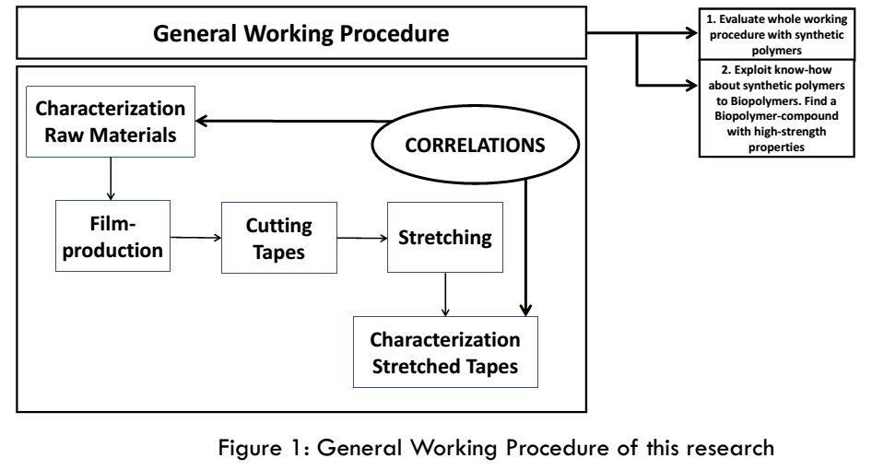
Recent Publications
- Alves V D, Mali S, Beleia A, Grossmann M V E (2007) Effect of glycerol and amylose enrichment on cassava starch film properties, Journal of Food Engineering, 78, 3, p. 941-946
- Laohakunjit N, Noomhorm A (2004) Effect of Plasticizers on Mechanical and Barrier Properties of Rice Starch Film, Starch-Stärke, 56, 8, p. 348-356
- Li M, Liu P, Zou W, Yu L Xie F, Pu H, Liu H, Chen L (2011) Extrusion processing and characterization of edible starch films with different amylose contents, Journal of Food Engineering, 106, 1, p. 95-101
- Oses J, Niza S, Ziani K, Mate J I (2009) Potato starch edible films to control oxidative rancidity of polyunsaturated lipids: effects of film composition, thickness and water activity, International Journal of Food Science & Technology, 44, 7, p. 1360-1366
- Jimenez A, Fabra M J, Talens P, Chiralt A (2012) Edible and Biodegradable Starch films: A Review, Food and Bioprocess Technology, 5, 6, p. 2058-2076
- Ward I M M, Thompson G P, Unwin A P (2013) Flexible intermediate bulk container, US Patent 8, 349, 422
- Van Krevelen D W, Te Nijenhuis K (2009) Properties of Polymers: Their Correlation with Chemical Structure; their Numerical Estimation and Prediction from Additive Group Contributions, Elsevier B.V., chapter 24.2.4, p. 813 ff

Biography
Johanna began her scientific career at the Institute of Applied Synthetic Chemistry of the Technical University of Vienna, where she did her Bachelor Thesis about “Synthesis of planarized CBP-Derivates as Hots Materials for PHOLED Applications”. Her new findings were successfully published in Organic Electronics. During her master studies, Johanna found her passion for polymer chemistry and she did her Master Thesis in cooperation with the company “Semperit” where she gained experience with the topic of “Process Enhancement of Rubber Compounding” and polymer engineering. For her PhD Thesis, Johanna joined the Polymer Composite and Engineering group at the University of Vienna working on “High-Performance BIOpolymer-Compounds”. Her project is based on a cooperation with the company Franz S. Huemer Holding, and the research institute Laboratory for Polymer Engineering. Furthermore, the Agrana Research and Innovation Center is involved, who provides BIOpolymers.
Email: johanna.eichelter@chello.at

