Cellulose/PSA alloy fibers with advanced properties
Kaijian Wu, Yumei Zhang*, Huaping Wang
State Key Laboratory for Modification of Chemical Fibers and Polymer Materials, College of Materials Science and Engineering, Donghua University, Shanghai, 201620, China

Abstract
Cellulose fibers have unique advantages including good wearing comfort, hygroscopicity and permeability, which are widely used in the fields of garments, household and industry. However, cellulose fibers are flammable which limits its applications in some special fields. In order to prepare flame-retardant fibers with improved flame retardancy, hydrophilic and mechanical properties, the flame retardant polymer, aromatic polysulfonamide (PSA), was selected to be blended with cellulose with 1-butyl-3-methylimidazolium chloride ([BMIM]Cl) as solvent. The cellulose/PSA alloy fiber with the “sheath-core” structure was successfully prepared by dry-jet wet spinning technology. The effect of weight ratio, viscosity ratio of cellulose and PSA solutionon as well as spinning technology on the properties and phase morphology of the cellulose/PSA alloy fibers were studied in detail. The flame retardant properties of the alloy fibers were improved as the viscosity of PSA/[BMIM]Cl solution was lower. The contact angle and the water retention values of the alloy fibers showed that the moisture absorption was strengthen with the addition of the cellulose. PSA in blend solution with lower viscosity could migrate towards the out layer of the fibers, and cellulose in blend solution with higher viscosity stated in the core during the spinning process, which improved the flame-retardant property of the alloy fibers at a certain blend ratio. It is shown that the LOI, as well as the surface property varied not only with the weight ratio of cellulose and PSA but also with the viscosity ratio of two composites and the spinning technology. Therefore, the flame retardant and mechanical properties of the cellulose/PSA fibers could be optimized according to the various factors during spinning process.

Image
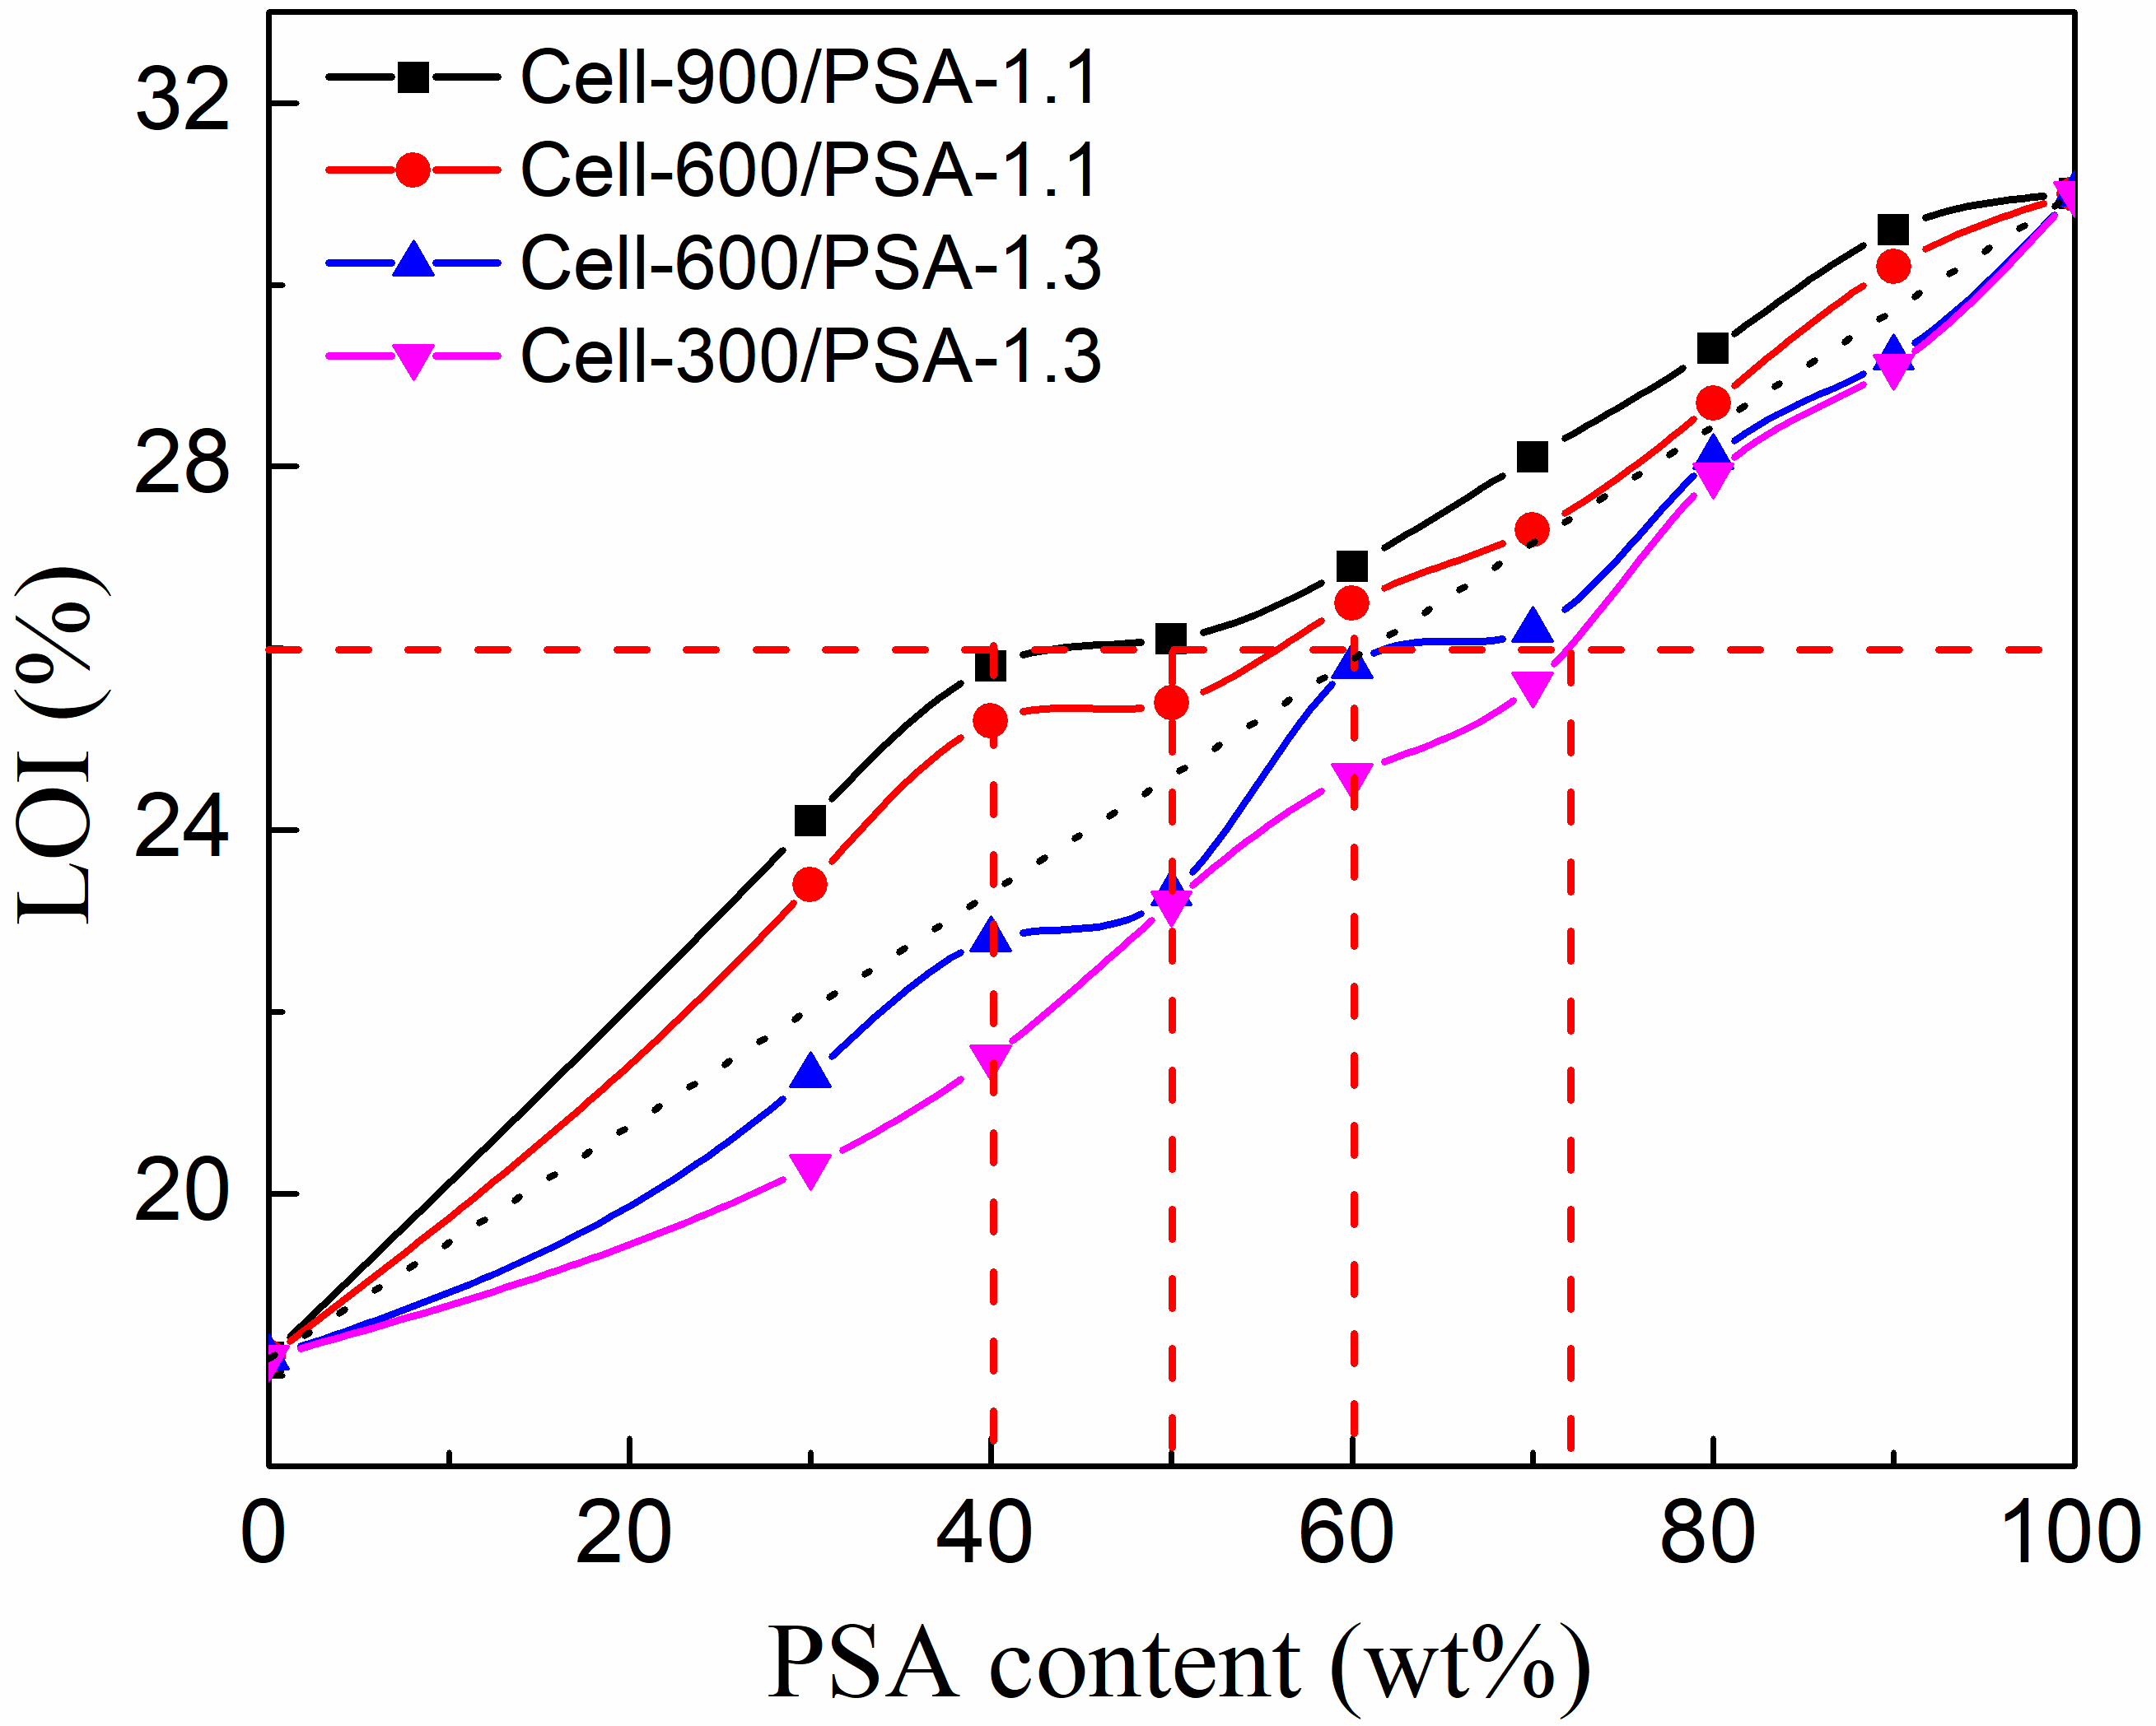
Fig. 1 Relationship between LOI of cellulose/PSA alloy fibers and viscosity ratio of their solutions in [BMIM]Cl
Recent Publications
- Wu K, Yao Y, Yu J, Chen S, Wang X, Zhang Y, Wang H(2017). Cellulose/aromatic polysulfonamide blended fibers with improved properties. Cellulose 24(8): 3377-3386.
- Cao C, Wu K, Yuan W, Zhang Y, Wang H (2017). Synthesis of Non-water Soluble Polymeric Guanidine Derivatives and Application in Preparation of Antimicrobial Regenerated Cellulose. Fibers and Polymers 18(6): 1040-1047.
- Wu K, Yu J, Yang J, Chen S, Wang X, Zhang Y, Wang H (2018). Properties and phase morphology of cellulose/aromatic polysulfonamide alloy fibers regulated by the viscosity ratio of solution. Cellulose https://doi.org/10.1007/s10570-017-1605-2.
- Yu J, Chen K, Li X, Tian F, Chen S, Zhang Y, Wang H (2016). Performance and structure changes of the aromatic co-polysulfonamide fibers during thermal-oxidative aging process. Journal of Applied Polymer Science 133(41): 44078
- Xia X, Wang J, Wang H, Zhang Y (2016). Numerical investigation of spinneret geometric effect on spinning dynamics of dry-jet wet-spinning of cellulose/[BMIM]Cl solution. Journal of Applied Polymer Science 133(41): 43962

Biography
The corresponding author is Professor in fiber materials, College of Materials Science and Engineering at Donghua University. She is an expert in the area of fiber processing dynamics and technology for about 20 years.

Email: zhangym@dhu.edu.cn

