Efficient large-scale preparation of defect-free few-layer graphene using a conjugated ionic liquid as green media
Ye Chen, Donghua University, Shanghai, China
Chunyu Wang, Donghua University, Shanghai, China
Huaping Wang, Donghua University, Shanghai, China

Abstract
Graphene has received extensive attention and wide application in electrical device, energy materials, and biomaterials, due to its large surface area and excellent performance in mechanical, thermal conductive, electrical and optical properties. All the properties depend on the distinct structure of graphene, such as layers, scale, surface defects. However, the difficulty of fast and efficient preparing high-quality graphene limits its industrial application. In this study, a conjugated IL named 1-methyl-3-pyrenemethyl-imidazolium hexafluorophosphate ([MPIM][PF6]) was synthesized and used to exfoliate graphite into graphene with the assistance of microwave irradiation. Owing to the cation-π interaction and additional strong π-π interaction between [MPIM][PF6] and graphite, large-scale, defect-free and few-layer high-quality graphene (GNP^{IL}) was efficiently prepared. And the results show that a relatively high yield of 40% is obtained. Moreover, the GNP^{IL} has good dispersability and conductivity due to the presence of ionic liquids in the interlayer. The high-quality GNP^{IL} could be dispersed in organic solvent homogeneously and stably with a high content, which is beneficial for its further applications. The AFM results show that the ionic liquid-functionalized graphene has a thickness of 4 to 6 nm and 5 to 10 layers. FTIR curves further prove ionic liquids exist in the graphene sheets. UV-Vis is used to characterize the dispersibility of the graphene in the organic solvent. Furthermore, this GNPIL is used to improve the conductivity and mechanical property of polymer. Compared with the resistivity of pure polymer, the resistivity of the composites decreases by eleven orders of magnitude, when 0.75 wt% graphene is added. With the increase of graphene content, the tensile strength of the composites increases gradually and when the content is 0.75 wt%, the tensile strength reaches the maximum, after that, it decreases. However, the thermal properties of composites do not change too much after the addition of graphene, so the composite still maintains good thermal properties.

Image
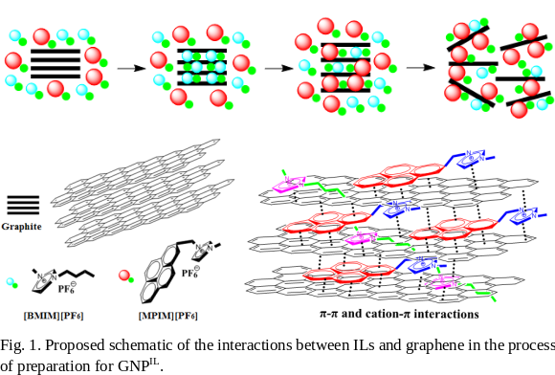
References
- Chen Y., Tao J., Deng L., Li L., Li J., Yang Y., Khashab N.M.(2013) Polyetherimide/Bucky Gels Nanocomposites with Superior Conductivity and Thermal Stability, ACS Appl. Mater. Interfaces 15:7478-7484.
- Chen Y., Tao J., Hammami MA., Hoang P., and Khashab N.M.(2016) Self-Assembly of Single-Crystal Silver Micro-Flakes on Reduced Graphene Oxide and Their Use in Ultrasensitive Sensors. Adv. Mater. Interfaces. 1500658
- Liu C.Z., Ye S.B., Feng J.C. (2017) Promoting the dispersion of graphene and crystallization of poly (lactic acid) with a freezing-dried graphene/PEG masterbatch, Compos. Sci. Technol. 144: 215-222.
- Zarasvand K.A., Golestanian H. (2017) Investigating the effects of number and distribution of GNP layers on graphene reinforced polymer properties: Physical, numerical and micromechanical methods, Compos. Sci. Technol. 139: 117-126
- Kuilla T., Bhadra S., Yao D.H., Kim N.H., Bose S., Lee J.H. (2010) Recent advances in graphene based polymer composites, Prog. Polym. Sci. 35:1350-1375.

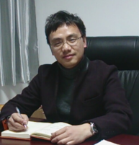 Biography
Ye Chen has completed his PhD from Donghua University in China at 2011 and postdoctoral studies from King Abdullah University of Science and Technology (KAUST) in Saudi Arabia. Now he joined into College of Material Science and Engineering in Donghua University as an associate professor. His research is about biomaterials science, the preparation of advanced nanocomposites and its application. Now as a subject head, he participated in a National key R & D Program of Ministry of Science and Technology of China. He has got more than 10 patents including US patents, and has published more than 30 papers in ACS Appl.Mater.Interfaces, Adv. Mater. Interfaces, Polymer etc. This work was supported by the National Natural Science Foundation of China and Shanghai Pujiang Program.
Email: chenye@dhu.edu.cn

Notes/Comments:

