Application of Co⁶⁰ gamma irradiated chitosan on betel vine plants
Ferdous Aktar¹, Dr. Papia Haque^{1*}, Dr. Mubarak Ahmad Khan² and Dr. A. I. Mustafa³

¹PhD Candidate, Department of Applied Chemistry & Chemical Engineering, University of Dhaka, Bangladesh, Email: ferdousaktar7@gmail.com
^{1*} Associate professor of the Department of Applied Chemistry & Chemical Engineering, University of Dhaka, Bangladesh, Email: papiahq@du.ac.bd
²Director General of the Atomic Energy Research Establishment (Ex), Atomic Energy Commission, Bangladesh, Advisor of the Ministry of textile and Jute (Present), Bangladesh
Email: makhan.inst@gmail.com
³Professor of the Department of Applied Chemistry & Chemical Engineering (Ex.), University of Dhaka, Bangladesh; Dean of the Faculty of Allied Health Sciences (Present), Daffodil International University, Bangladesh, Email: ai_mustafa@yahoo.com

^{1*}Corresponding Author; Email: papiahq@du.ac.bd

Abstract
In recent years, there is a trend in agriculture to limit the usage of chemical compounds. Natural biomaterials are new promising materials that possess important properties like biodegradability or lack of toxicity. Radiation processing of biomaterials is an area of current research for development of new applications. Consequently, the present study was designed to evaluate the potential uses of biomaterial Chitosan as plant growth promoter, disease control action and biofertilizer. Betel leaf is an export item and one of the cash crops of Bangladesh. Betel vine (Piper betel L.) is a perennial dioeciously creeper belonging to the family Piperaceae. Its cultivation is concentrated in the greater district of Cox’s Bazar, Bangladesh. These experiments were held in Cox’sbazar district of Bangladesh. After consult with the local agriculture office, Coxsbazar it was informed that there was no betel research institute. But they noticed that this perennial crop is found to be infected by various diseases of which Powdery mildew, Foot Rot & Leaf Rot caused by various pathogens, Phytophthora parasitical and Colletotrichumcapsici are the major constraints for cultivation of the crop across the country. Leaf rot can damage the crop within a week when it attacks the vine. Leaf rot and foot rot have been reported to be caused by Phytophthpra palmivora and leaf rot may cause 30-100% leaf yield loss. The relative humidity enhances the incidence of the leaf rot disease. In rainy season the belel vine were also attacked more than other season. Betel farmers face reflective loss due to attack by leaf rot. Figure 1 shows the photograph of diseased betel leaves on untreated betel vine and 100% healthy and disease free piper betel leaves on irradiated chitosan treated betel vine after 90 days, by the treatment of 350ppm, 50kGy irradiated chitosan solution. In treated plants the absorption of irradiated chitosan acted as a growth promoter, disease control activity which resulted in elongation of plant root and shoot growth, increase in plant productivity and an improvement in physiological parameters compared with the untreated plants and could act as a bio-fertilizer.
Keyword: Gamma radiation, Chitosan, Biofertilizer, Disease control

Diseased leaves | Healthy leaves
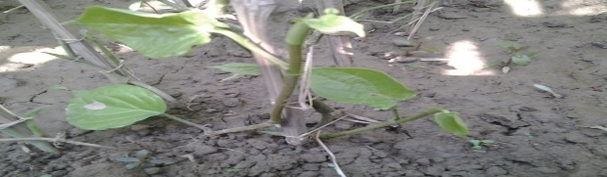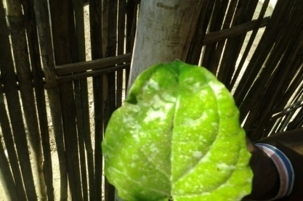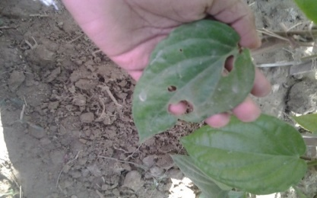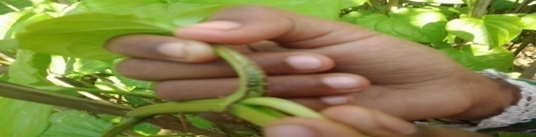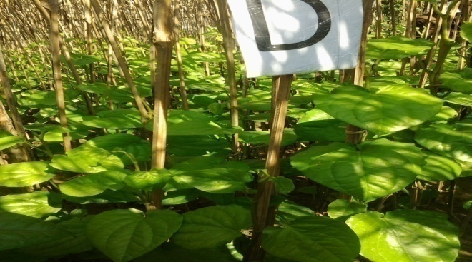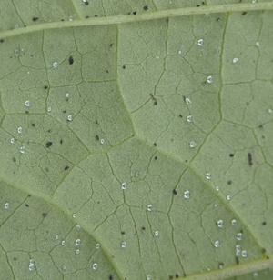
Figure 1: The effect on diseases of piper betel vine after 90 days due to applying nonirradiated and irradiated chitosan of different concentration

